

**VA Form 21-686c:  
Request to Add/Remove Dependents  
  
VA Form 21-674:  
Request For Approval of School Attendance**

Version 2  
Launch: March 2025

Revision History

| Date | Version | Description | Author |
| --- | --- | --- | --- |
| 09/2020 | 001 | The initial debut of the product | eBenefits Team (VSA) |
| 02/2025 | 002 | Form parity and addition to v3 Design System components | Dependents team: Fiorella Geedi |

Table of Contents

**1. Overview**

**2. User Access**

**3. Navigation**

Homepage

Main menu

View or change dependents on your VA disability benefits page

About form 21-686c

About form 21-674

Search results

**4. Functionality**

Introduction page

Not signed in

Signed in

In-process

Verify: Missing the VA file number

Finish later—Saved

Step 1: What would you like to do?

1.0 What would you like to do—Level 1

1.1 What would you like to do—Add

1.2 What would you like to do—Remove

Step 2: Veteran’s information

2.0 Confirm personal information

2.1 Mailing address

2.2 Mailing address (outside the U.S.)

2.3 Phone and email address

Step 3: Add your spouse

3.0 Spouse’s current legal name

3.1 Spouse’s identification information

3.2 Spouse’s military service information

3.3 Information about your marriage

3.4 Spouse’s address

3.5 Information about your marriage

3.6 Where did you get married?

Outside the U.S.

3.7 How did you get married?

By common law

By proxy

In a tribal ceremony

Some other way

3.8 Reason you live separately from your spouse

3.9 Spouse’s marital history

3.10 Spouse’s former marriage

3.11 Spouse’s former marriage (Con’t)

3.12 Spouse’s former marriage (Con’t)

3.13 Spouse’s former marriage (Con’t)

3.14 Spouse’s former marriage (Con’t)

3.15 Spouse’s former marriage (Con’t)

3.16 Review your spouse’s marital history

3.17 Your marital history

3.18 Your former marriage

3.19 Your former marriage (Con’t)

3.20 Your former marriage (Con’t)

3.21 Your former marriage (Con’t)

3.22 Your former marriage (Con’t)

3.23 Your former marriage (Con’t)

3.24 Review your former marriages

Step 3: Add one or more children

3.25 Your children

3.26 Add a child

3.27 Child’s identification information

3.28 Child’s birthplace

Born outside the U.S.

3.29 Your relationship to this child

3.30 Your relationship to this child

Adopted child

Stepchild

3.31 Child’s biological parents

3.32 Child’s disability

3.33 Child’s disability (Con’t)

3.34 Additional information about this child

3.35 How and when the marriage ended

3.36 Additional information about this child

3.37 Child’s address

3.38 Tell us who this child lives with

3.39 Review your children

Step 3: Add one or more students between the ages of 18 and 23

3.40 Your students

3.41 Add a student

3.42 Student’s information

3.43 Student’s information (Con’t)

3.44 Student’s address

3.45 Student’s marital status

3.46 Student’s marital status

3.47 Student’s education benefits

3.48 Student’s education benefit payments

3.49 Student’s education program or school

3.50 Additional information for this student

3.51 Additional information for this student (Con’t)

3.52 Additional information for this student (Con’t)

3.53 Student’s term dates

3.54 Student’s term dates (Con’t)

3.55 Student’s previous term

3.56 Student’s income

3.57 Student’s income in the year their current school term began

3.58 Student’s expected income next year

3.59 Value of student’s assets

3.60 Additional information

3.61 Review your students

Step 3: Remove a divorced spouse

3.62 Divorced spouse’s information

3.63 When, where, and why did this marriage end?

3.64 Divorced spouse’s income

Step 3: Remove one or more dependents who have died

3.65 Your dependents who have died

3.66 Remove a dependent who has died

3.67 Your relationship with this dependent

3.68 Your relationship with this dependent (Con’t)

3.69 Dependent’s death date

3.70 Dependent’s death place

3.71 Dependent’s income

3.72 Review your dependents who have died

Step 3: Remove one or more stepchildren who have left your household

3.73 Your stepchildren who have left your household

3.74 Remove a stepchild who has left your household

3.75 Your support of this stepchild

3.76 Your support of this stepchild (Con’t)

3.77 Stepchild’s address

3.78 Tell us who this stepchild lives with

3.79 Review your stepchildren who have left your household

Step 3: Remove one or more children who got married

3.80 Your children under 18 who got married

3.81 Remove a child who got married

3.82 Child’s marriage date

3.83 Child’s income

[3.84 Review your children under 18 who got married  
(This is the last page to add information about the Veteran’s children under 18 who got married.)](#_heading=h.yssh8n54xo3d)

Step 3: Remove one or more children between the ages of 18 and 23 who left school

3.85 Your children between the ages of 18 and 23 who left school

3.86 Remove a child between the ages of 18 and 23 who left school

3.87 Child’s school information

3.88 Child’s income

3.89 Review your children between the ages of 18 and 23 who left school

Step 4 Your net worth

4.0 Your net worth

Step 5 Additional information

5.0 Submit supporting evidence to add your spouse

Uploaded file

Supporting evidence

Document upload instructions

5.1 Submit supporting evidence to add your child

Uploaded file

Supporting evidence

Step 5 Review application

5.0 Review application

Confirmation

6.0 Confirmation

6.0 Confirmation (Con’t)

**5. Email Notifications**

Reminder

In-progress

686c

674

686 and 674

Received

686c

674

686c and 674

Action needed

686c

674

686c and 674

**6. Major Issues and Error Messages**

Required response

Incomplete information

Privacy policy

Missing information

Submission failure

Connection error

## 1. Overview

The online 21-686c form allows Veterans to add or remove dependents from their VA benefits. The online form flow is integrated with the 21-674 form (Request for Approval of School Attendance), which is used when claiming benefits for a Veteran's child who is at least 18 years old but under 23 and attending school.

## 2. User Access

Who can access this form?

* **Authenticated users** are Veterans with LOA3-verified accounts. LOA users have had the required verification of the documents or references through record checks. ID.me facilitates this through an industry-recognized standard known as FICAM. Credentials are needed to log in.

## 3. Navigation

How can Veterans access this form?

Veterans can go to VA.gov to access this form from the following pages:

* Homepage (under the Top Pages section): <https://www.va.gov/>
* Menu (logged in): <https://www.va.gov/view-change-dependents/view>
* View or change dependents on your VA disability benefits page: <https://www.va.gov/view-change-dependents>
* About form 21-686c: <https://www.va.gov/find-forms/about-form-21-686c/>
* About form 21-674: <https://www.va.gov/find-forms/about-form-21-674/>
* Search results: <https://staging.va.gov/search/?query=dependents&t=false>
* PDF: There might be direct links on PDFs at VA.gov
* Online form: <https://www.va.gov/view-change-dependents/add-remove-form-21-686c/introduction>

### Homepage

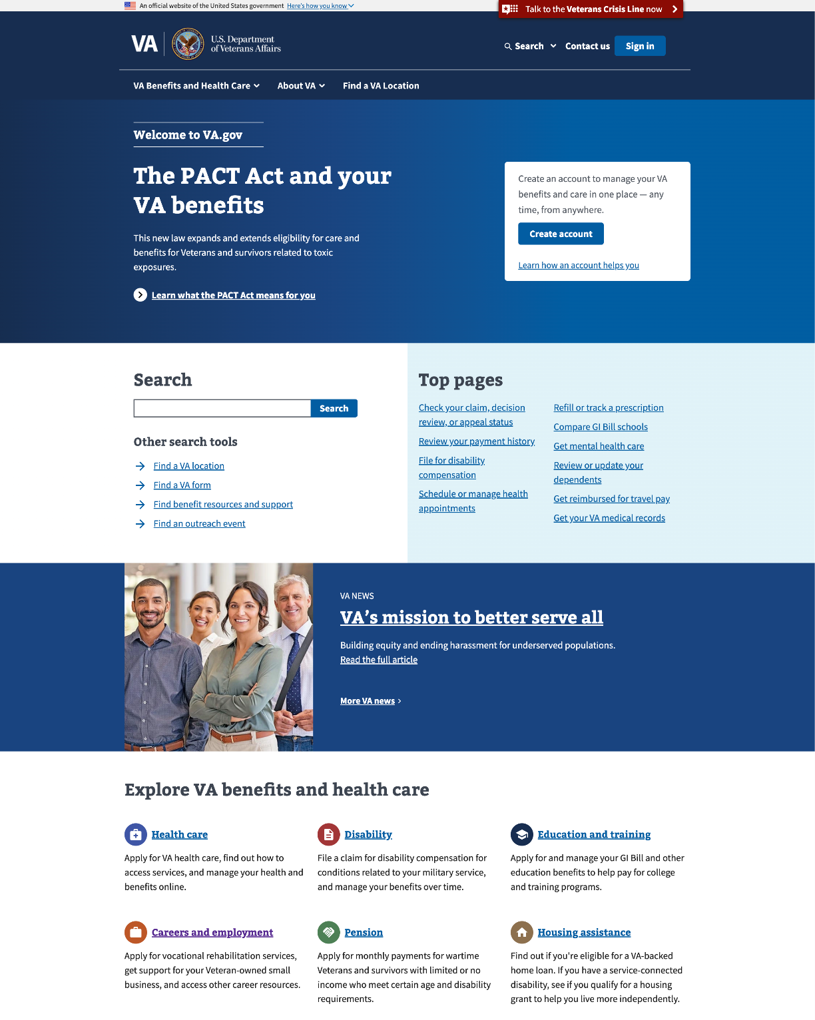

### Main menu

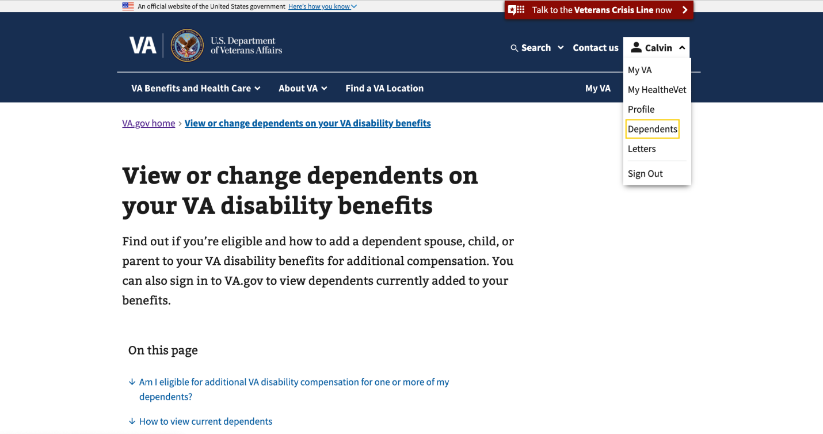

### View or change dependents on your VA disability benefits page

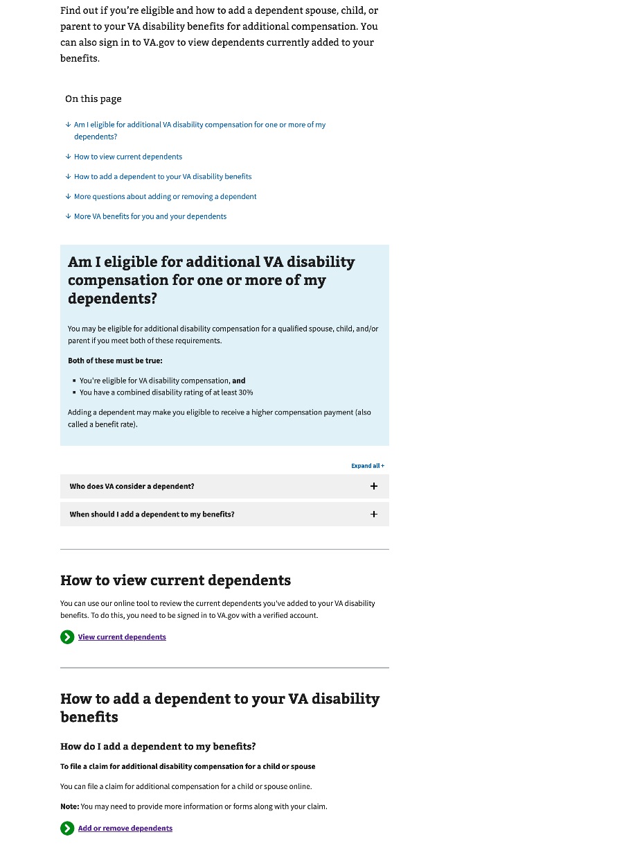

### About form 21-686c

### About form 21-674

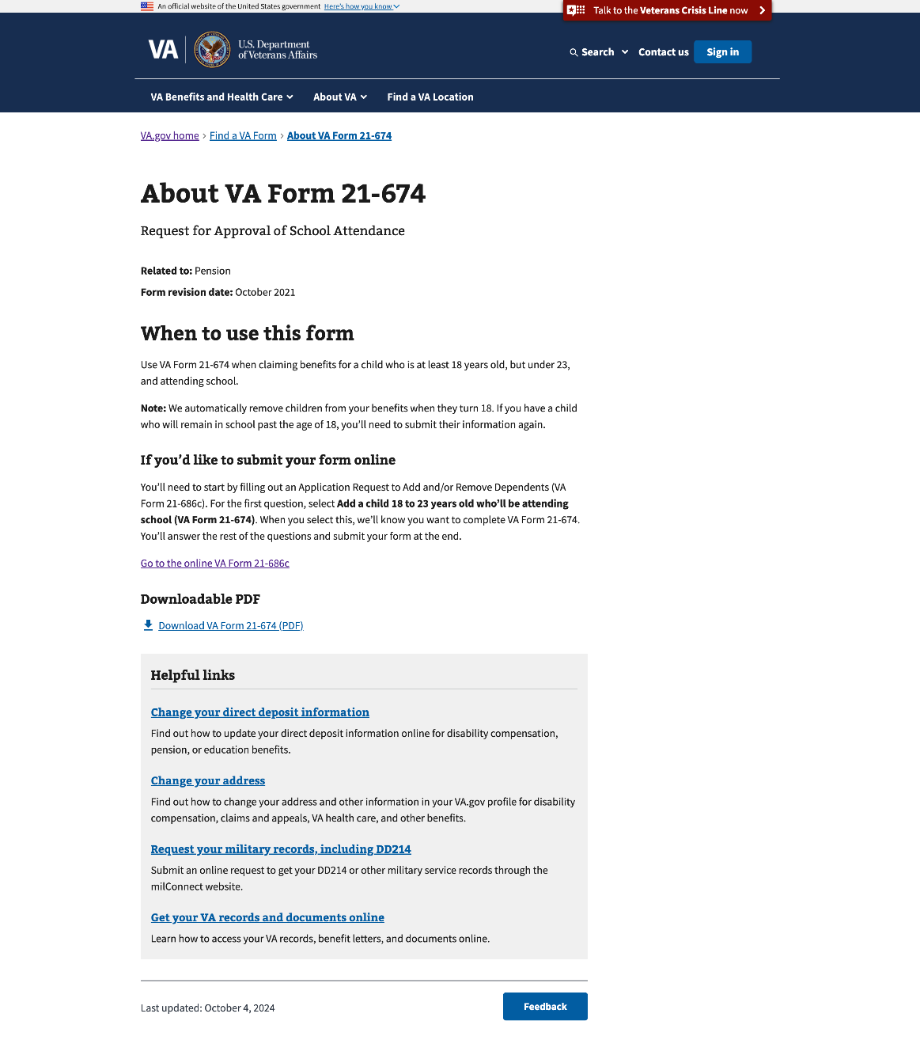

### Search results

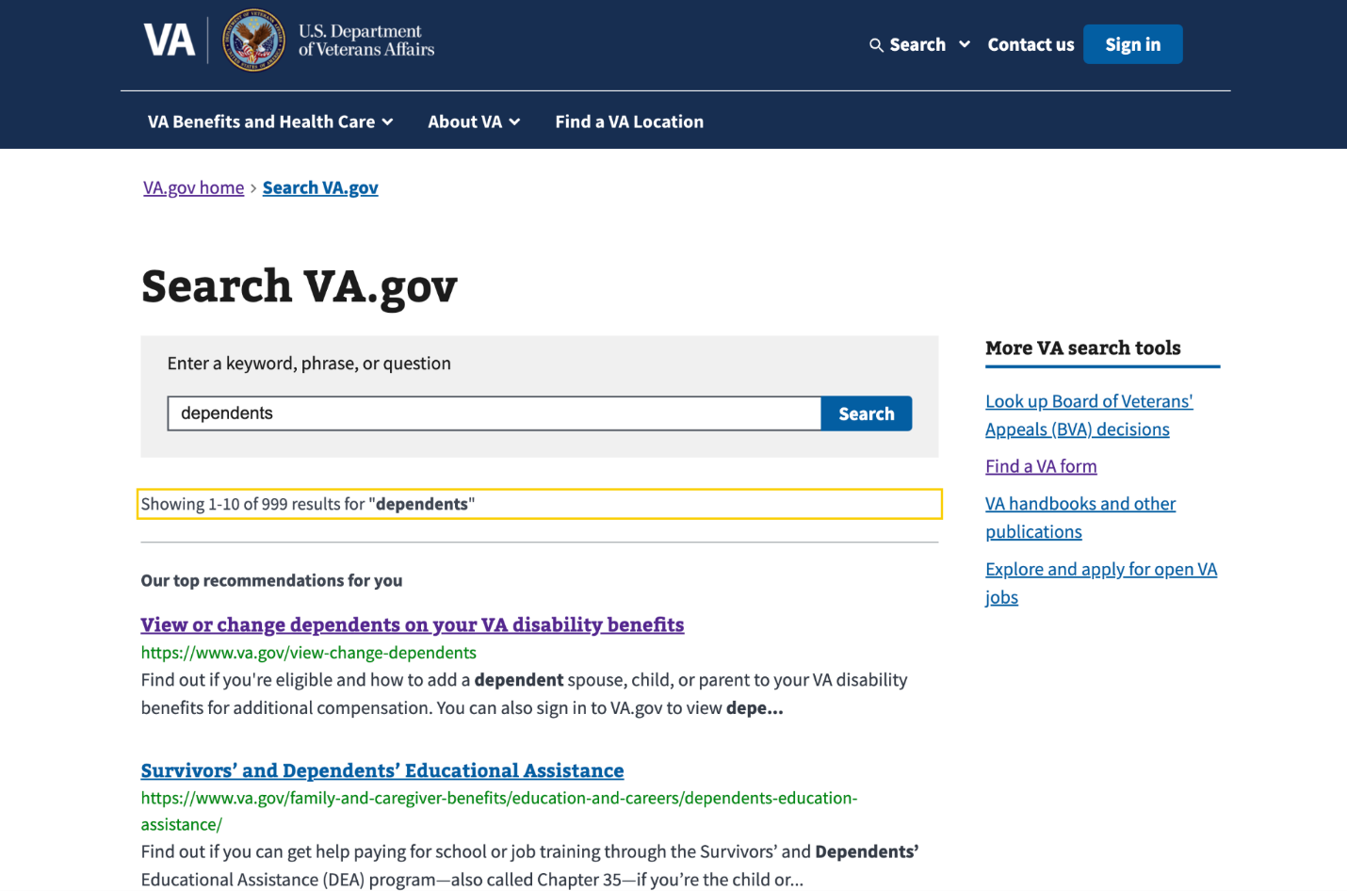

## 4. Functionality

Direct URL of the form: <https://www.va.gov/view-change-dependents/add-remove-form-21-686c/introduction>

The dependent's online 21-686c and 21-674 forms have five steps. The form expires 365 days after the Veteran’s last update date. It resets to 365 days every time the Veteran updates the progress of their application until submission.

### Introduction page

This page explains the following expectations for the Veteran:

* **Check eligibility:** Reminds the Veteran to review the eligibility page before  
  they apply.
* **Gather your information:** It lists all the information the Veteran will need to complete the form successfully.
* **Start your request:** It explains how long it should take and what would  
  happen next.

#### Not signed in

#### 

#### Signed in

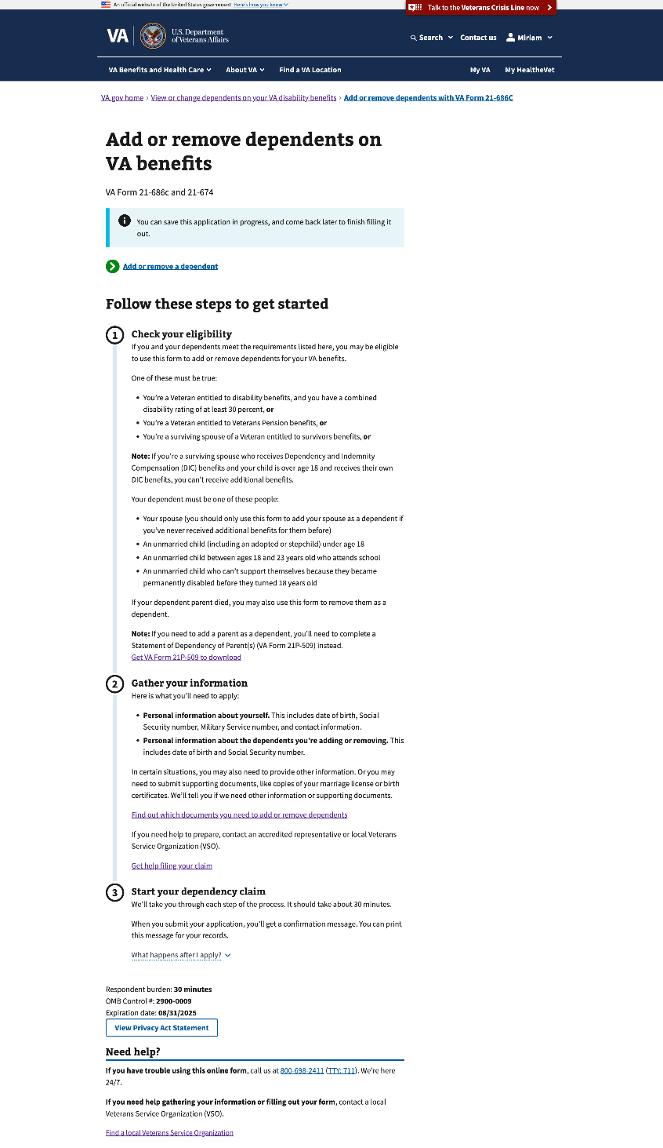

#### In-process

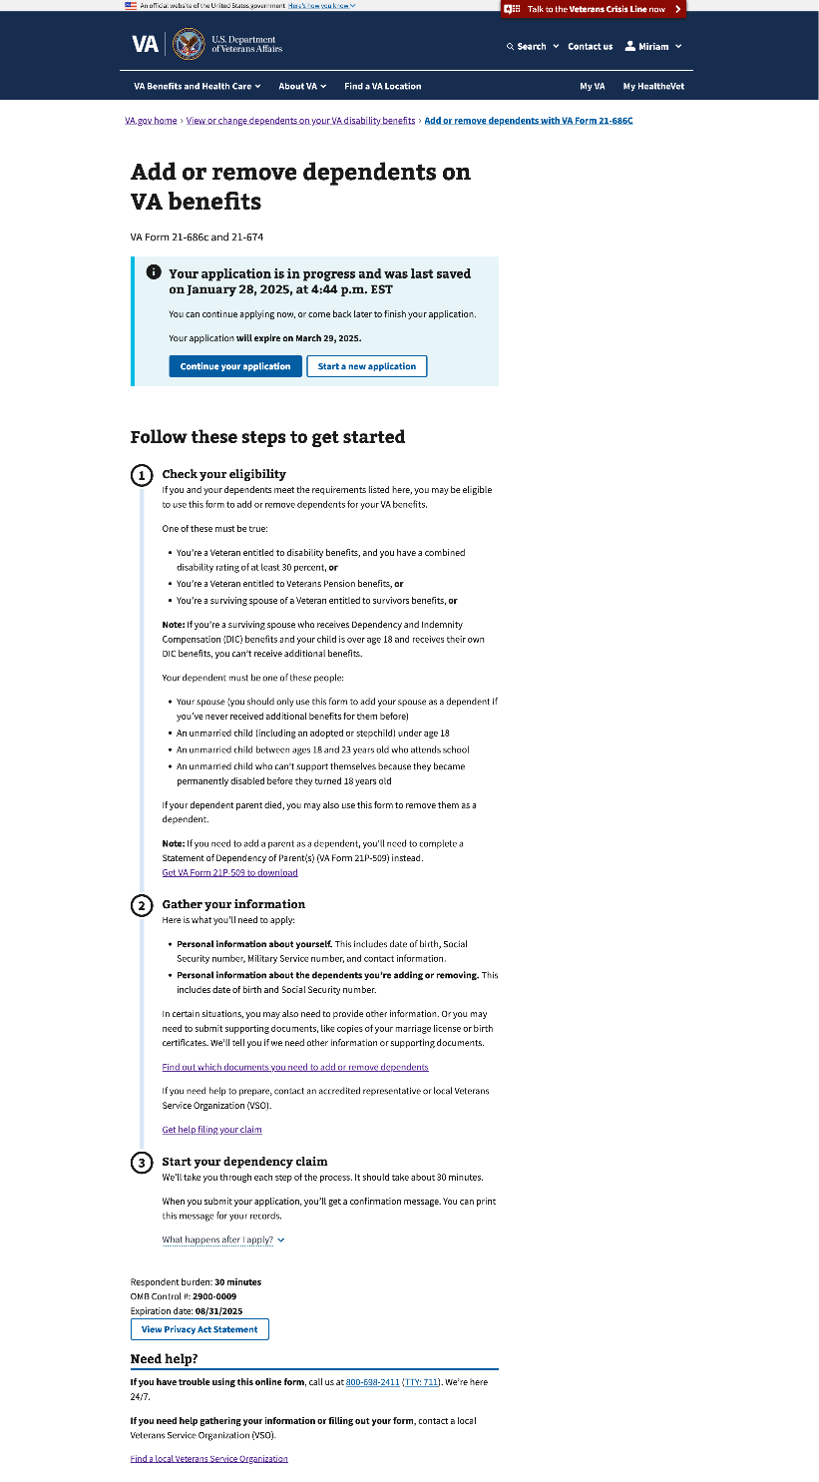

#### Verify: Missing VA file number

This alert will show up if the Veteran is missing their VA file number on their profile.

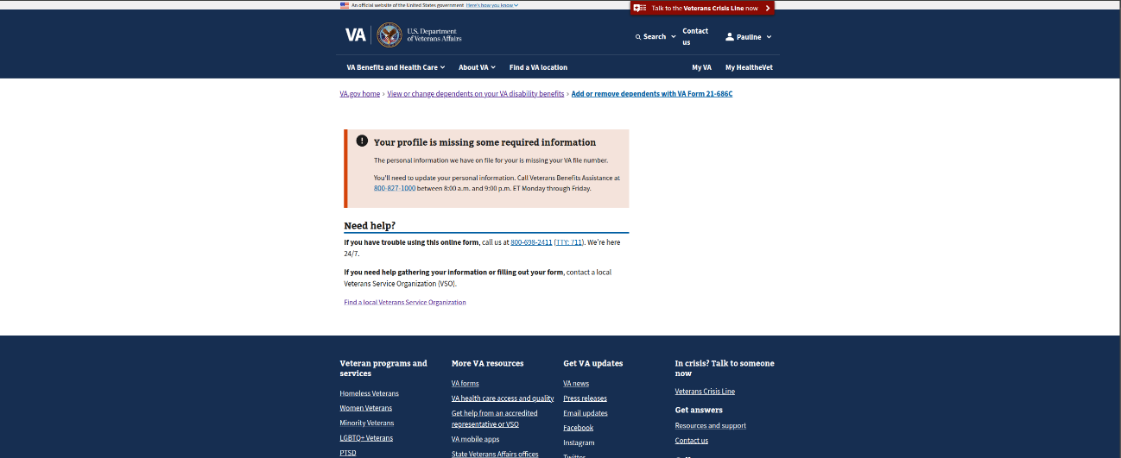

#### Finish later—Saved

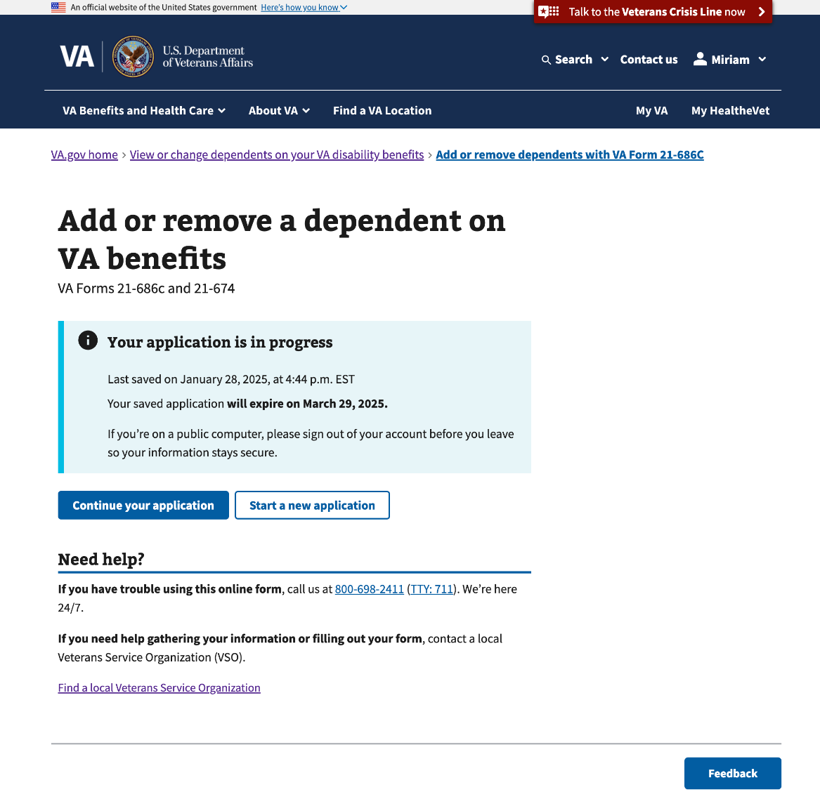

### Step 1: What would you like to do?

This step has 3 sub-pages that ask the Veteran what they’d like to do. Depending on the selection(s), it would add pages to this step and Step 3.

* Add one or more dependents
* Remove one or more dependents

#### 1.0 What would you like to do—Level 1

This page shows 2 options to either add or remove a dependent.

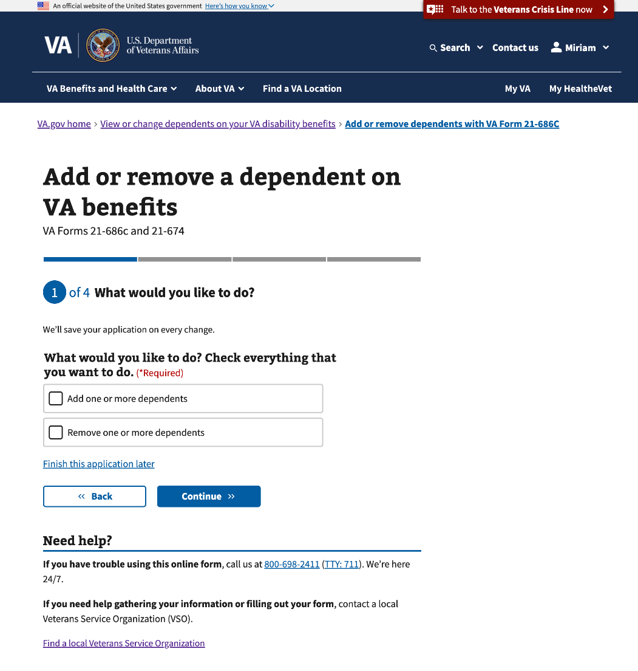

#### 1.1 What would you like to do—Add

This page drills down on the dependent type they’d like to add.

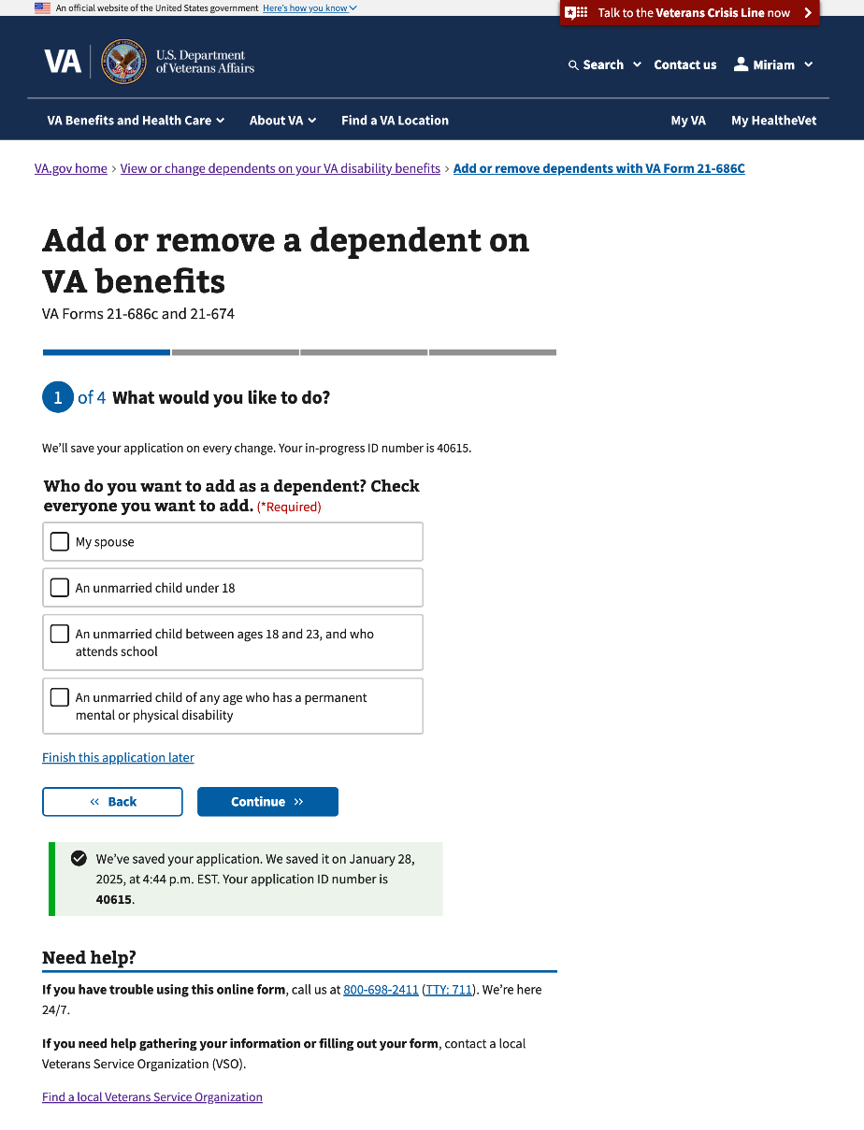

#### 1.2 What would you like to do—Remove

This page drills down on the dependent type they’d like to remove.

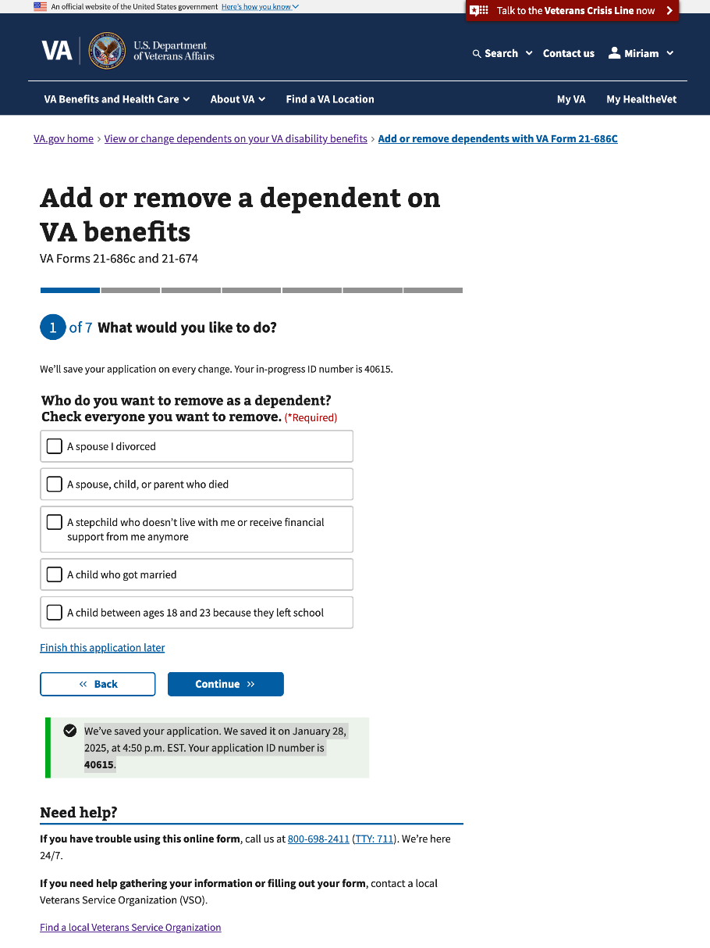

### Step 2: Veteran’s information

This step has 4 sub-pages that ask questions about the Veteran’s information.

#### 2.0 Confirm personal information

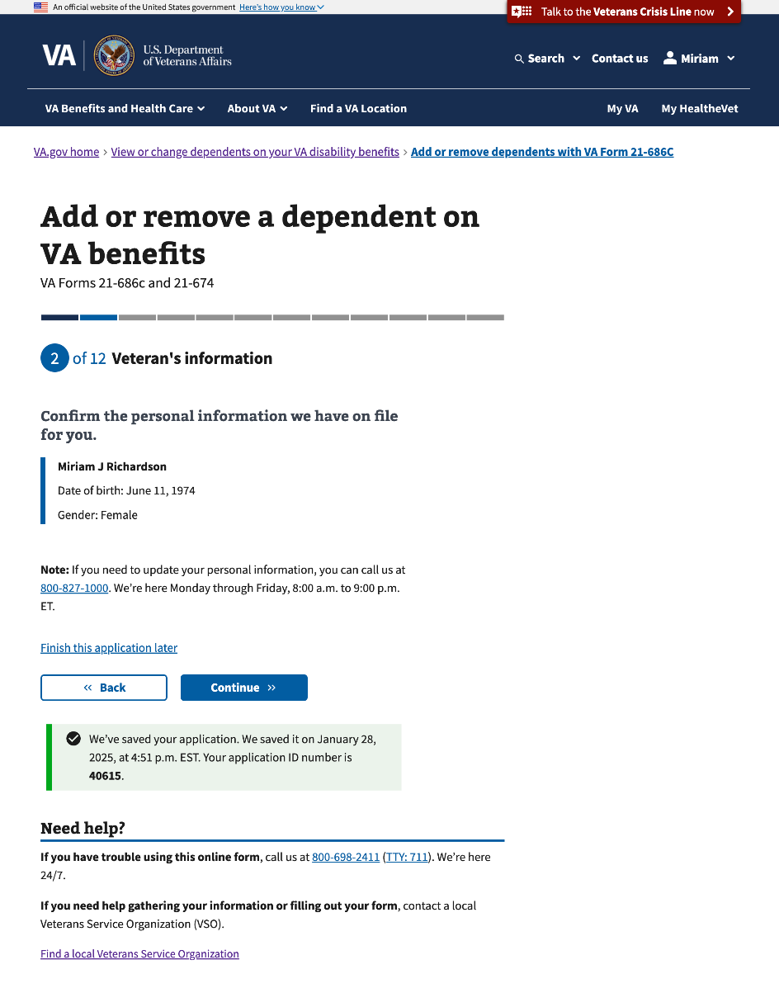

#### 2.1 Mailing address

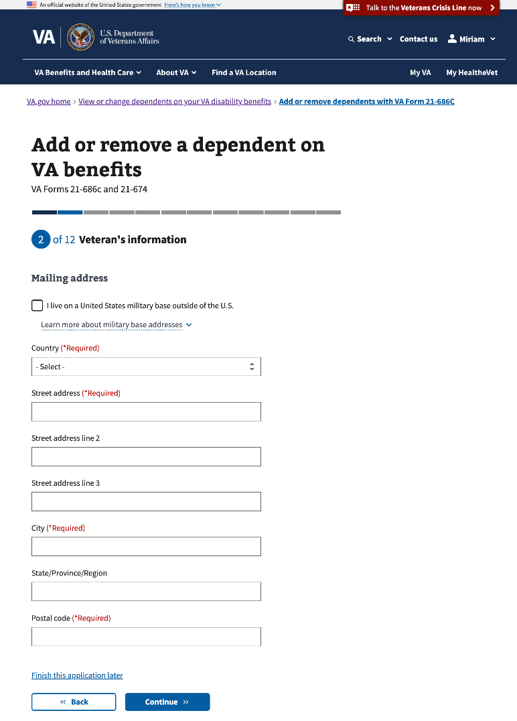

#### 2.2 Mailing address (outside the U.S.)

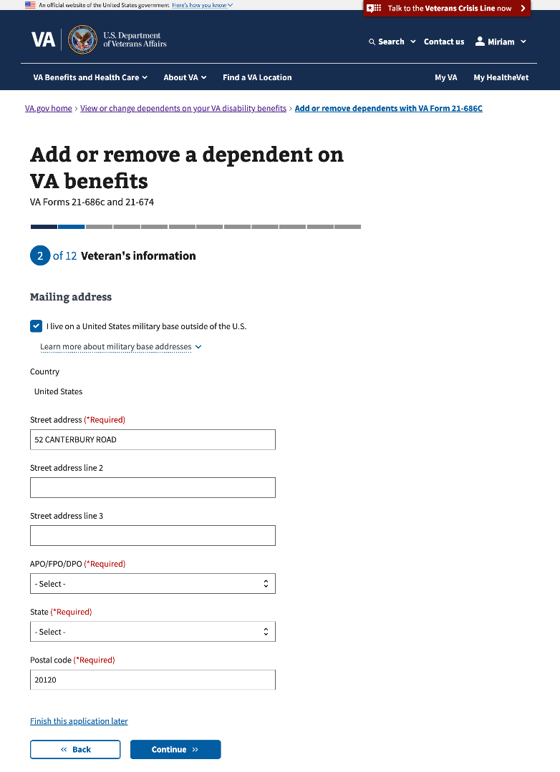

#### 2.3 Phone and email address

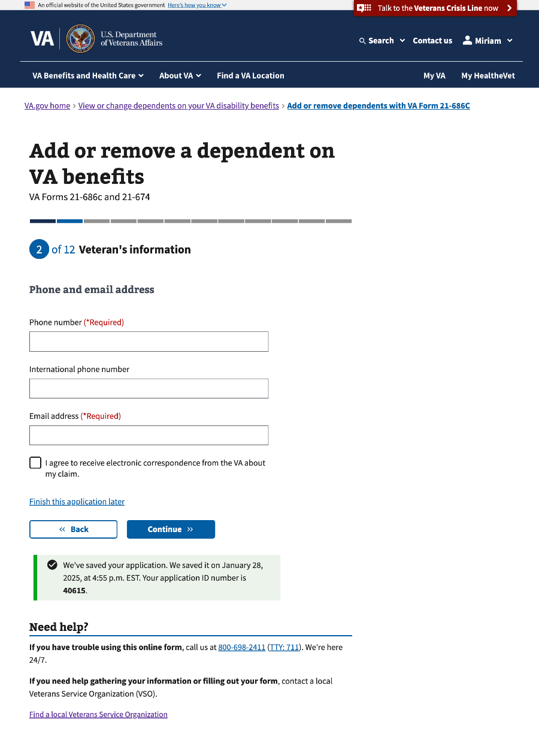

### Step 3: Add your spouse

This section of Step 3 will conditionally show if the Veteran selects to add a spouse on Step 1. This section has 25 sub-pages that ask questions about the spouse’s personal information, contact information, military service information, and marital history.

#### 3.0 Spouse’s current legal name

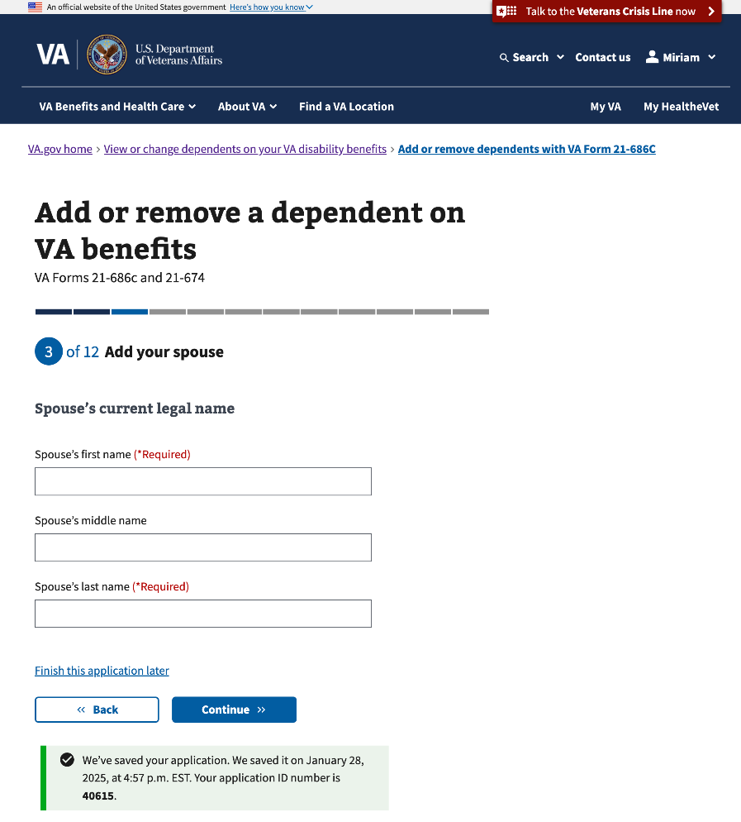

#### 

#### 3.1 Spouse’s identification information

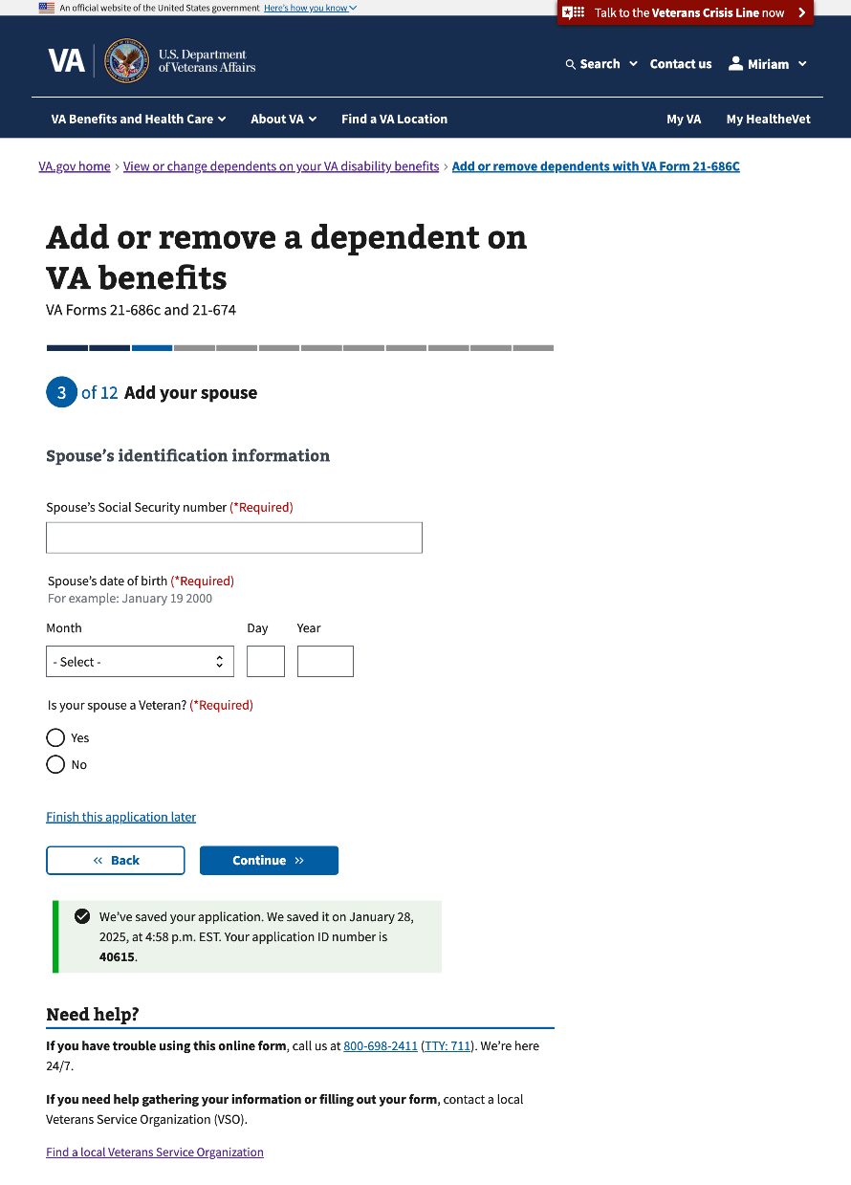

#### 3.2 Spouse’s military service information

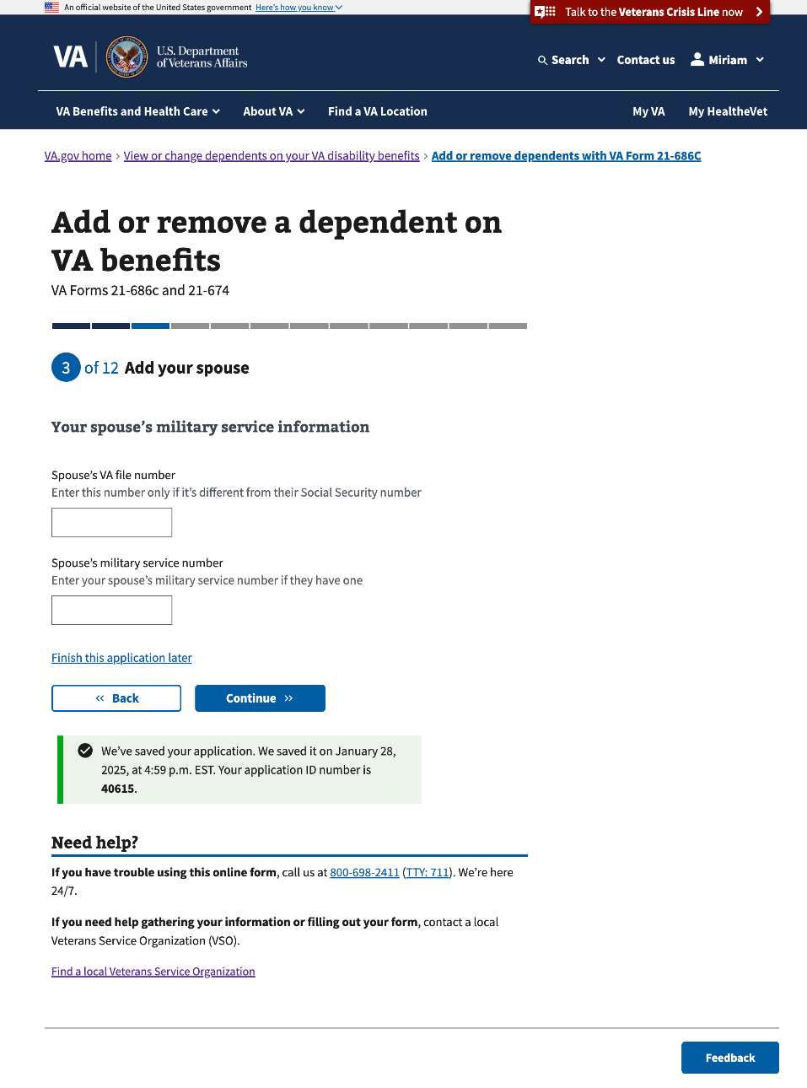

#### 3.3 Information about your marriage

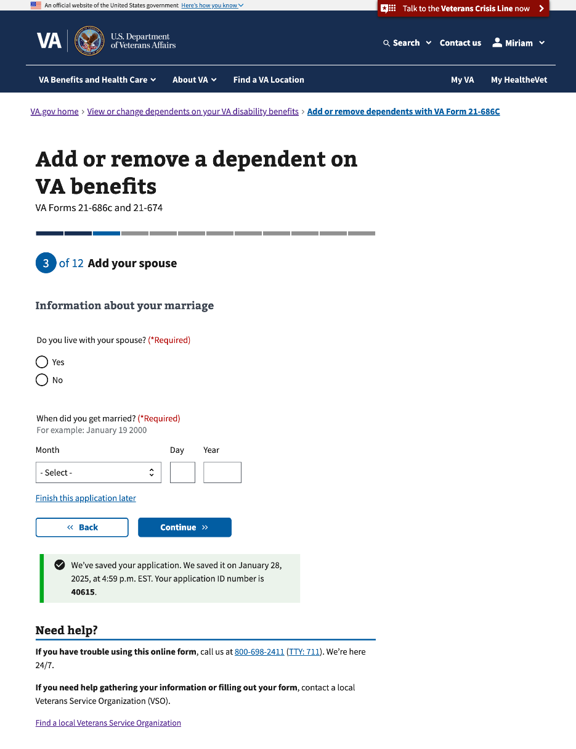

#### 

#### 3.4 Spouse’s address

This page conditionally appears if the Veteran selects “No” to “Do you live with your spouse?”

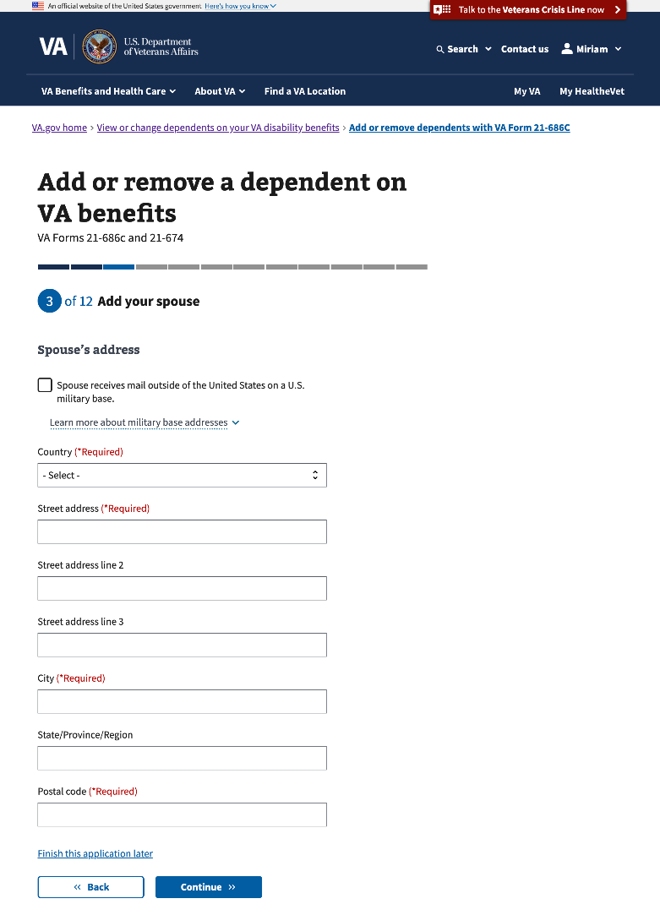

#### 3.5 Information about your marriage

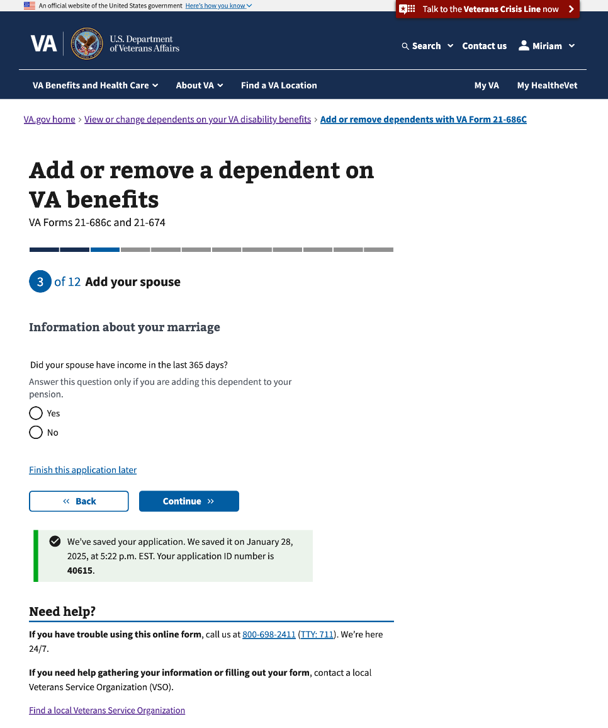

#### 

#### 3.6 Where did you get married?

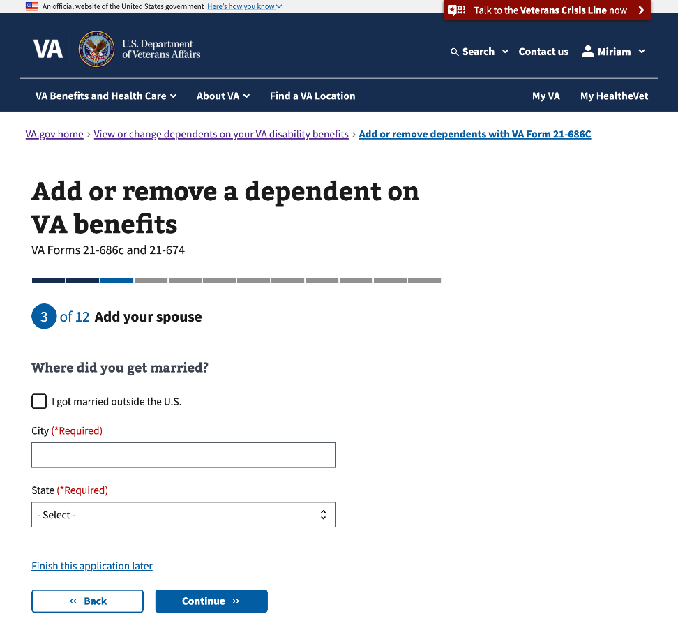

##### Outside the U.S.

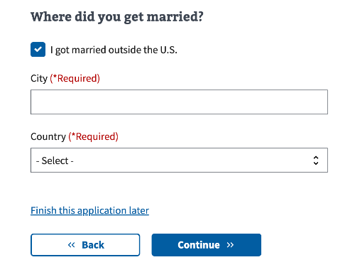

#### 3.7 How did you get married?

If “By common law,” “By proxy,” or “In a tribal ceremony” is selected, additional information about what type of supporting documents are needed will appear.

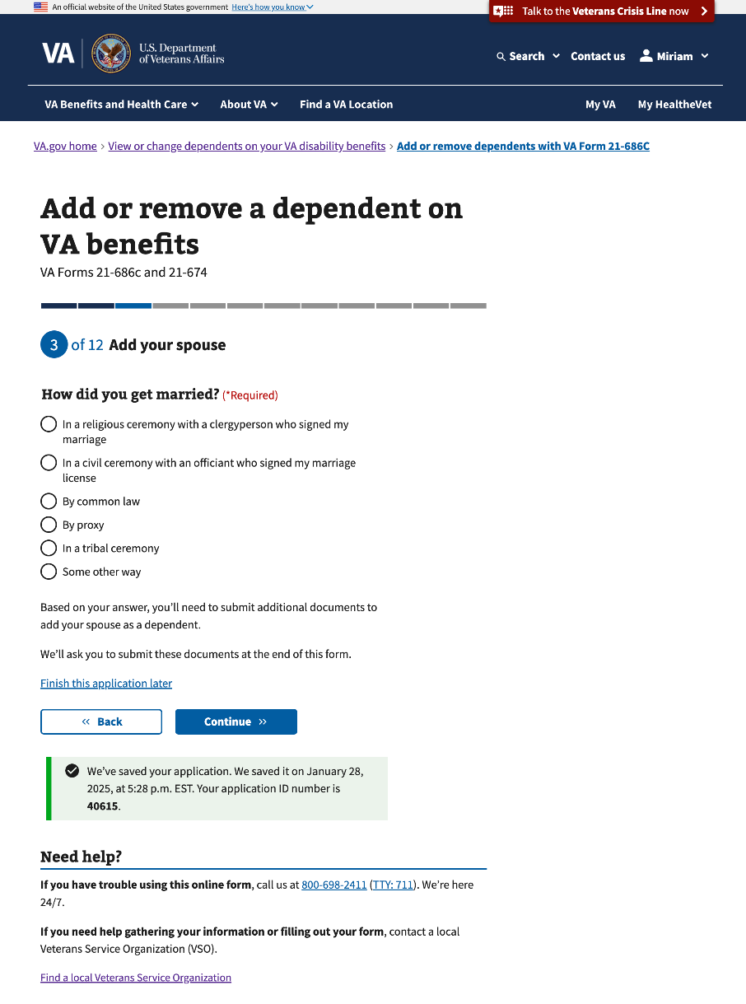

##### By common law

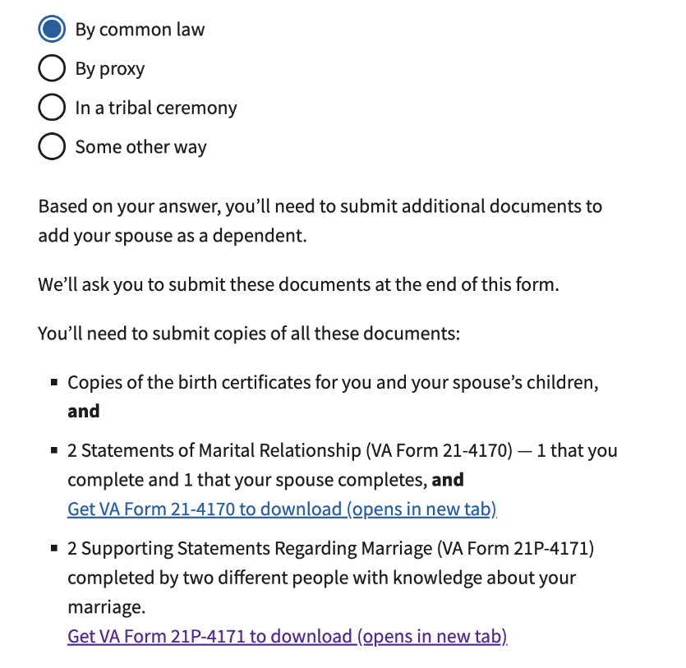

##### By proxy

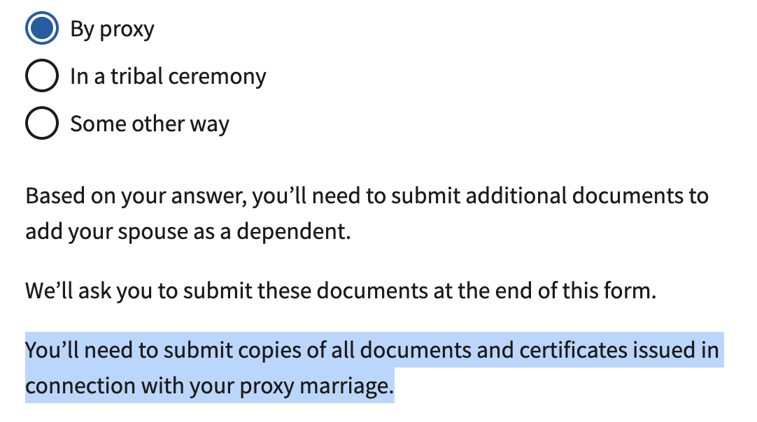

##### In a tribal ceremony

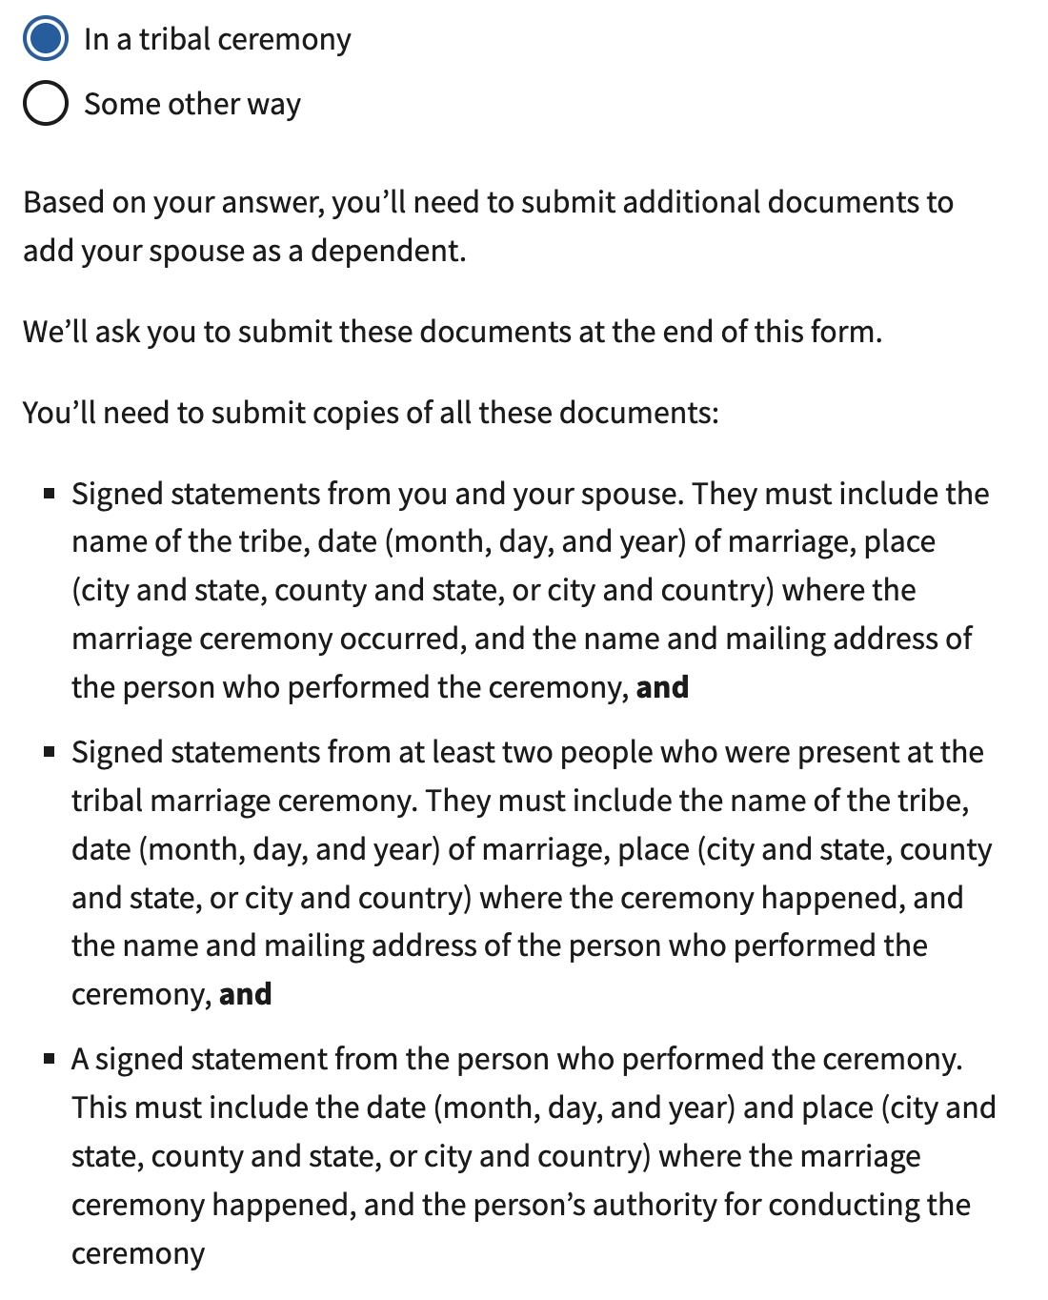

##### Some other way

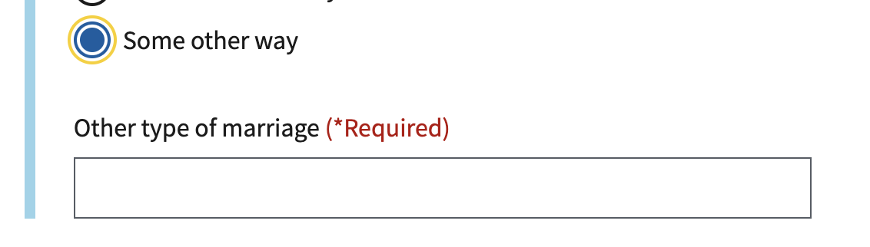

#### 3.8 Reason you live separately from your spouse

This page will conditionally show if the Veteran selects “No” to “Do you live with your spouse?”

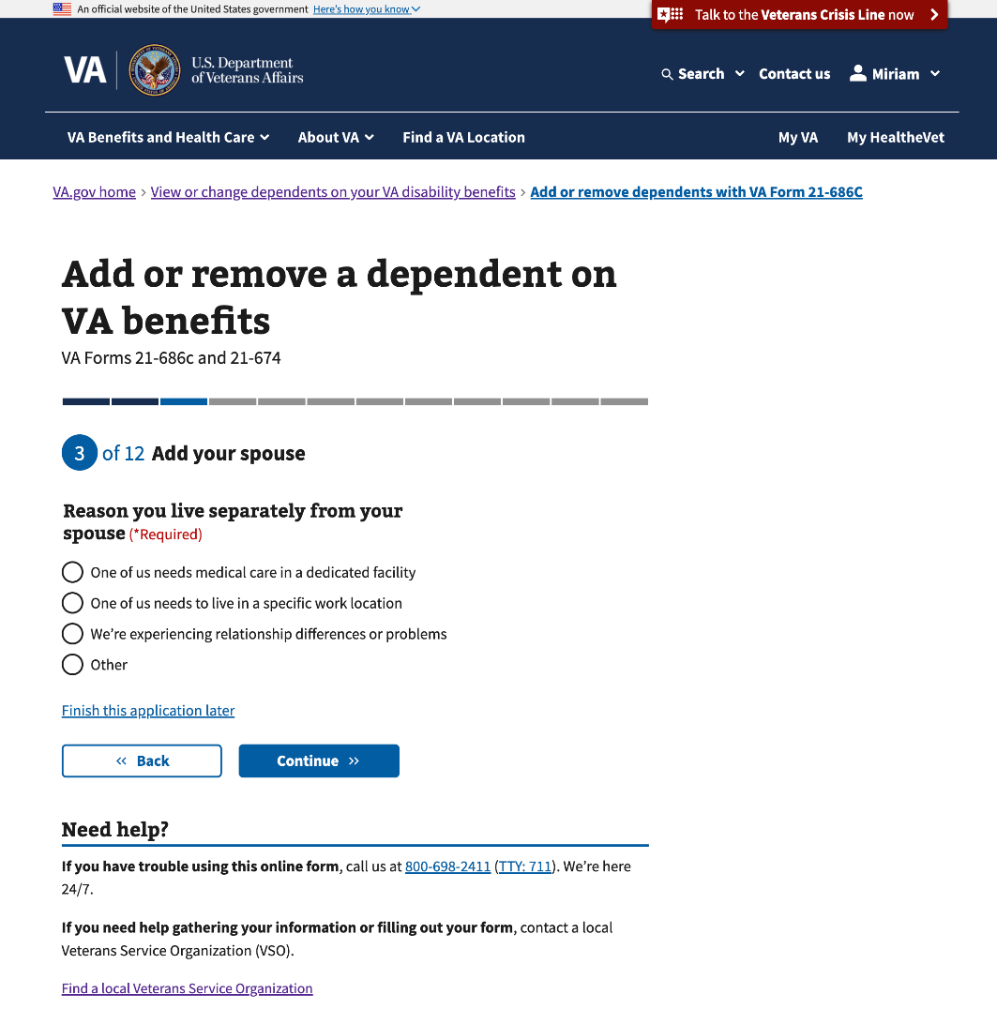

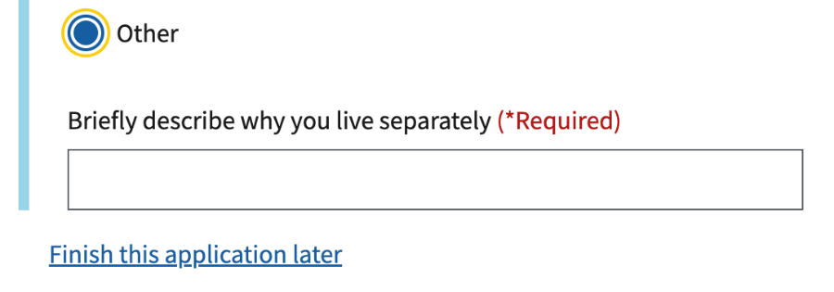

#### 

#### 3.9 Spouse’s marital history

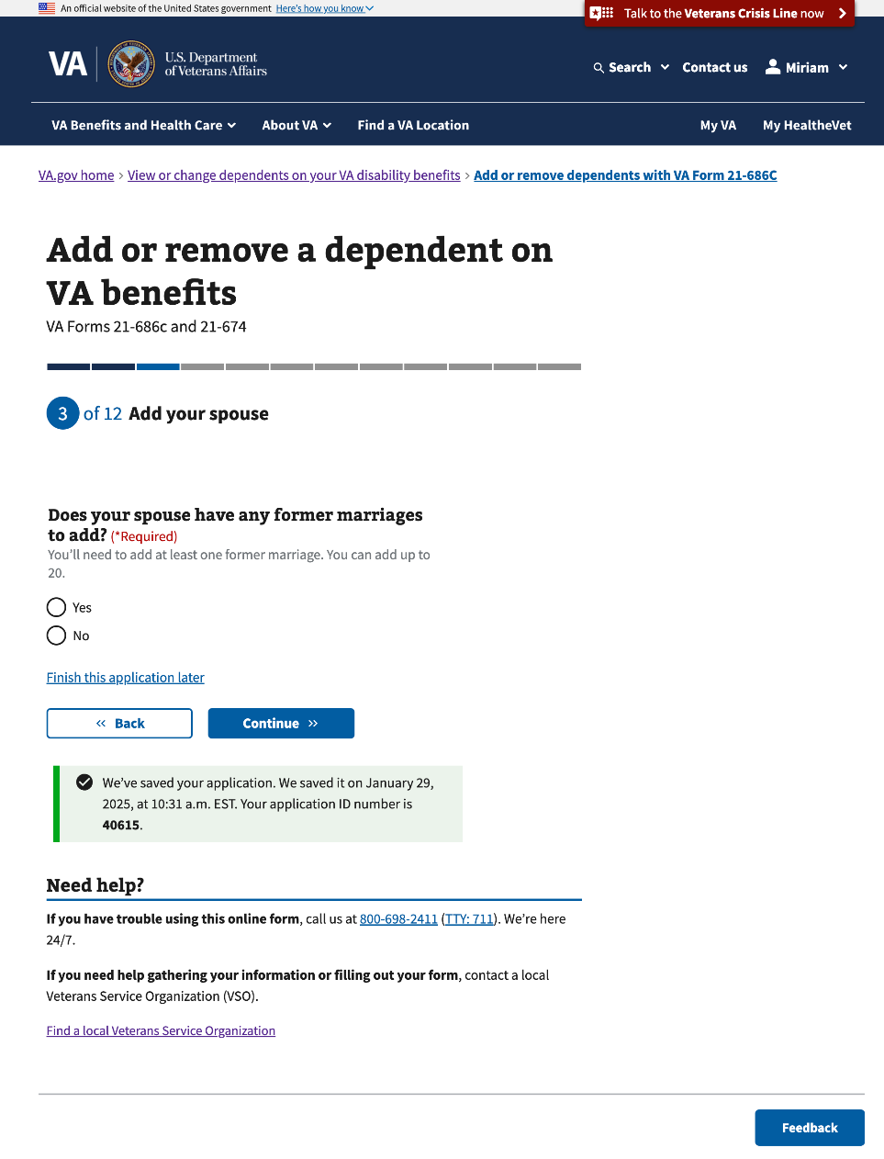

#### 

#### 3.10 Spouse’s former marriage

This and the following 6 pages will conditionally show if the Veteran selects “Yes” to “Does your spouse have any former marriages to add?”

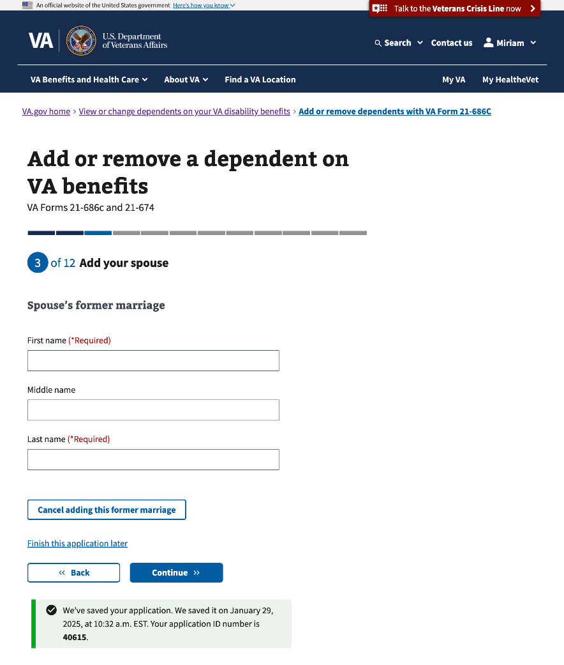

#### 3.11 Spouse’s former marriage (Con’t)

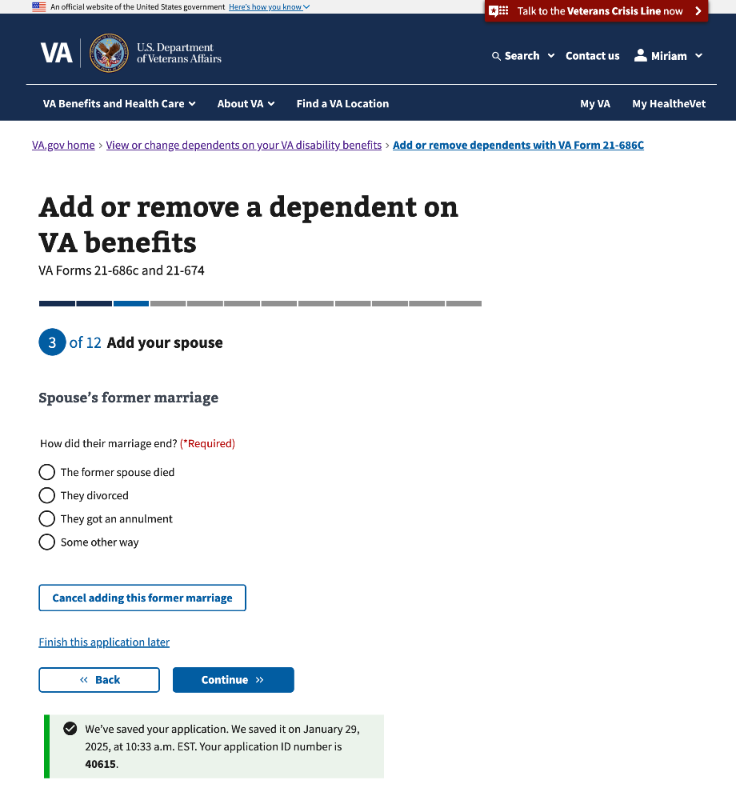

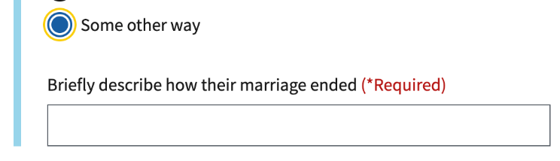

#### 3.12 Spouse’s former marriage (Con’t)

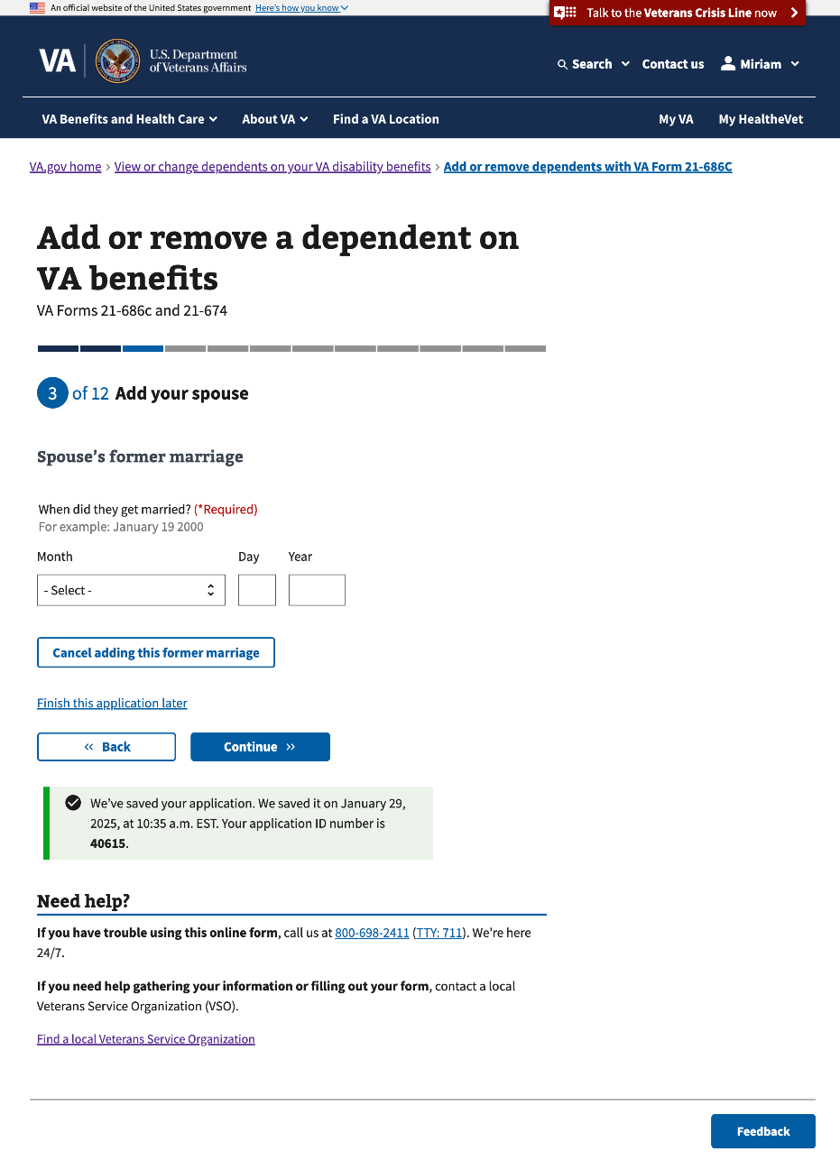

#### 3.13 Spouse’s former marriage (Con’t)

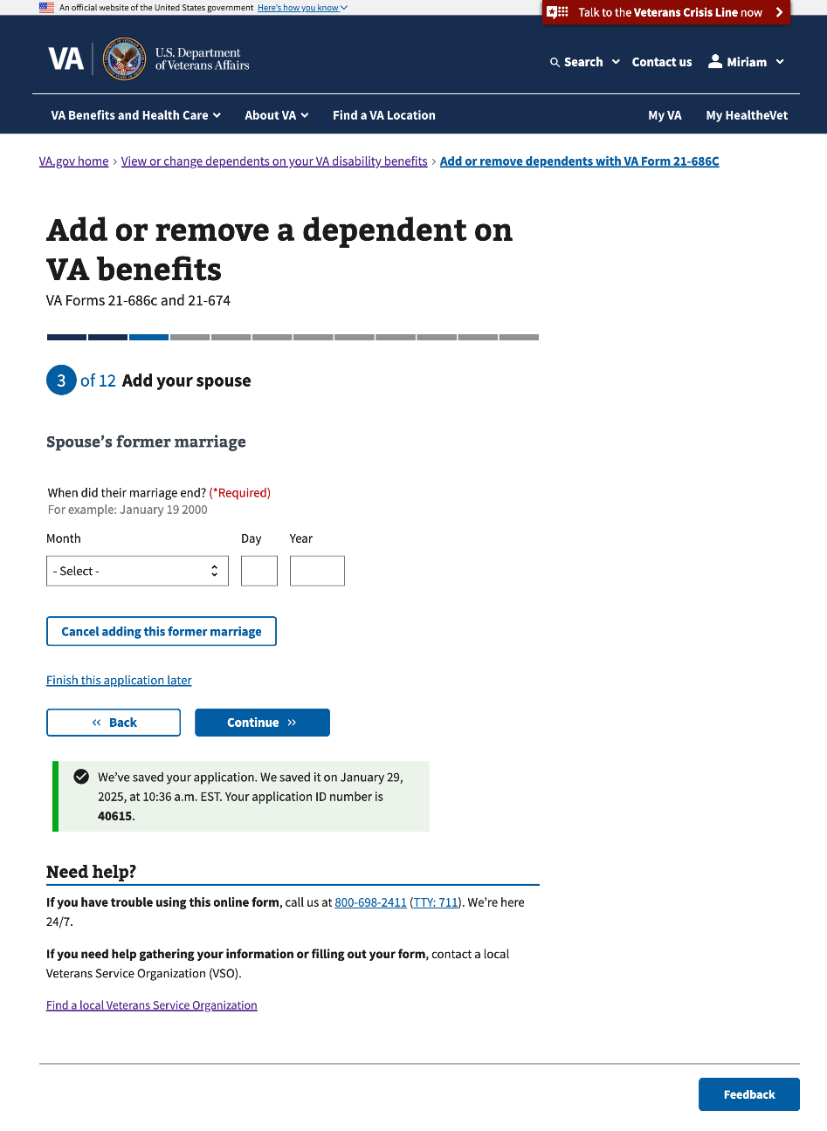

#### 

#### 3.14 Spouse’s former marriage (Con’t)

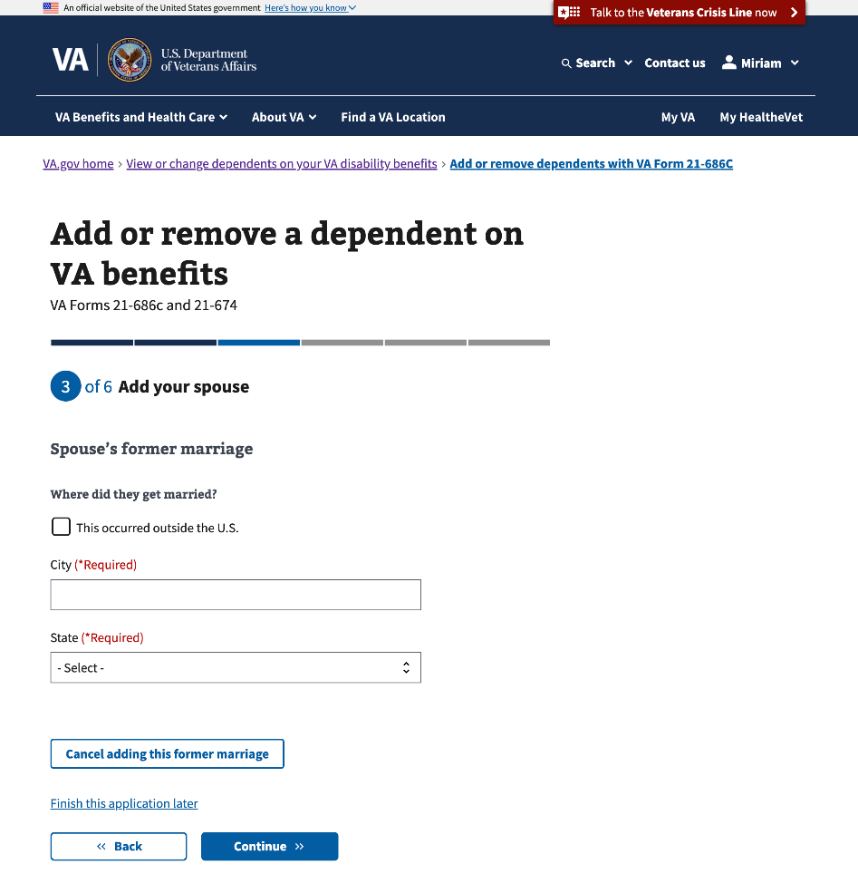

#### 

#### 3.15 Spouse’s former marriage (Con’t)

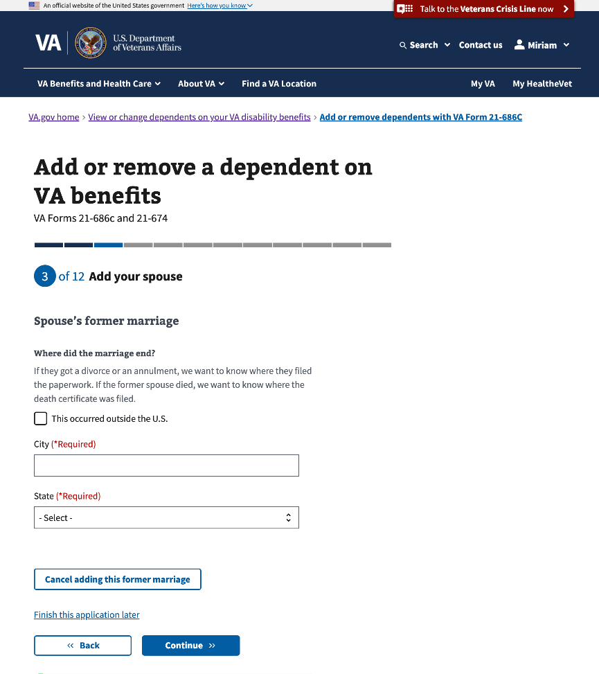

#### 

#### 3.16 Review your spouse’s marital history

This is the last page for adding your spouse’s former marriage information.

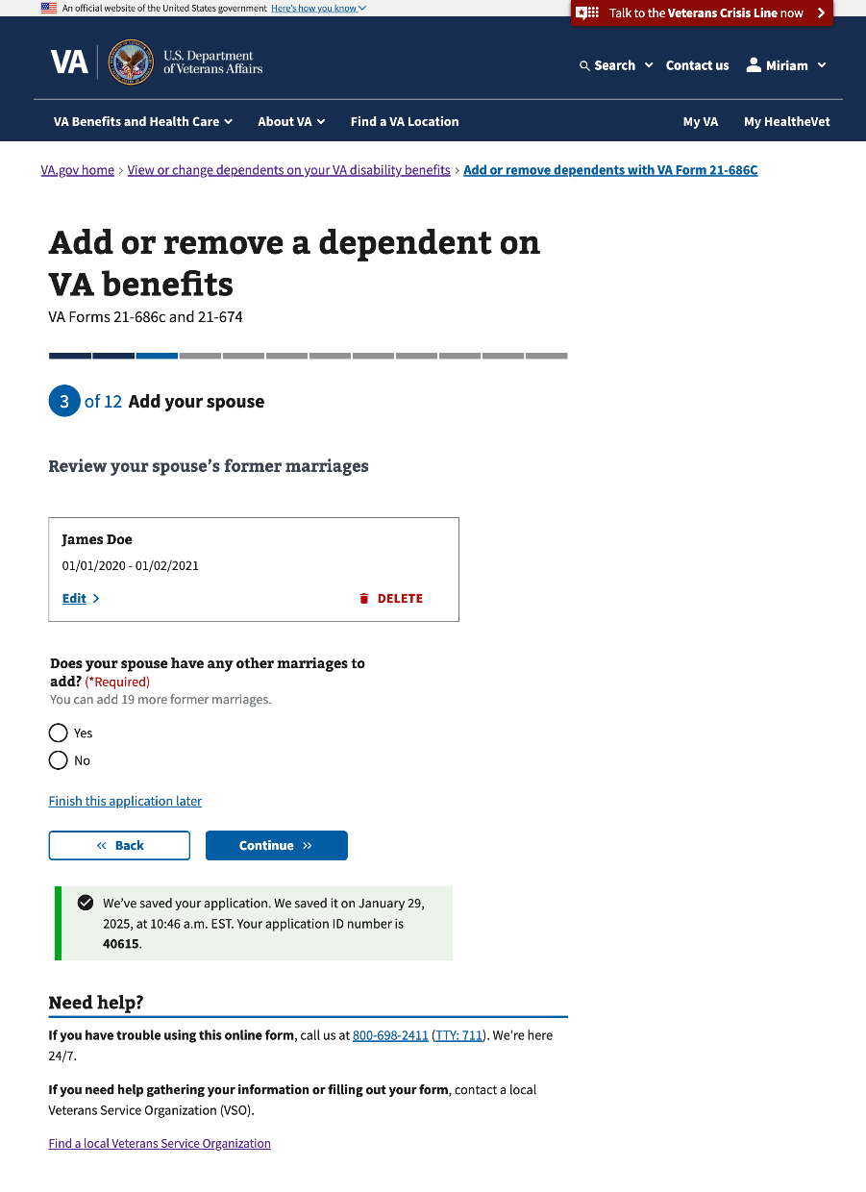

#### 3.17 Your marital history

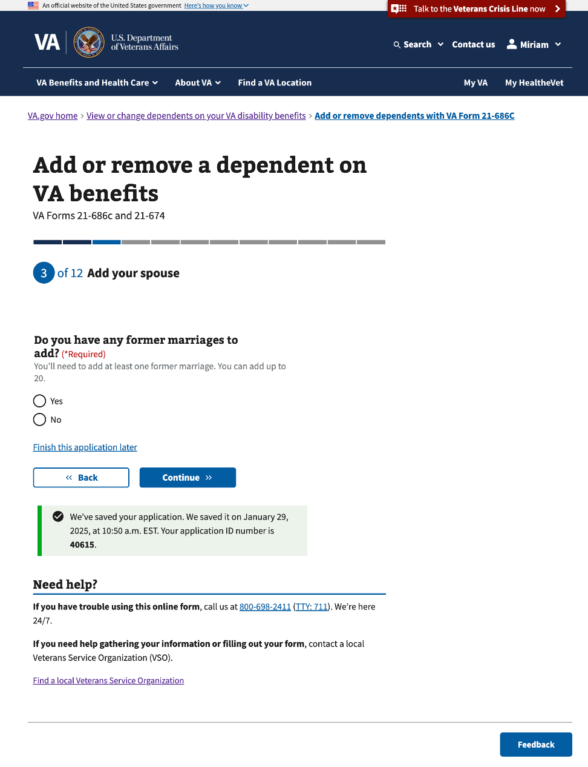

#### 

#### 3.18 Your former marriage

This and the following 7 pages will conditionally show if the Veteran selects “Yes” to “Do you have any former marriages to add?”

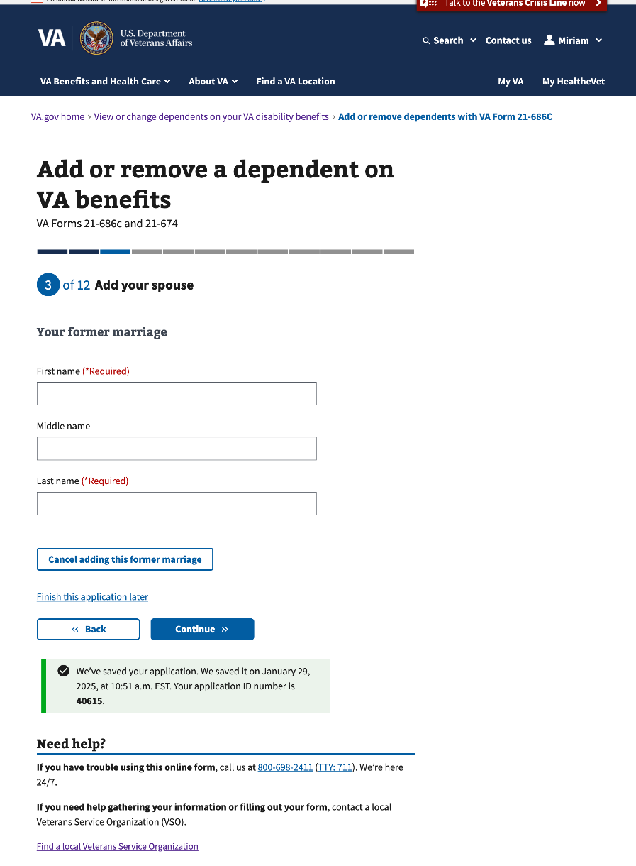

#### 3.19 Your former marriage (Con’t)

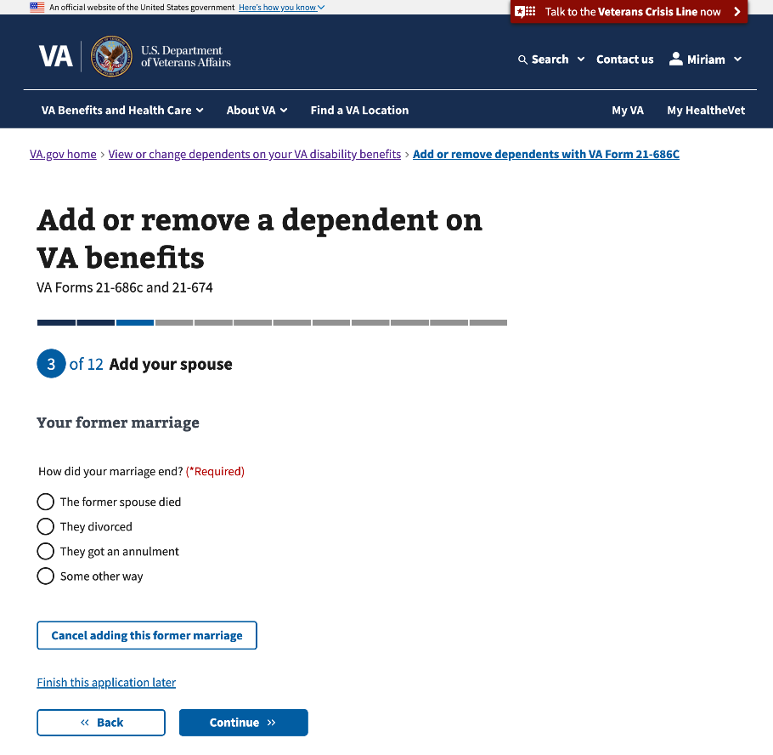

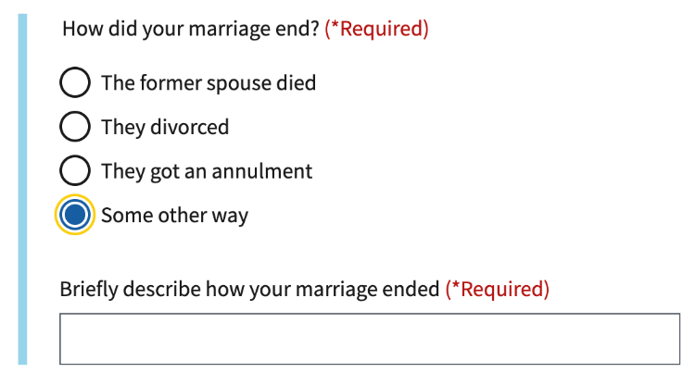

#### 

#### 3.20 Your former marriage (Con’t)

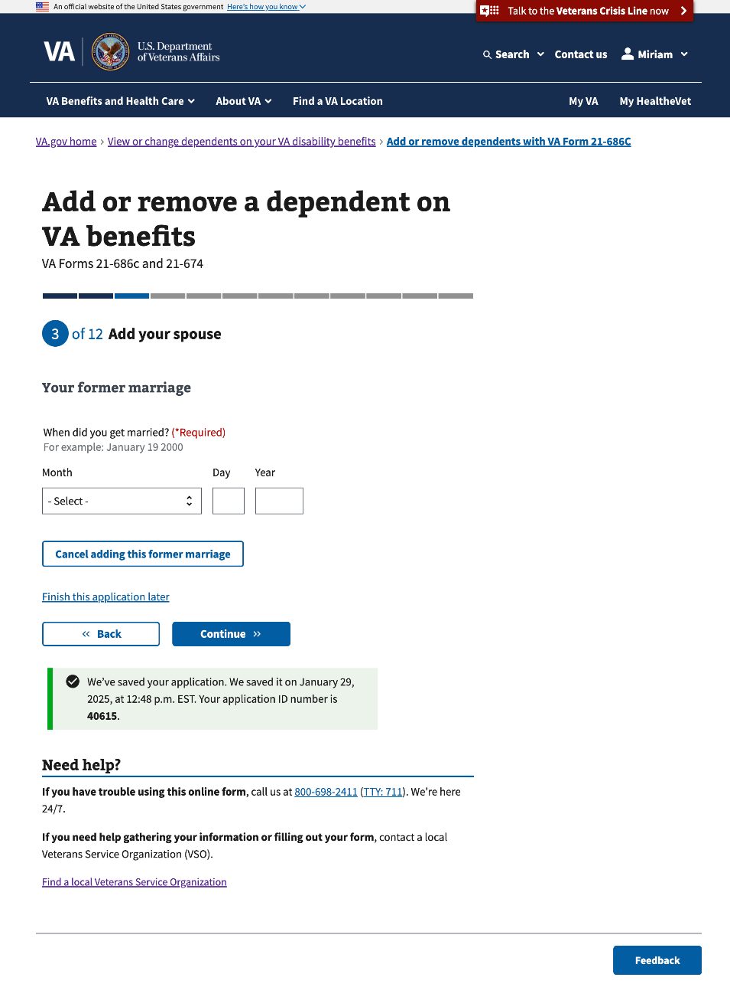

#### 

#### 3.21 Your former marriage (Con’t)

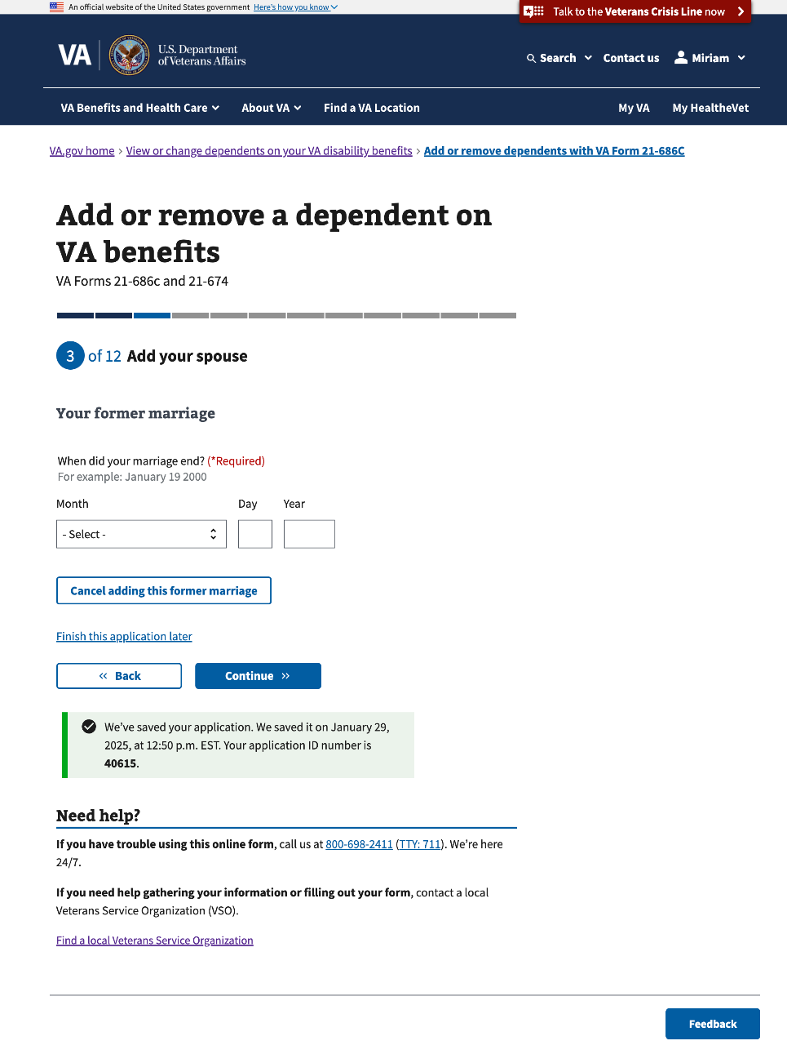

#### 

#### 3.22 Your former marriage (Con’t)

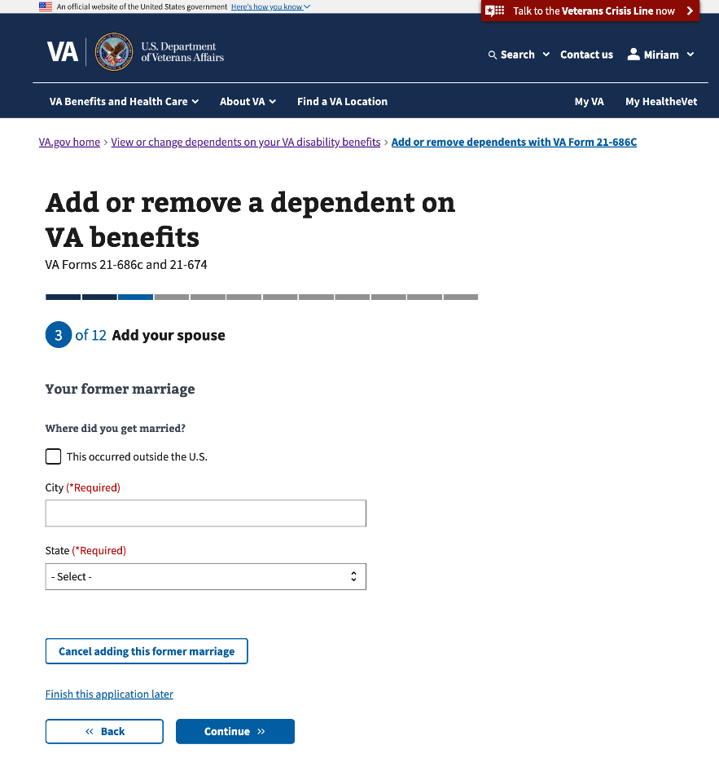

#### 

#### 3.23 Your former marriage (Con’t)

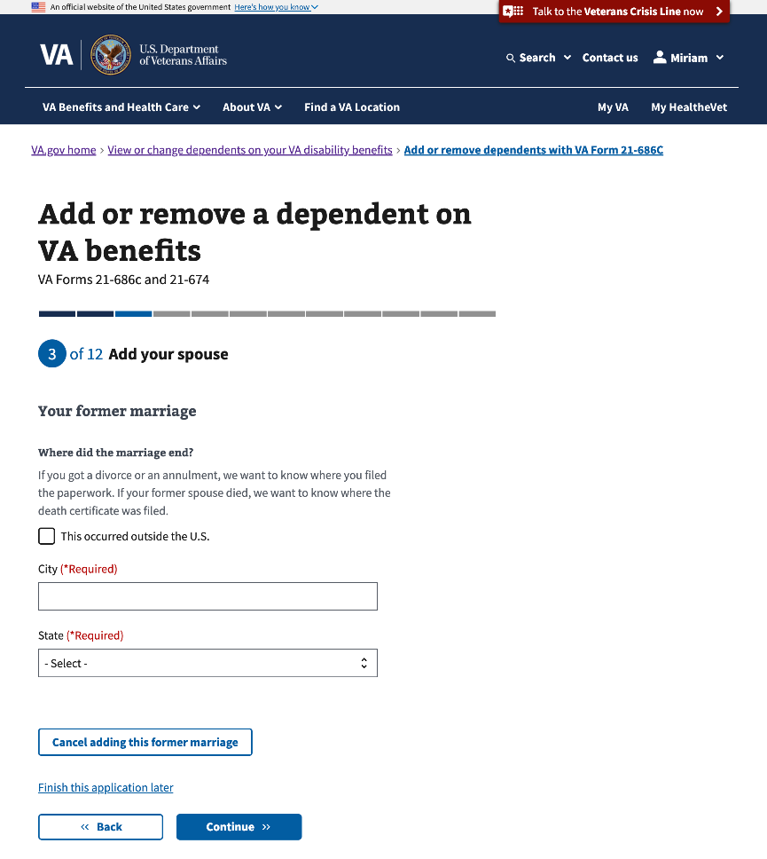

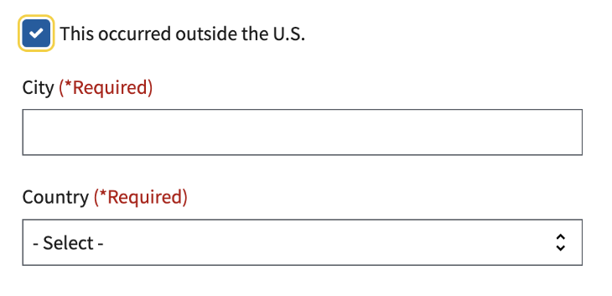

#### 3.24 Review your former marriages

This is the last page to add information about the Veteran’s former marriage(s).

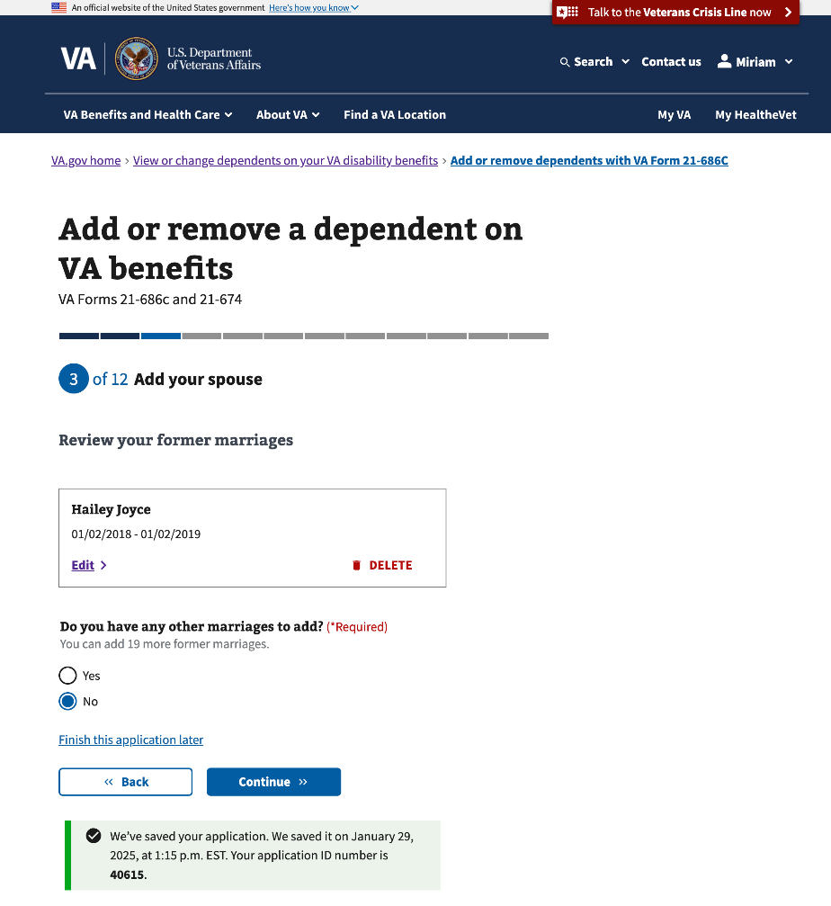

### 

### Step 3: Add one or more children

This section of Step 3 will conditionally show if the Veteran selects “An unmarried child under age 18” on Step 1 and/or “An unmarried child of any age who has a permanent mental or physical disability.” This section of Step 3 has 15 sub-pages asking questions about the child's personal and contact information.

#### 3.25 Your children

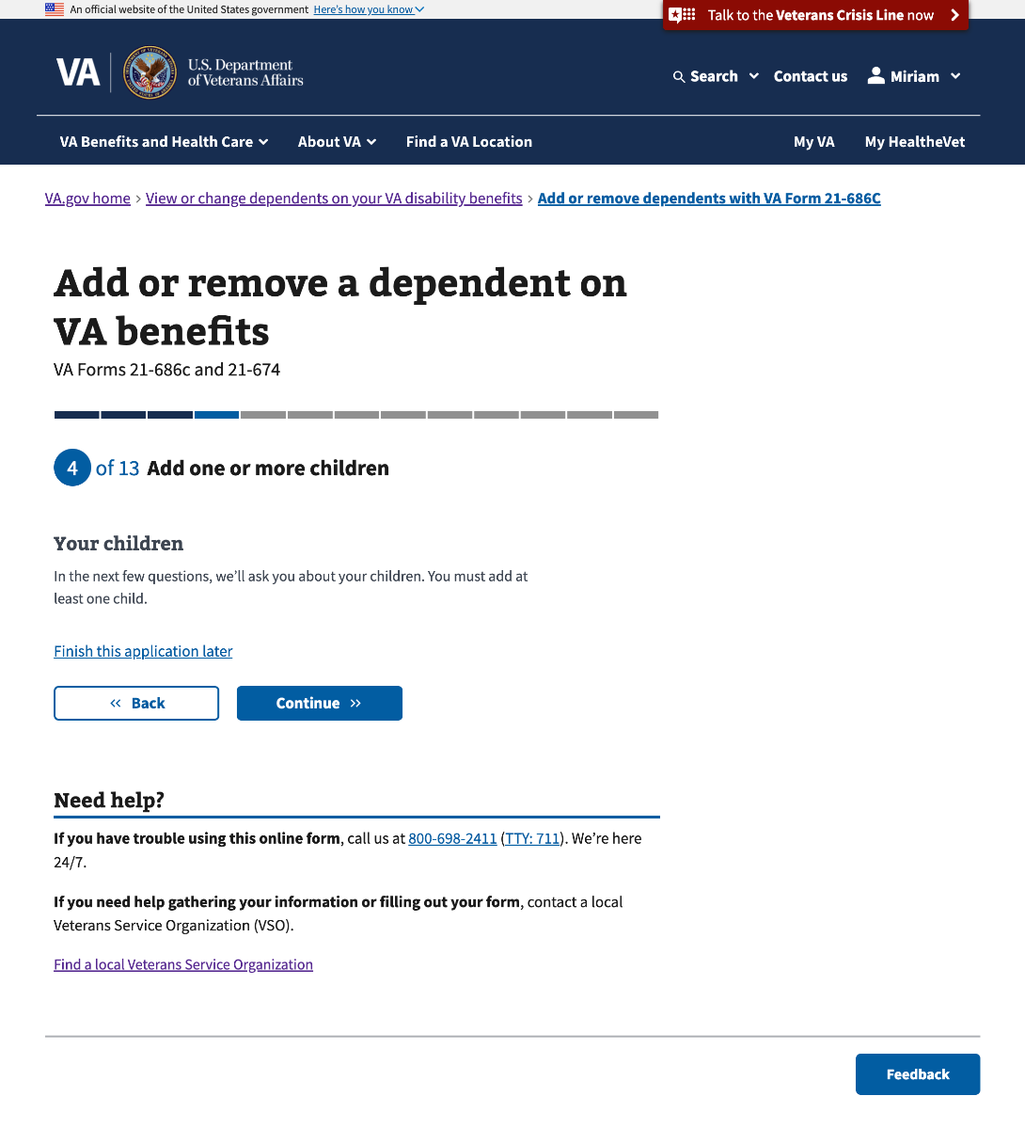

#### 3.26 Add a child

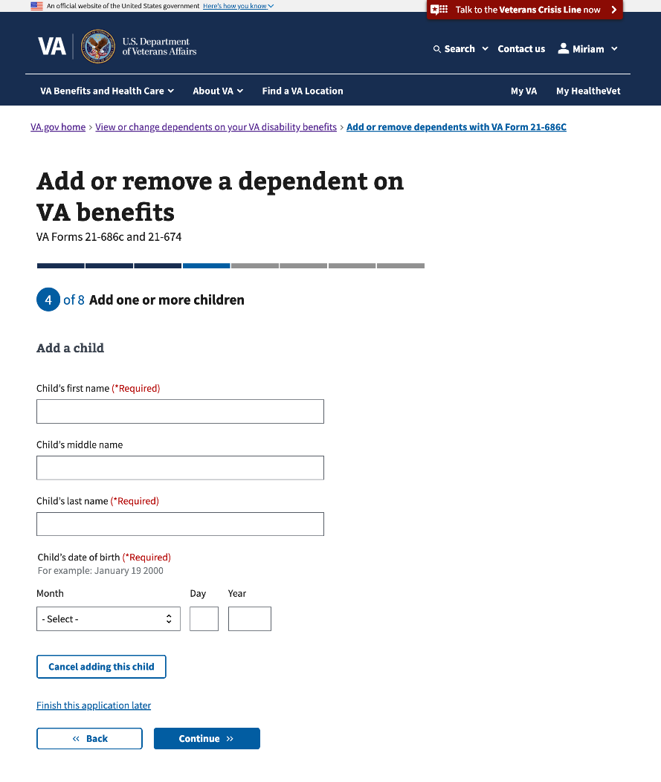

#### 

#### 3.27 Child’s identification information

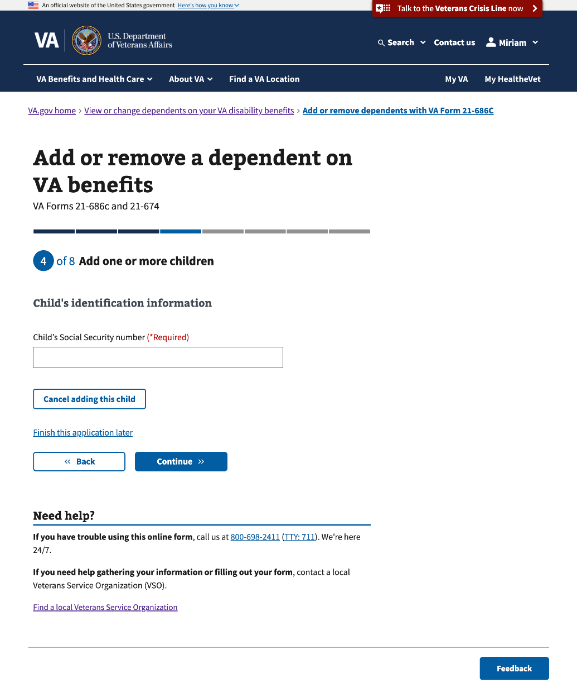

#### 

#### 3.28 Child’s birthplace

The message at the bottom of this page will only show if the Veteran, on Step 2, selects a country outside the U.S. or if they select “I live on a United States military base outside of the U.S.”

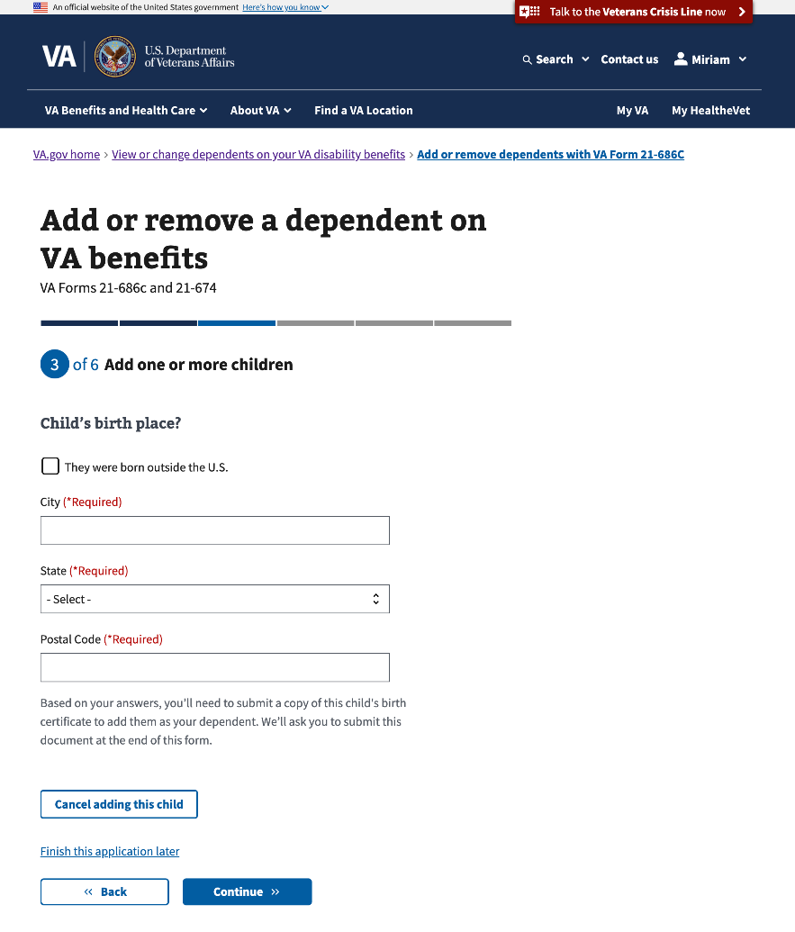

##### Born outside the U.S.

#### 

#### 3.29 Your relationship to this child

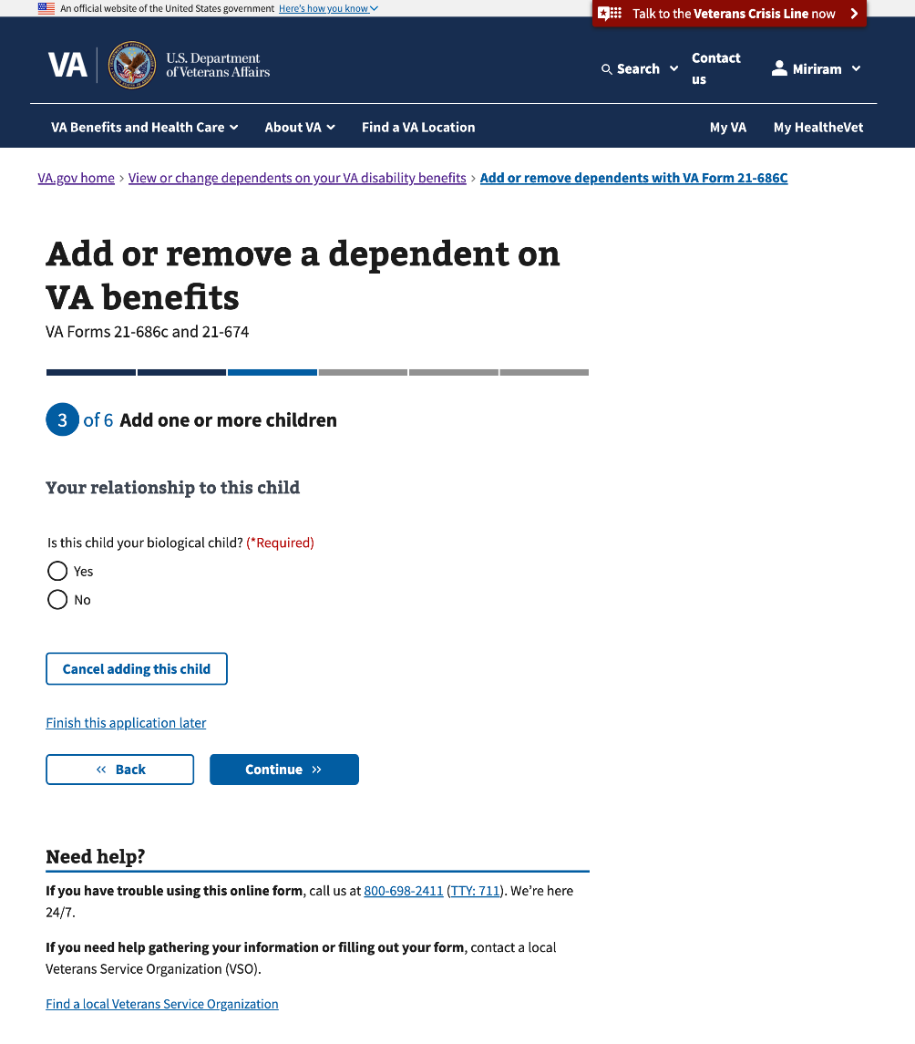

#### 

#### 3.30 Your relationship to this child

This page will conditionally show if the Veteran selects “No” to “Is this child your biological child?”  
  
If the Veteran selects “adopted child” and/or “stepchild,” there’s additional information about the supporting documentation the Veteran must submit.

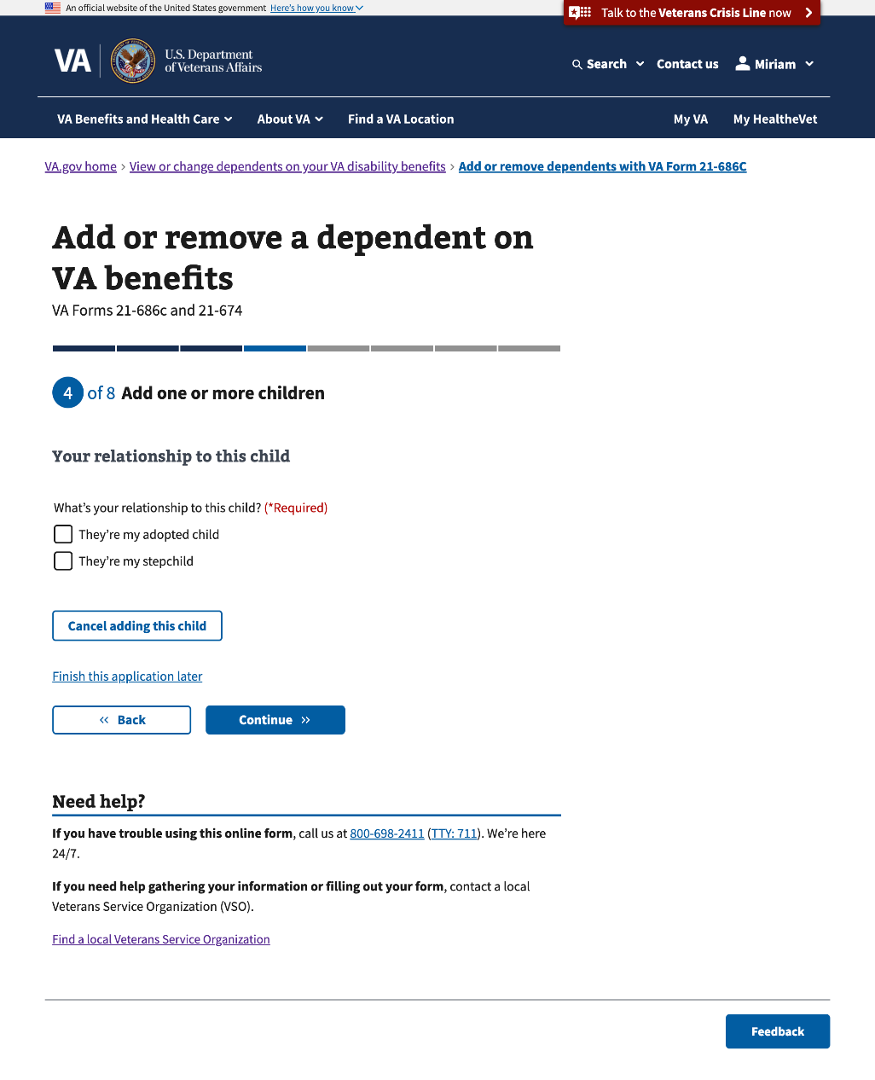

##### Adopted child

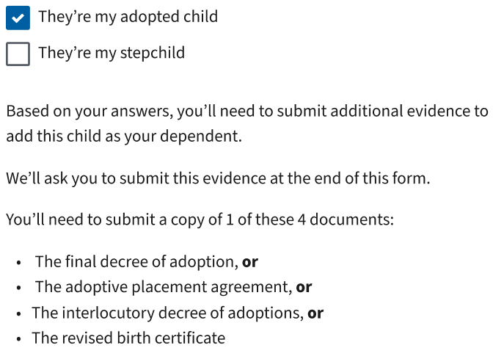

##### Stepchild

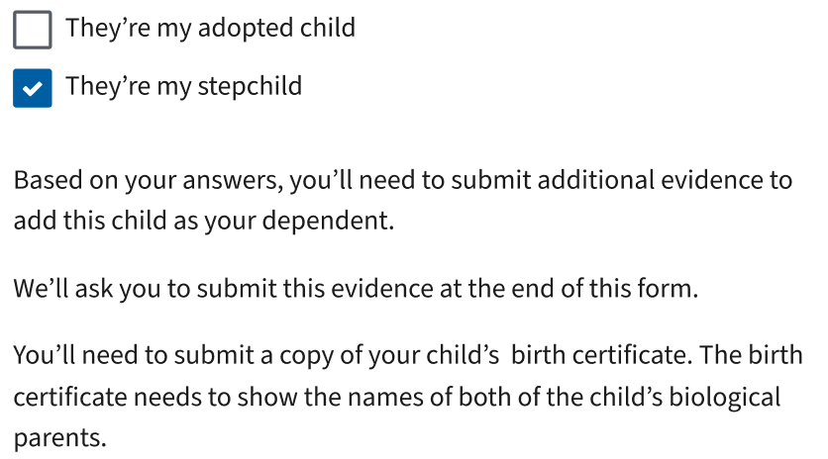

#### 

#### 3.31 Child’s biological parents

This page will conditionally show if the Veteran selects “Stepchild” to “What’s your relationship to this child?”

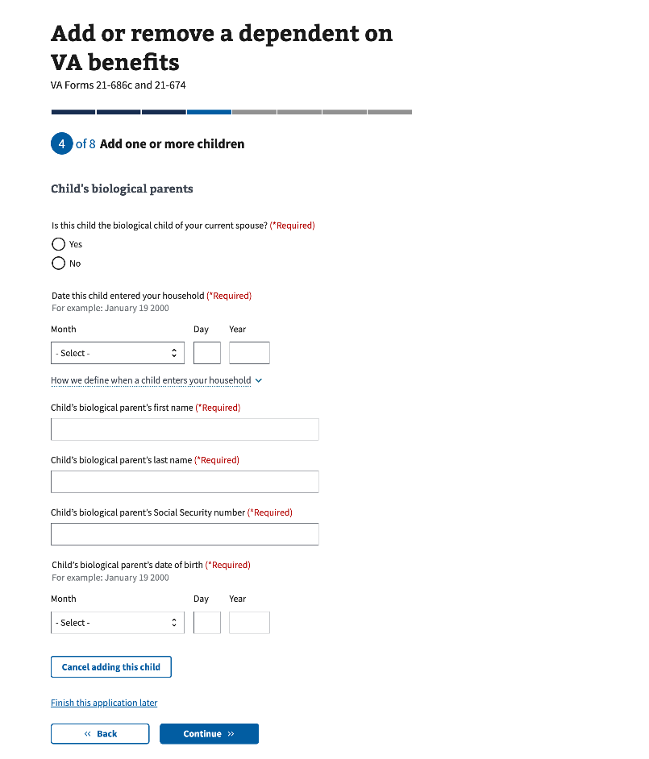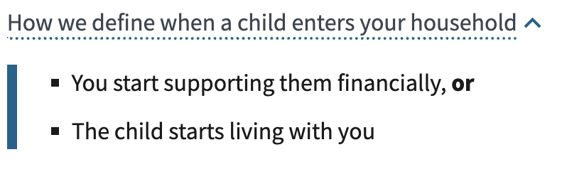

#### 3.32 Child’s disability

#### 

#### 3.33 Child’s disability (Con’t)

This page will conditionally show if the Veteran selects “Yes” to “Does the child have a permanent mental or physical disability?” on the previous page.

The note below the question will conditionally show if “Yes” is selected.

#### 

#### 3.34 Additional information about this child

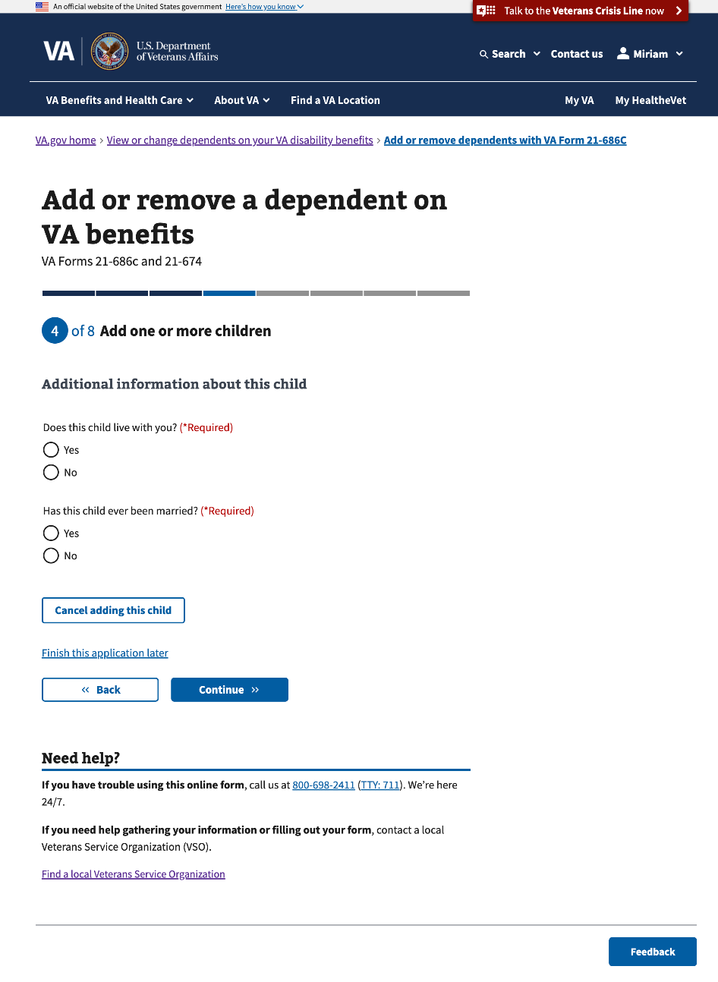

#### 3.35 How and when the marriage ended

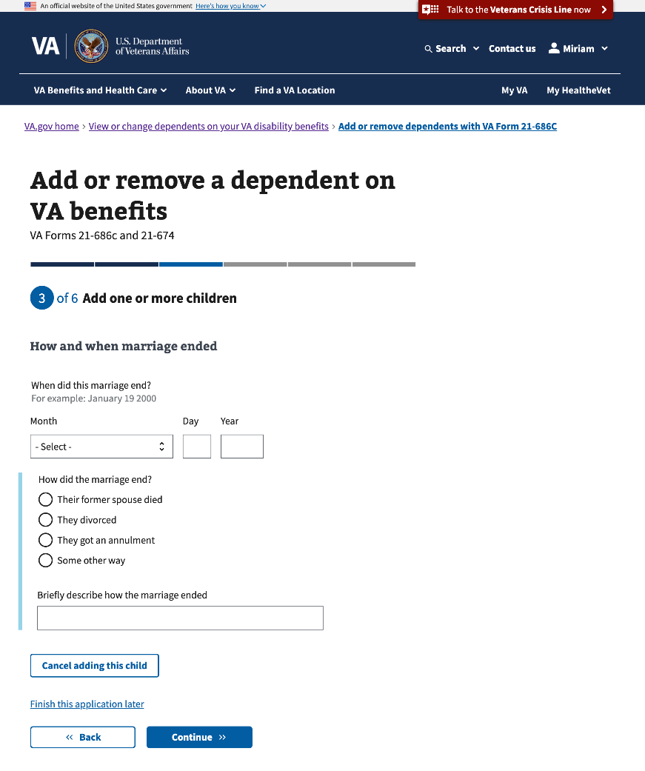

#### 3.36 Additional information about this child

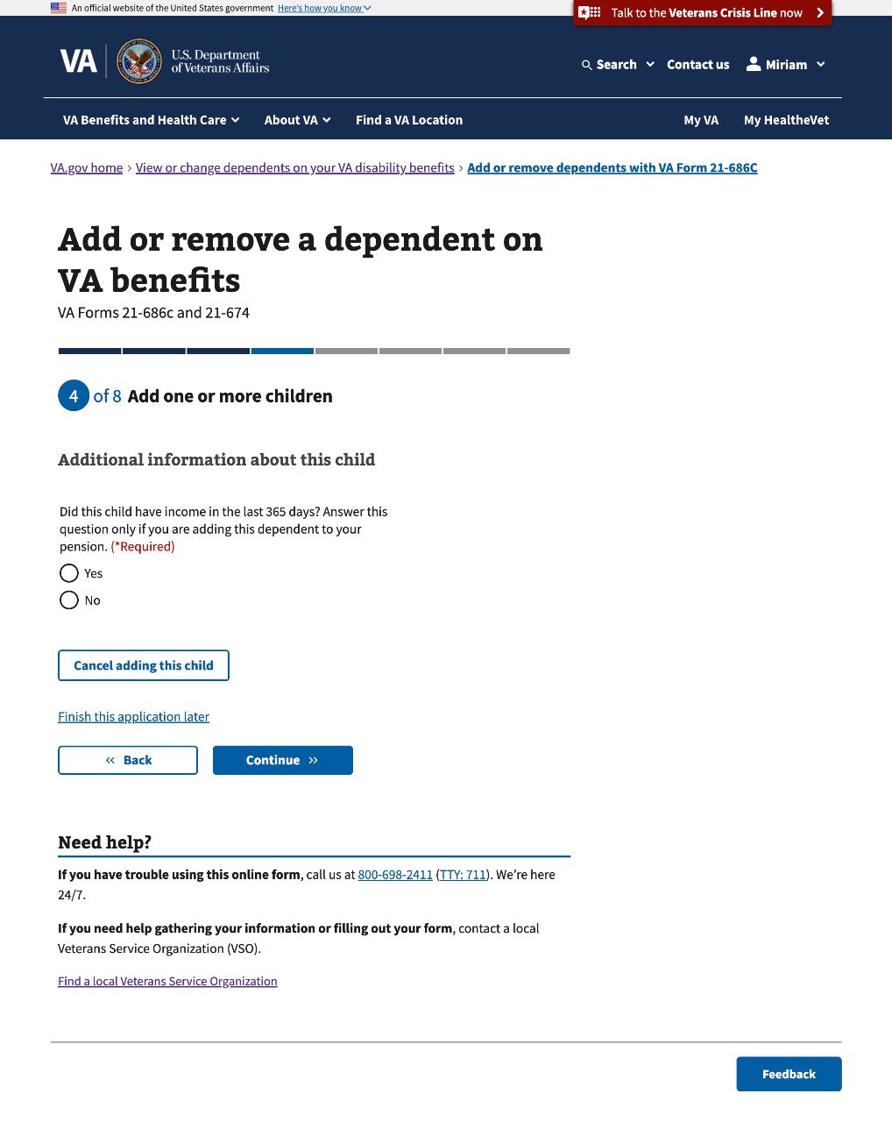

#### 

#### 3.37 Child’s address

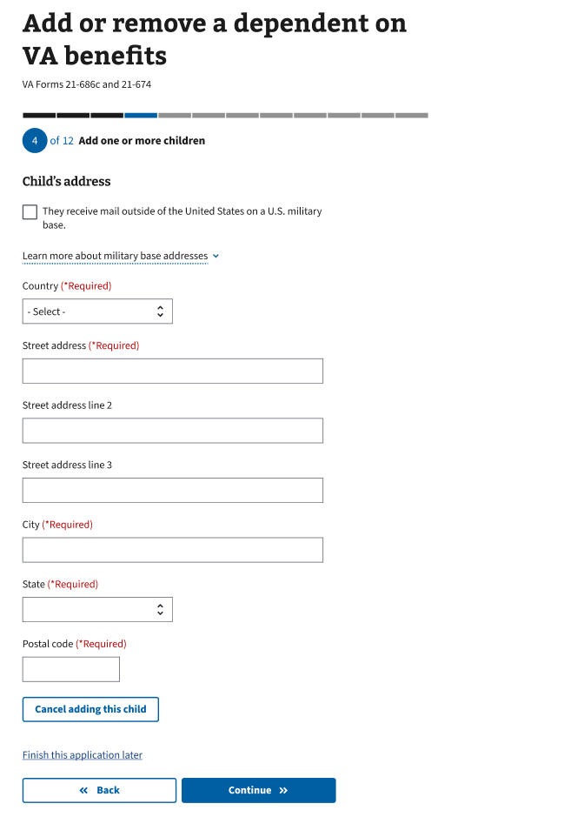

#### 3.38 Tell us who this child lives with

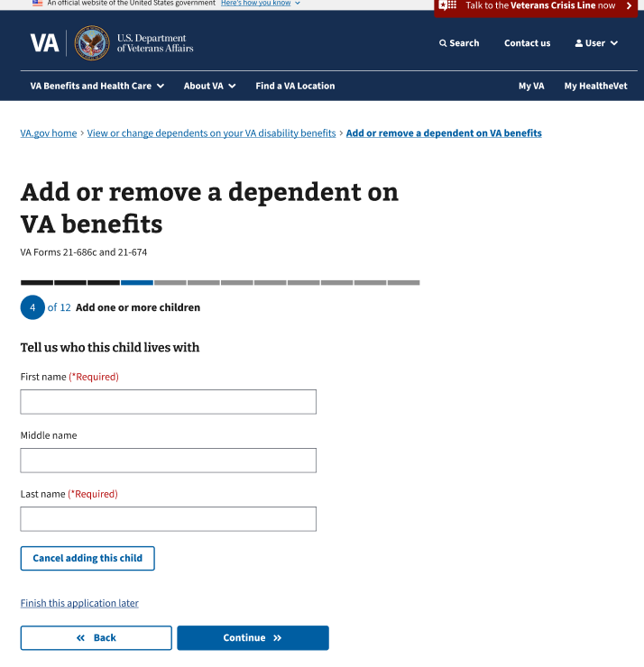

#### 

#### 3.39 Review your children

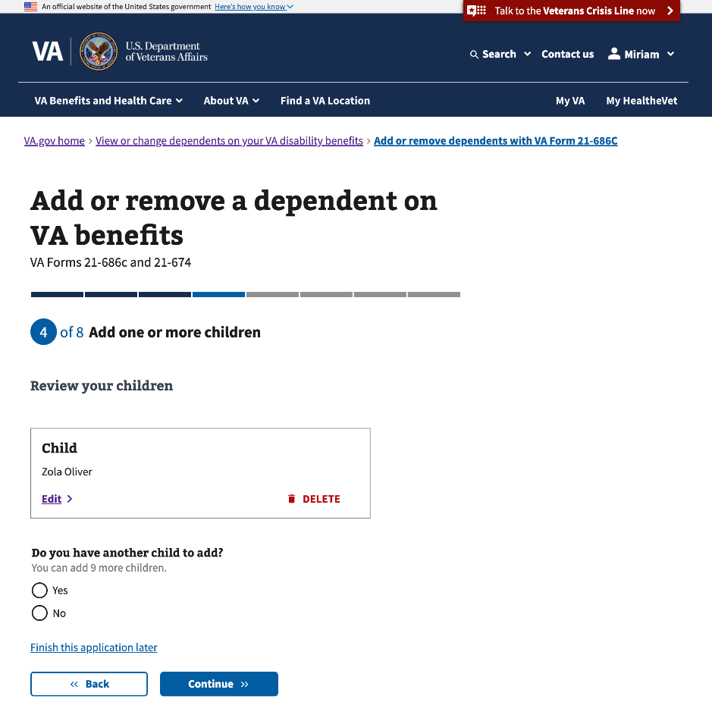

### 

### Step 3: Add one or more students between the ages of 18 and 23

This section of Step 3 will conditionally show if the Veteran selects to add one or more students between ages 18 and 23 on Step 1. This section of Step 3 has 20 sub-pages that ask questions about the student’s personal and contact information.

#### 3.40 Your students

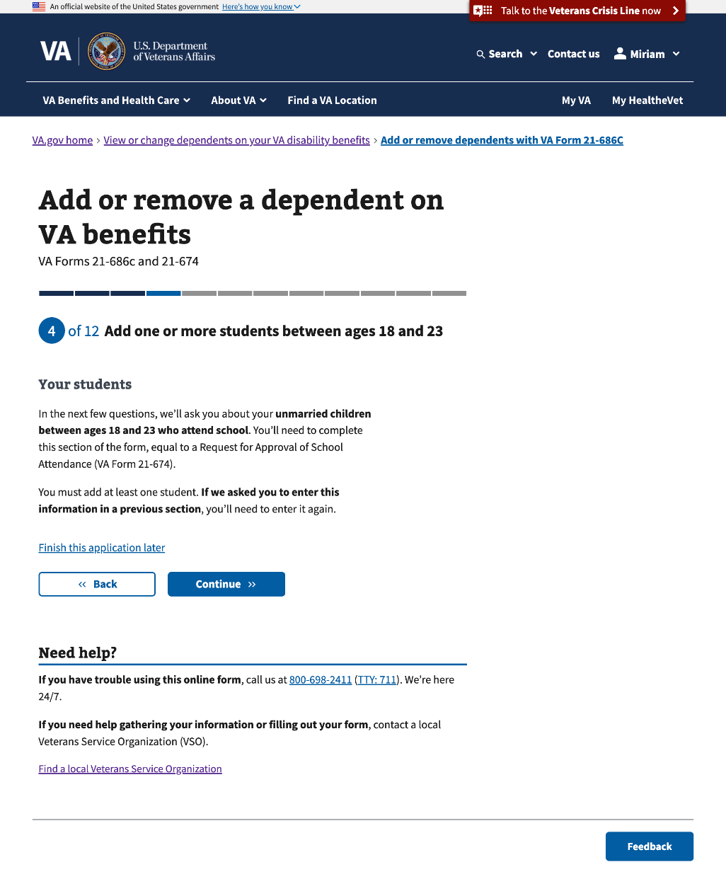

#### 3.41 Add a student

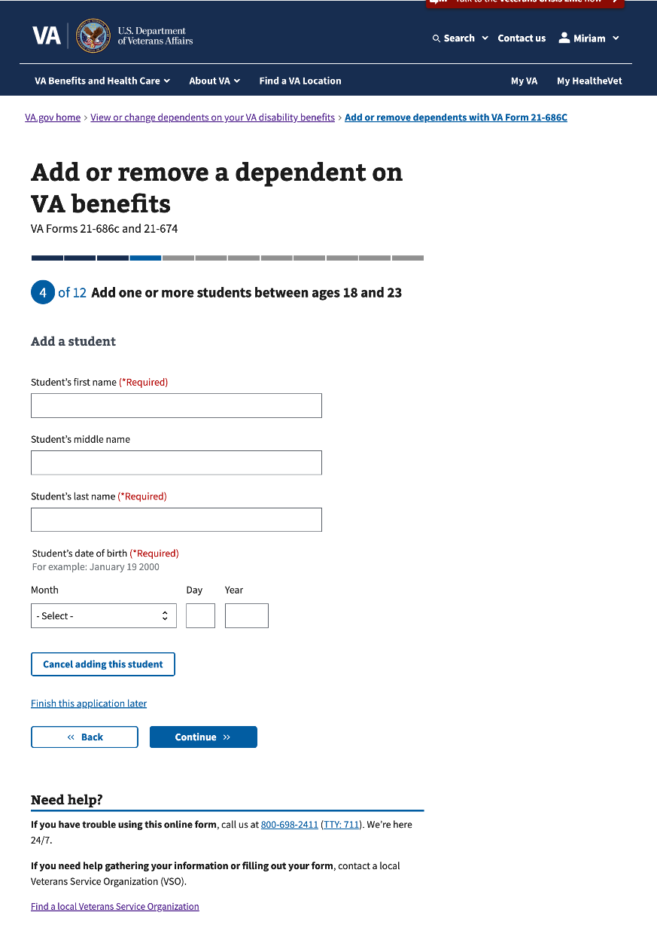

#### 3.42 Student’s information

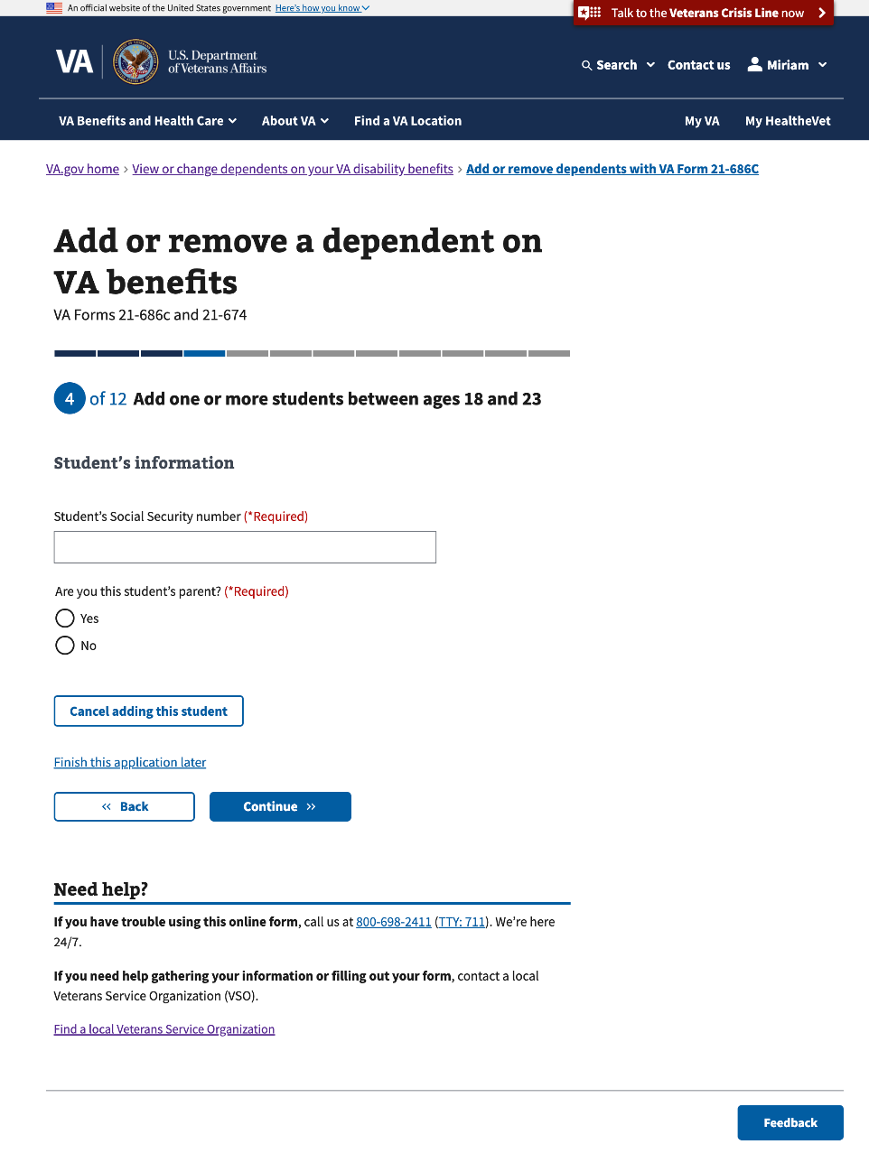

#### 3.43 Student’s information (Con’t)

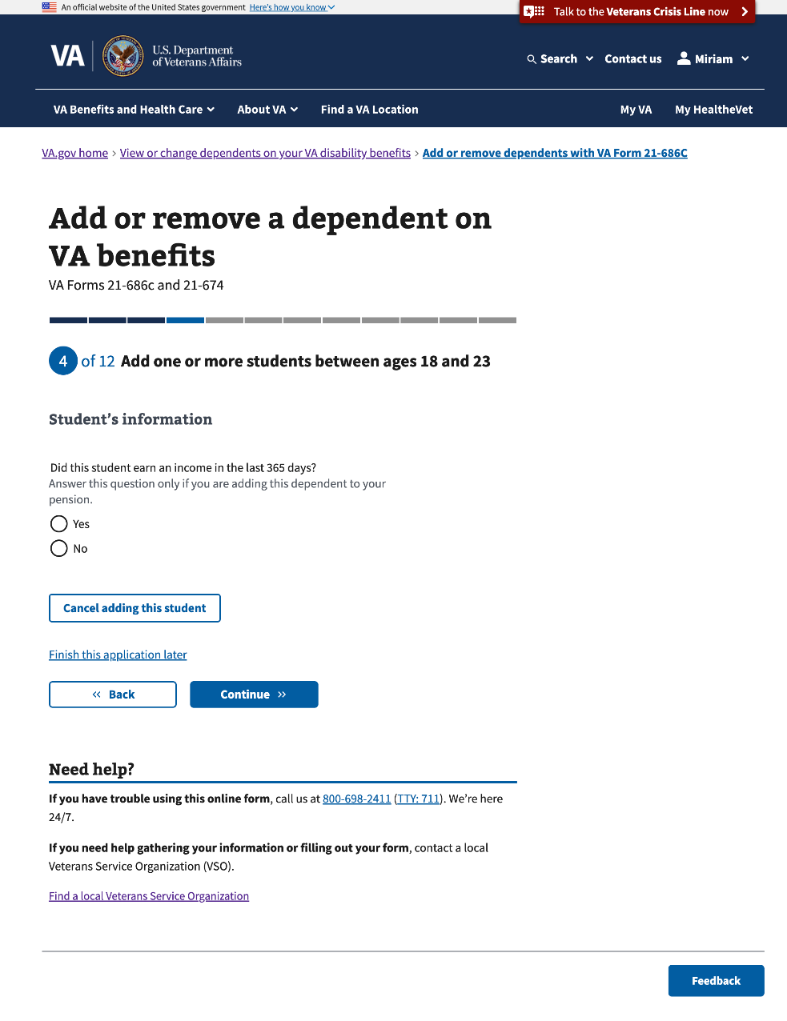

#### 3.44 Student’s address

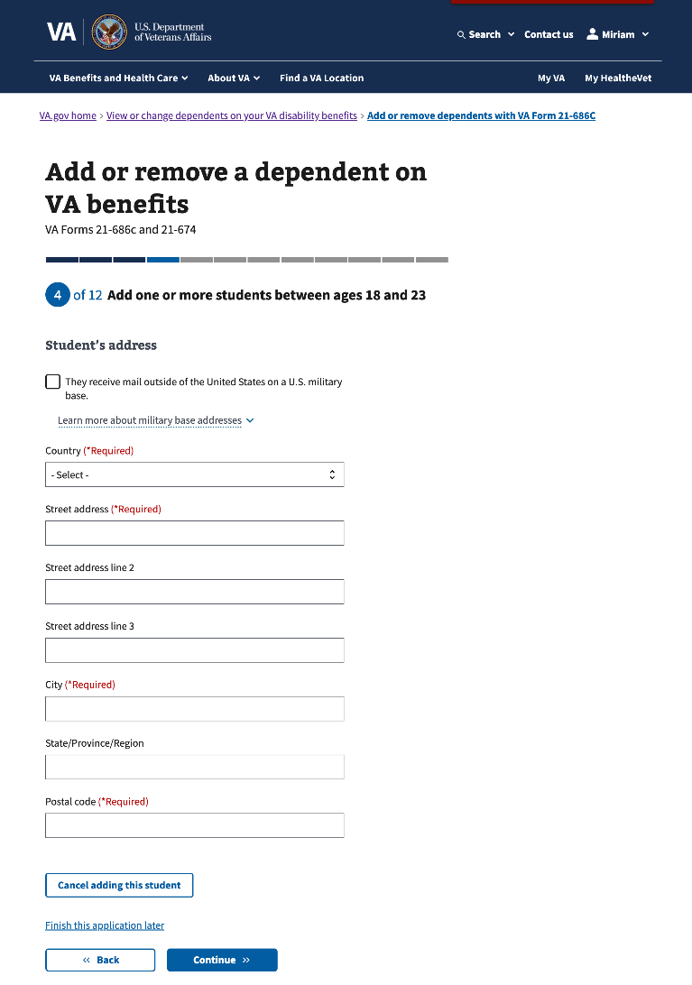

#### 3.45 Student’s marital status

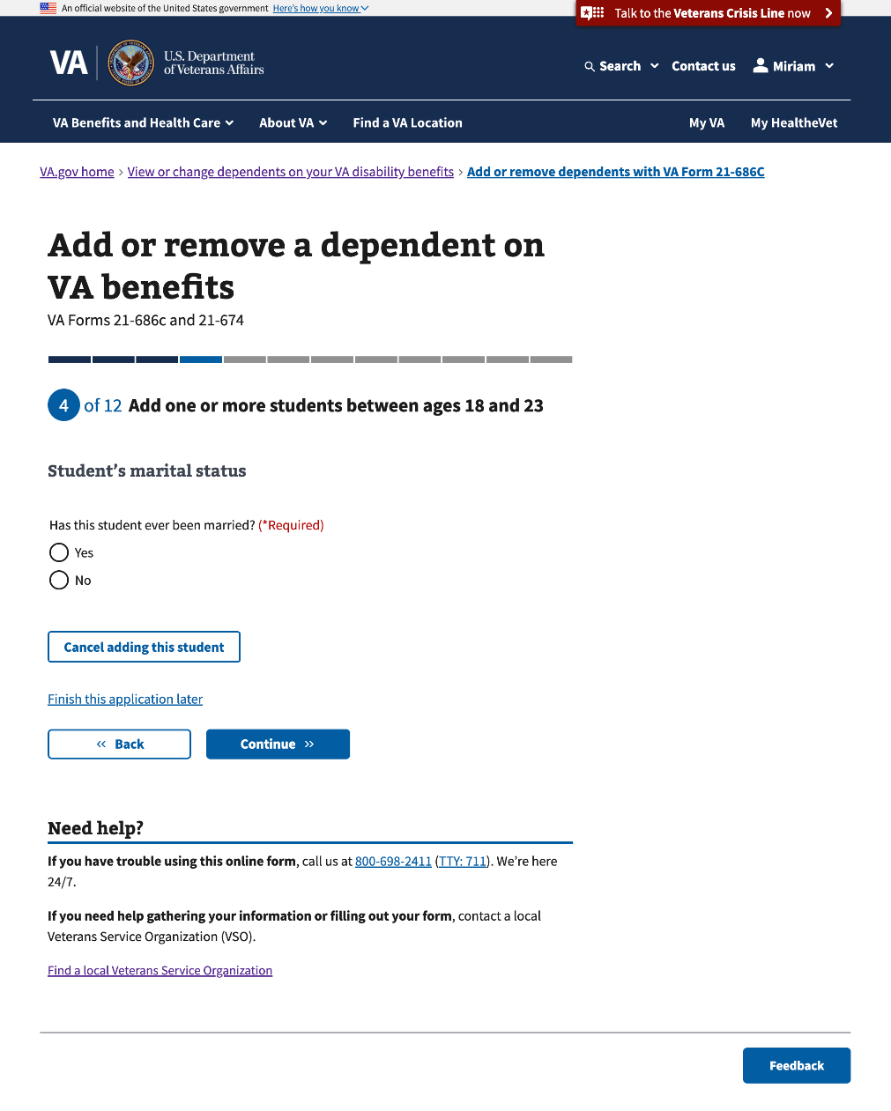

#### 

#### 3.46 Student’s marital status

This page will conditionally display if the Veteran selects “Yes” to the question, “Has this student ever been married?”

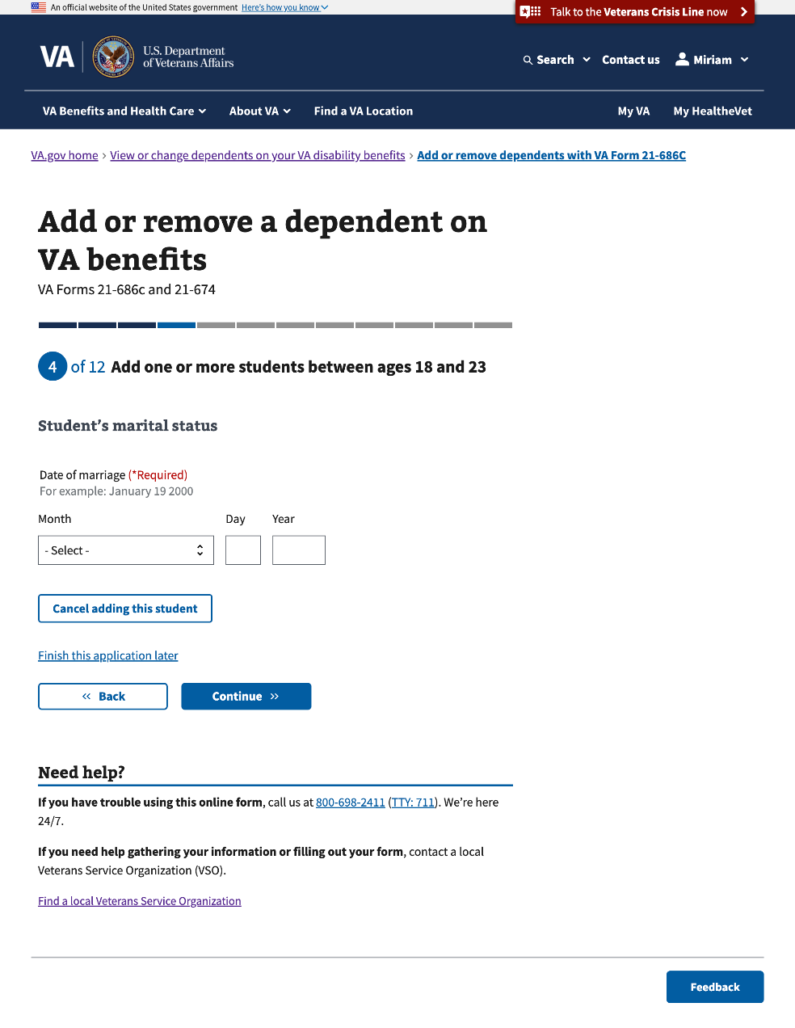

#### 3.47 Student’s education benefits

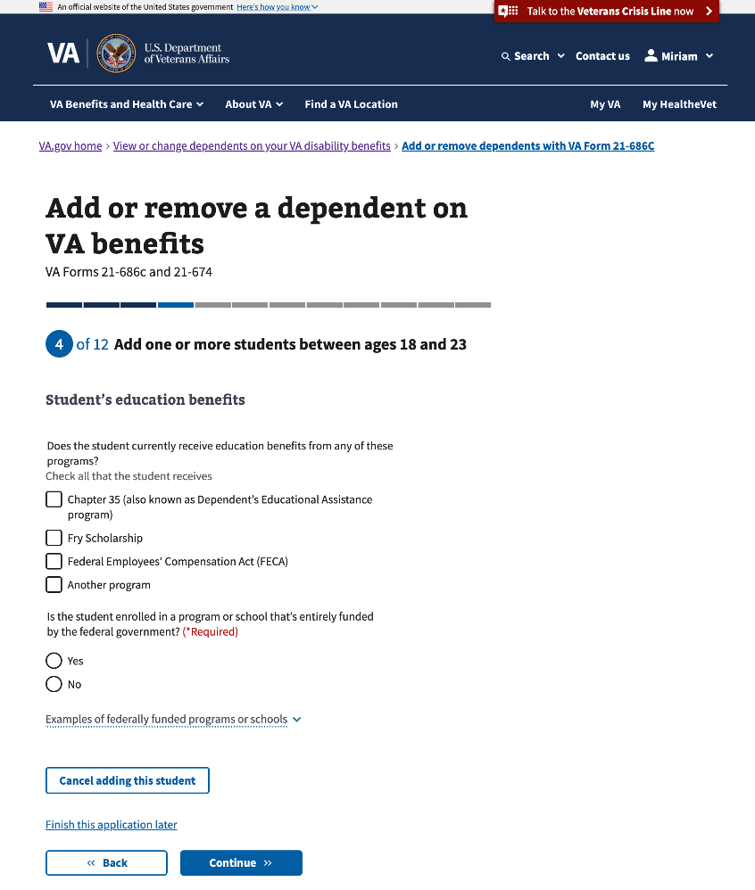

#### 

#### 3.48 Student’s education benefit payments

This page will conditionally show if the Veteran selects one or more options: “Does the student currently receive education benefits from any of these programs?”

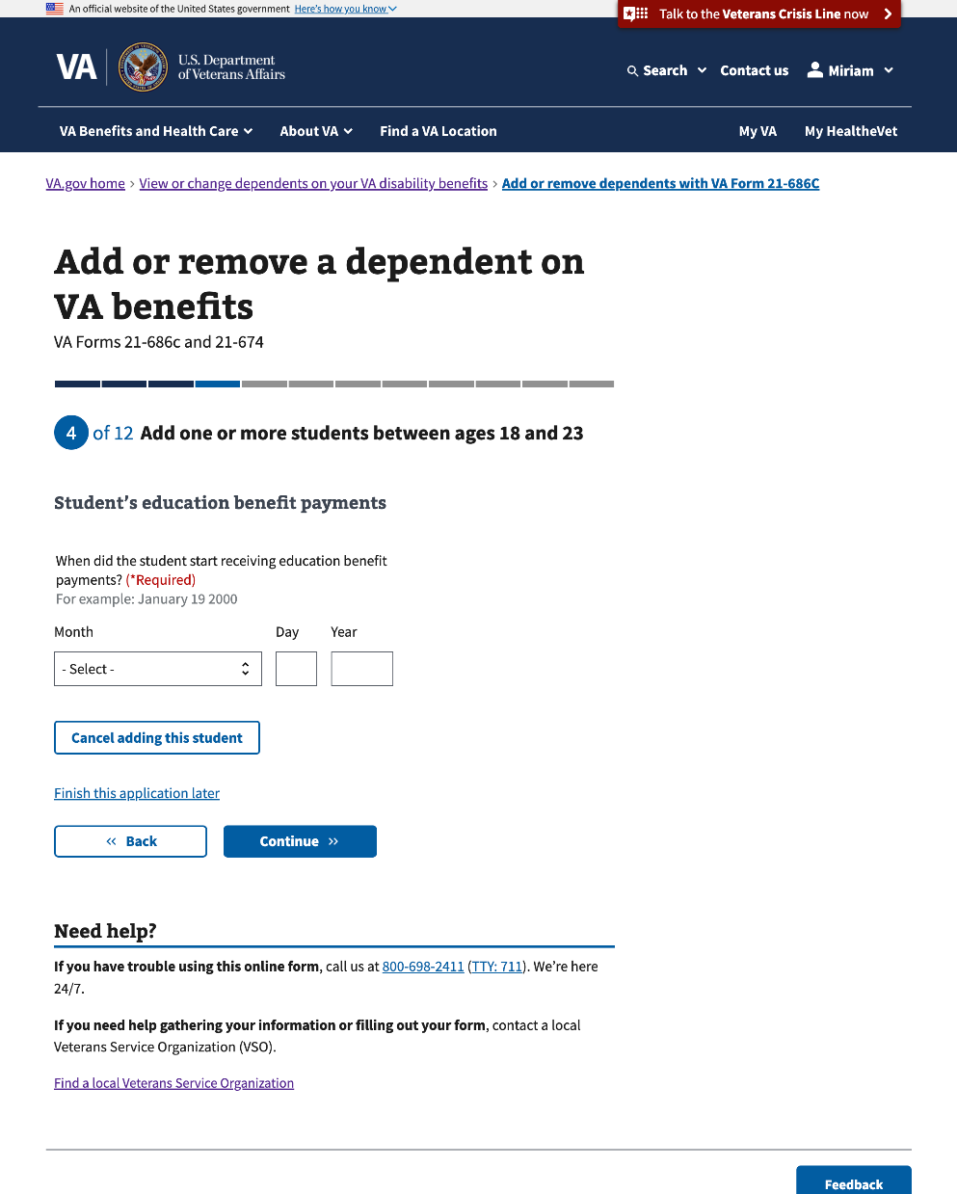

#### 

#### 3.49 Student’s education program or school

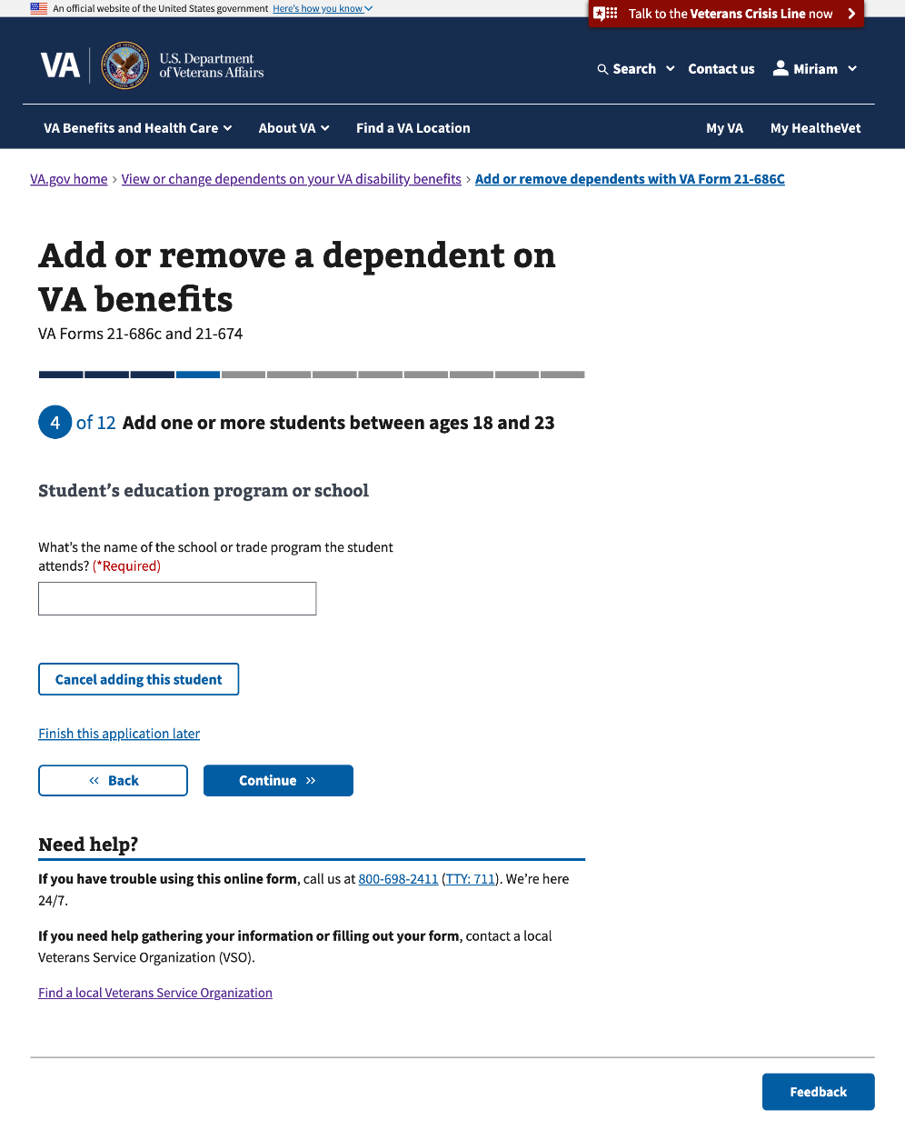

#### 

#### 3.50 Additional information for this student

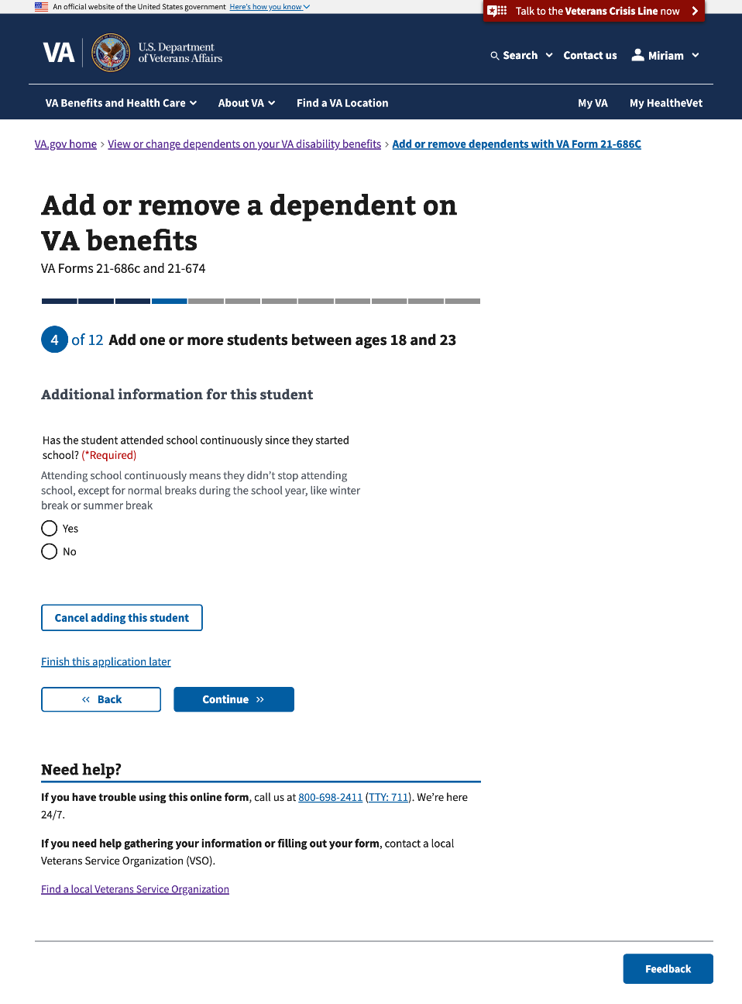

#### 

#### 3.51 Additional information for this student (Con’t)

This page will conditionally show if the Veteran selects “No” to “Has the student attended school continuously since they started?”

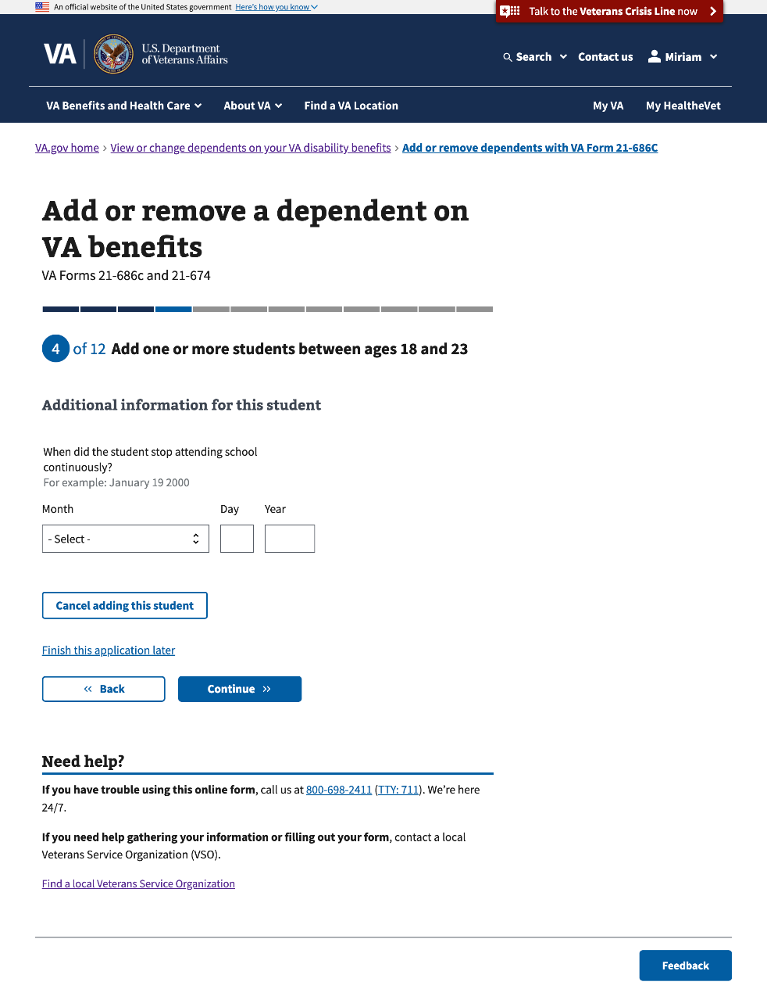

#### 3.52 Additional information for this student (Con’t)

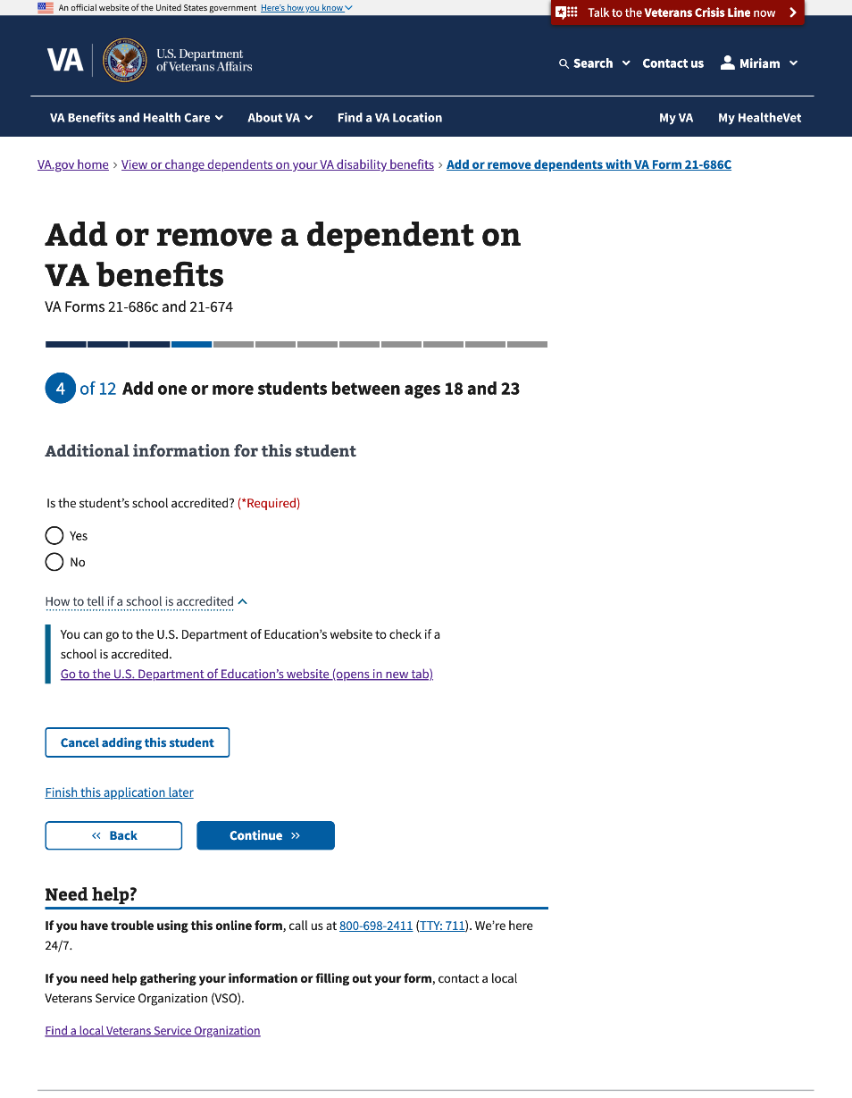

#### 

#### 3.53 Student’s term dates

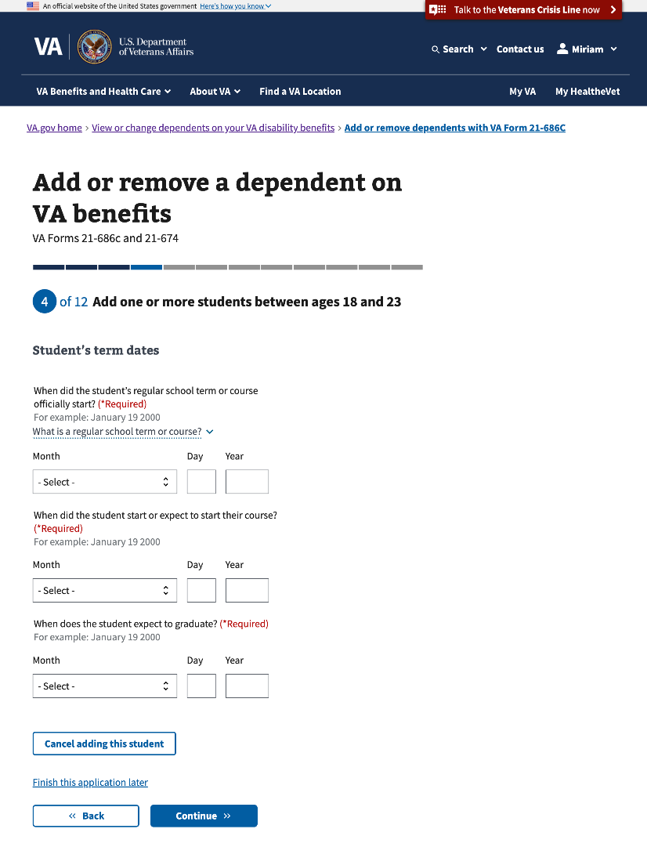

#### 3.54 Student’s term dates (Con’t)

#### 

#### 

#### 3.55 Student’s previous term

This page will conditionally appear if the Veteran selects “Yes” to “Did the student attend school last term?”

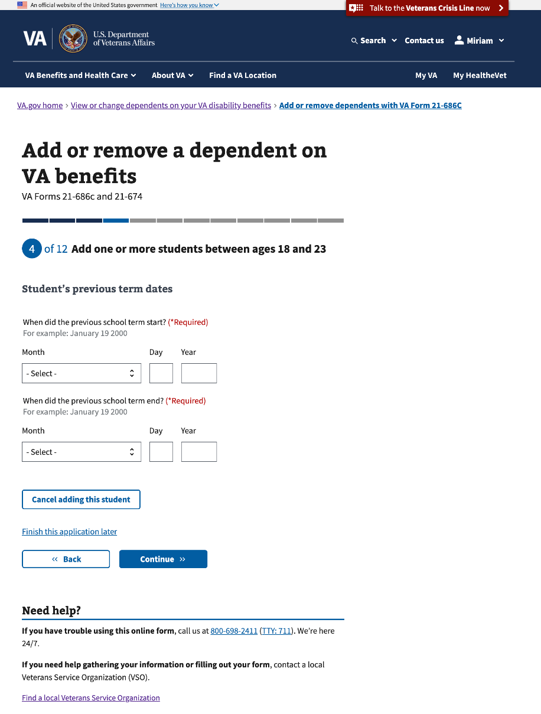

#### 3.56 Student’s income

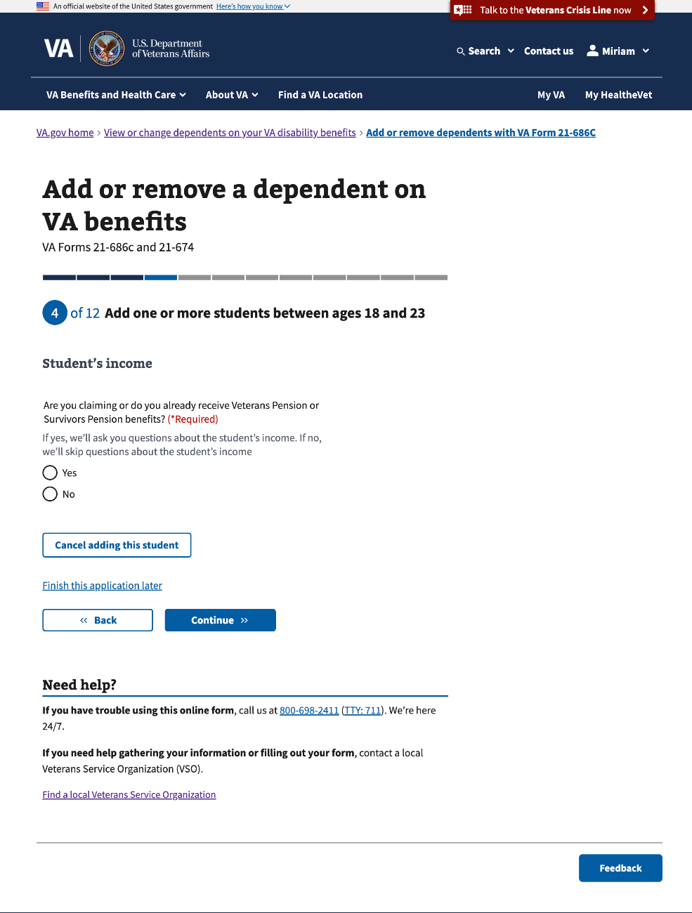

#### 

#### 3.57 Student's income in the year their current school term began

This page and the following 2 pages will conditionally appear if the Veteran selects “Yes” to “Are you claiming or do you already receive Veterans Pension or Survivors Pension benefits?”

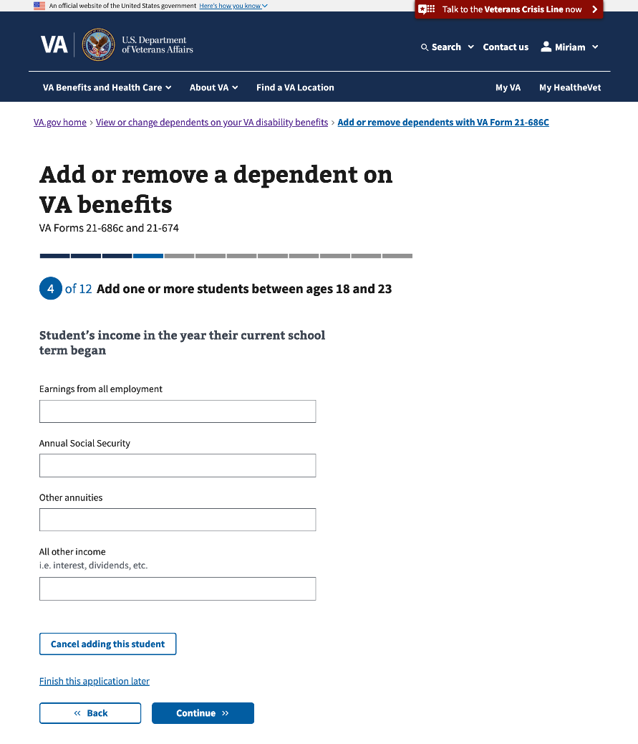

#### 

#### 3.58 Student’s expected income next year

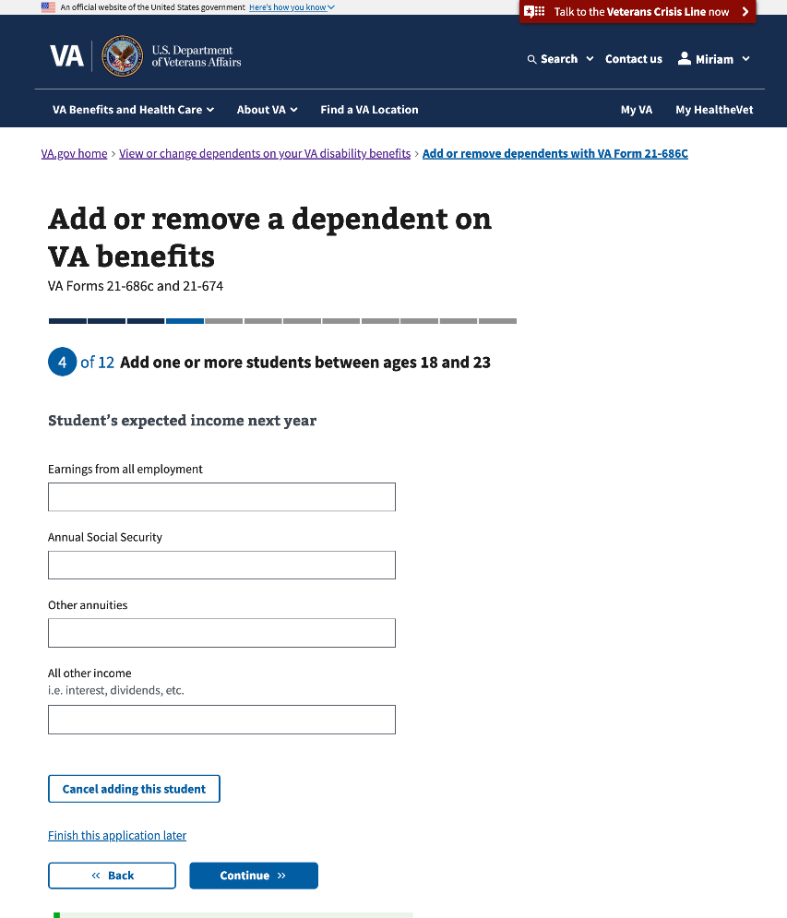

#### 

#### 3.59 Value of student’s assets

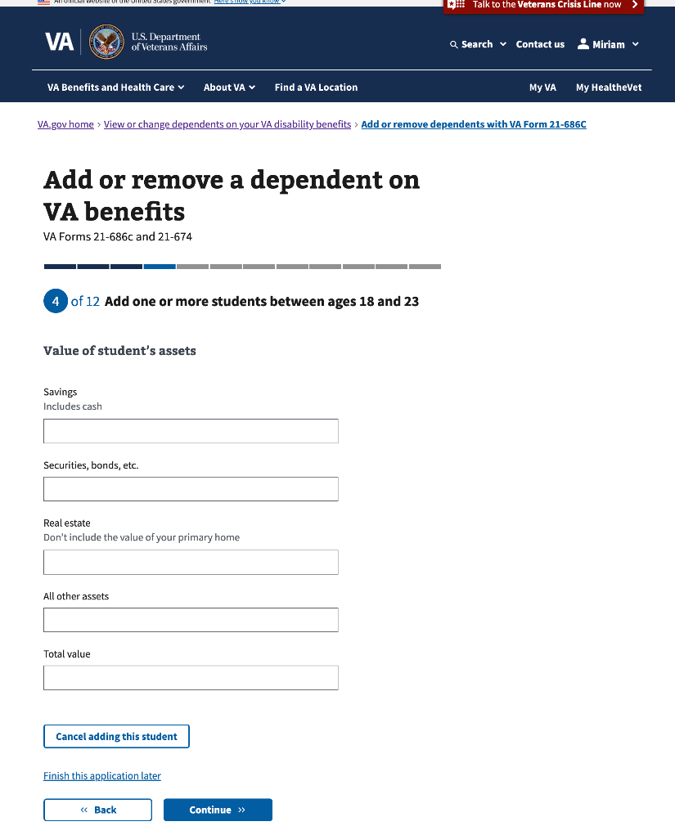

#### 

#### 3.60 Additional information

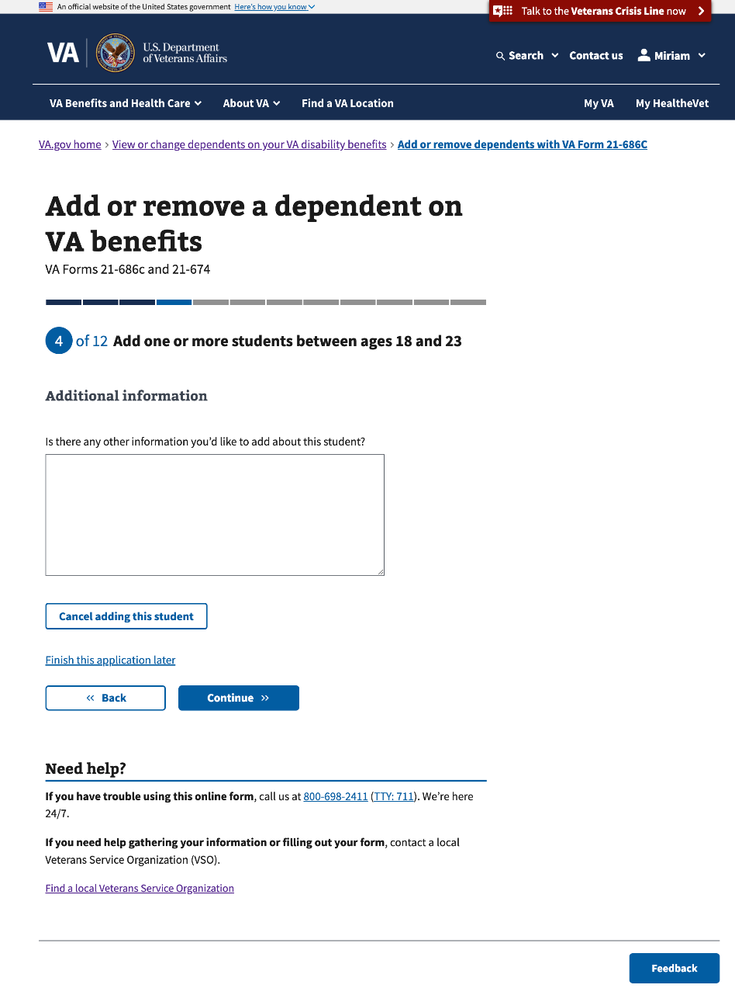

#### 3.61 Review your students

This is the last page to add information about the Veteran’s student(s).

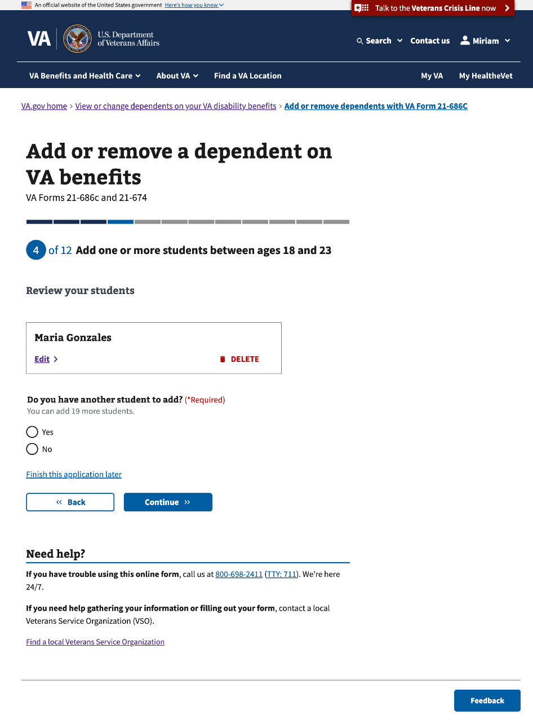

### Step 3: Remove a divorced spouse

This section of Step 3 will conditionally show if the Veteran selects to remove a divorced spouse on Step 1. It has 3 sub-pages that ask questions about the child’s personal and contact information.

#### 3.62 Divorced spouse’s information

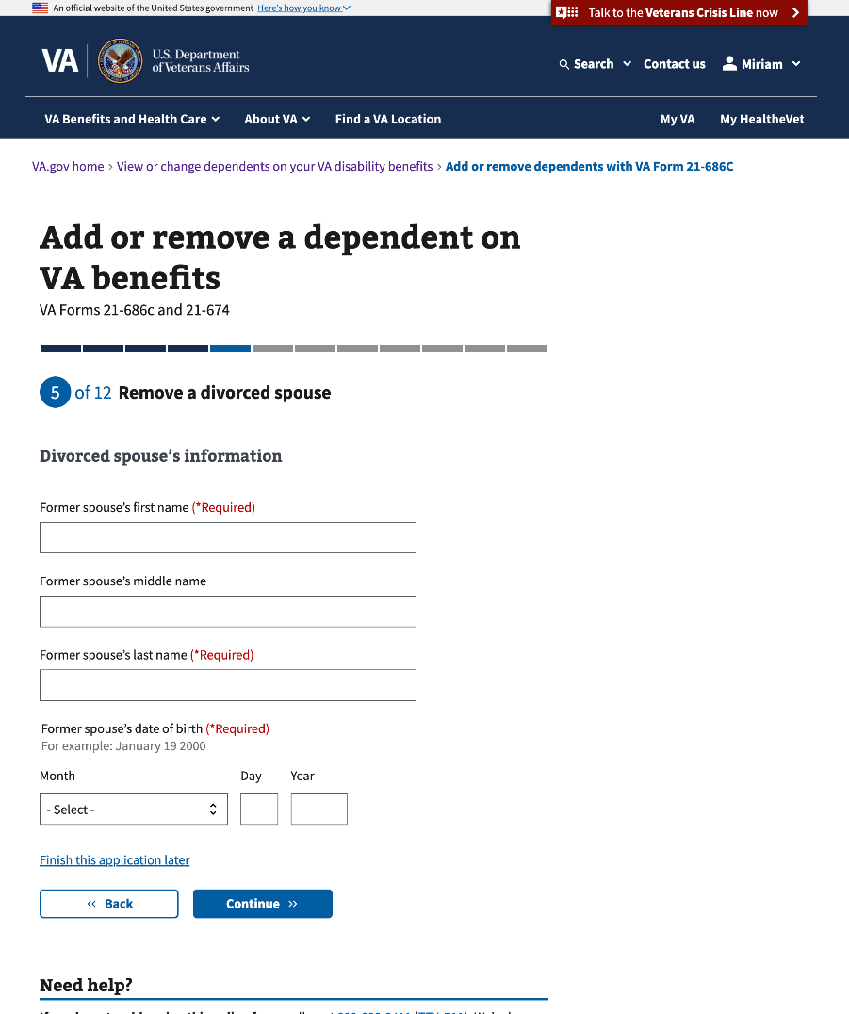

#### 3.63 When, where, and why did this marriage end?

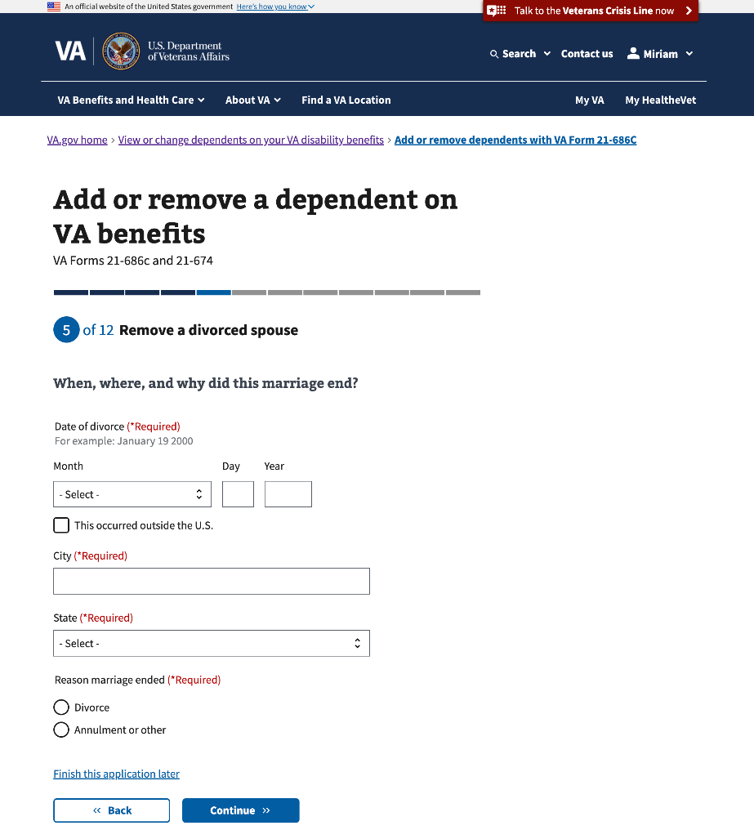

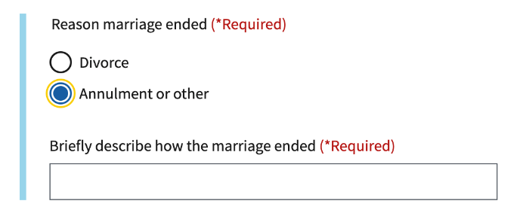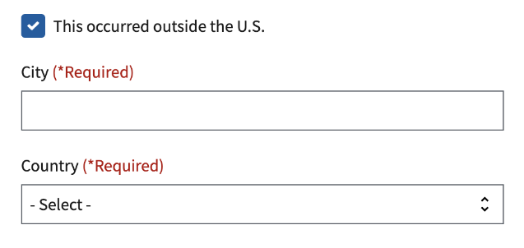

#### 3.64 Divorced spouse’s income

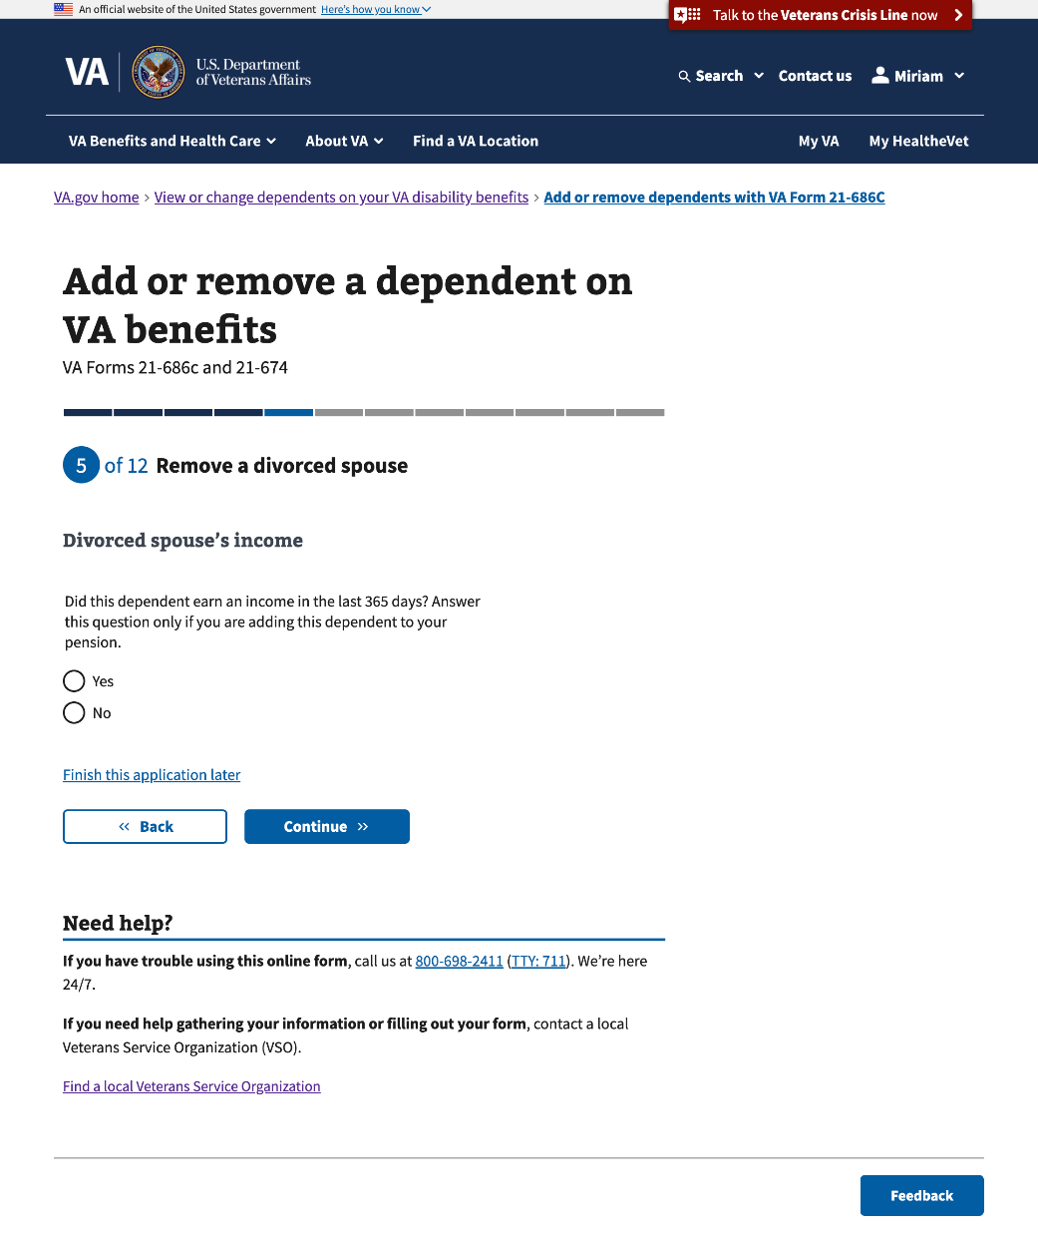

### 

### Step 3: Remove one or more dependents who have died

This section of Step 3 will conditionally show if the Veteran selects to remove one or more dependents who have died. This section of Step 3 has8 sub-pages that ask questions about the dependent’s information.

#### 3.65 Your dependents who have died

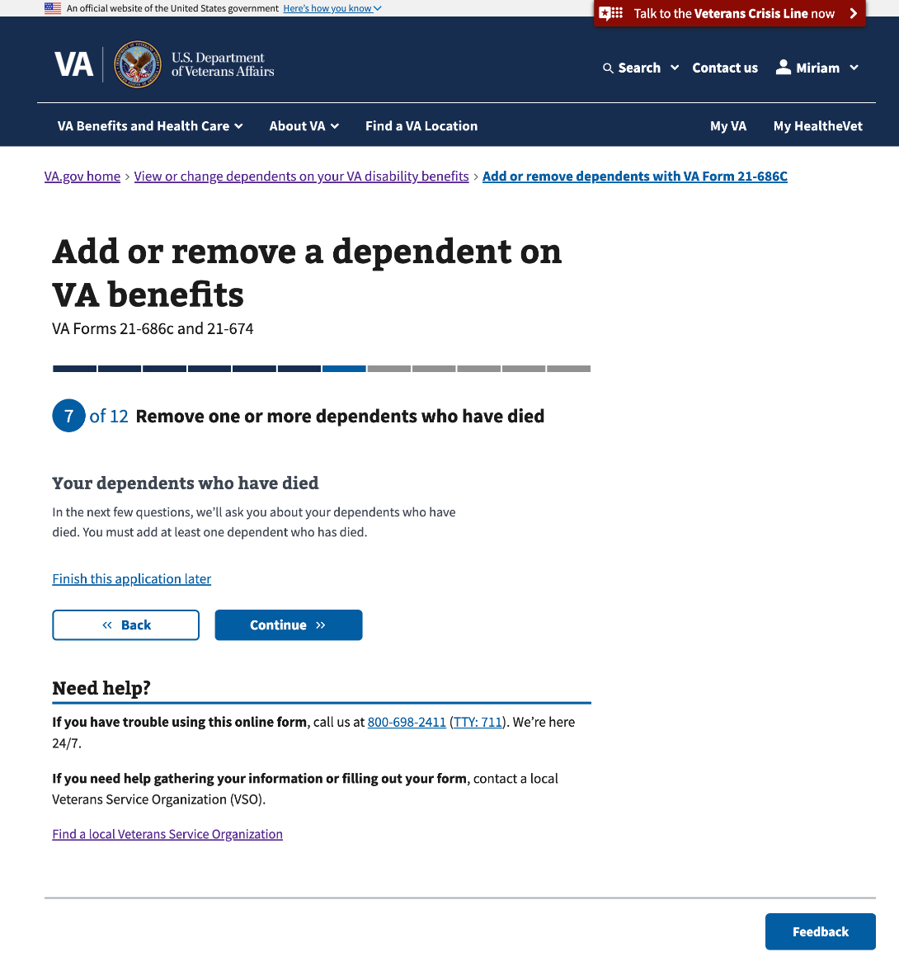

#### 

#### 3.66 Remove a dependent who has died

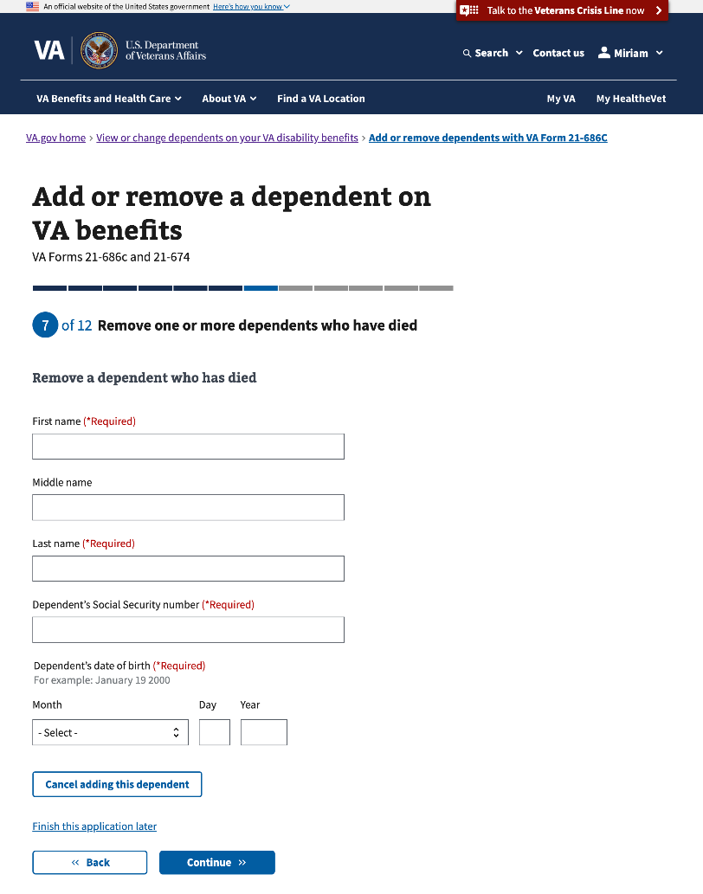

#### 

#### 3.67 Your relationship with this dependent

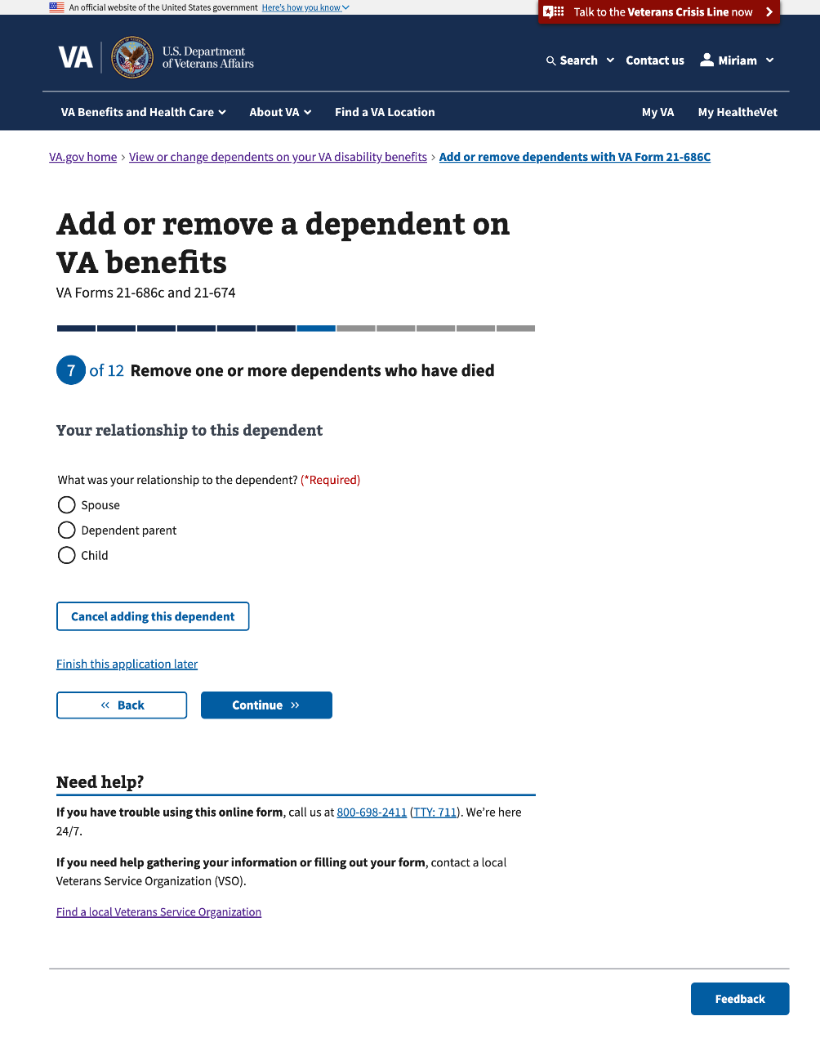

#### 

#### 3.68 Your relationship to this dependent (Con’t)

This page will conditionally show to a Veteran when they select “child” to “What was your relationship to the dependent?”

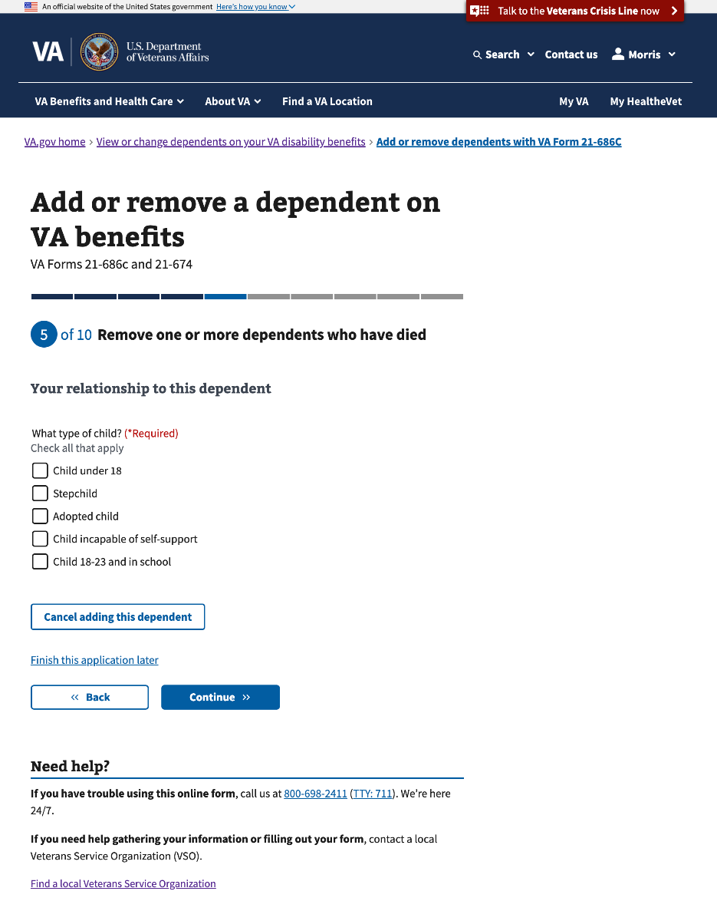

#### 3.69 Dependent’s death date

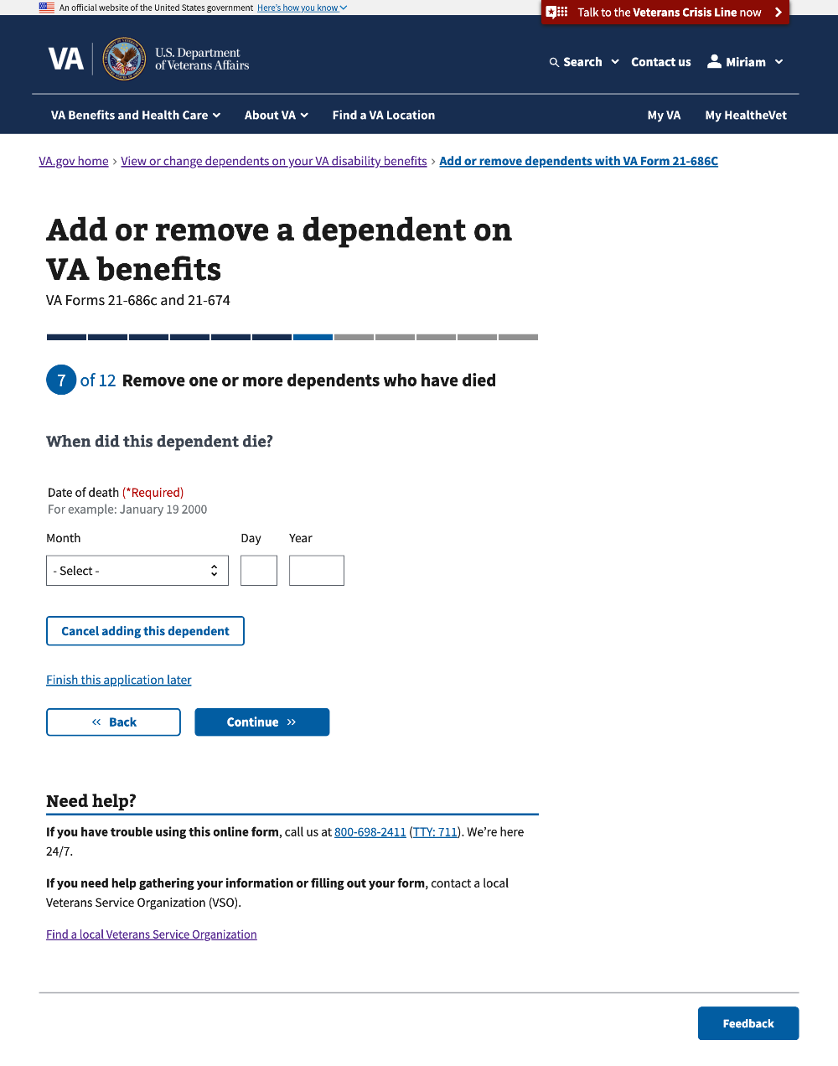

#### 

#### 3.70 Dependent’s death place

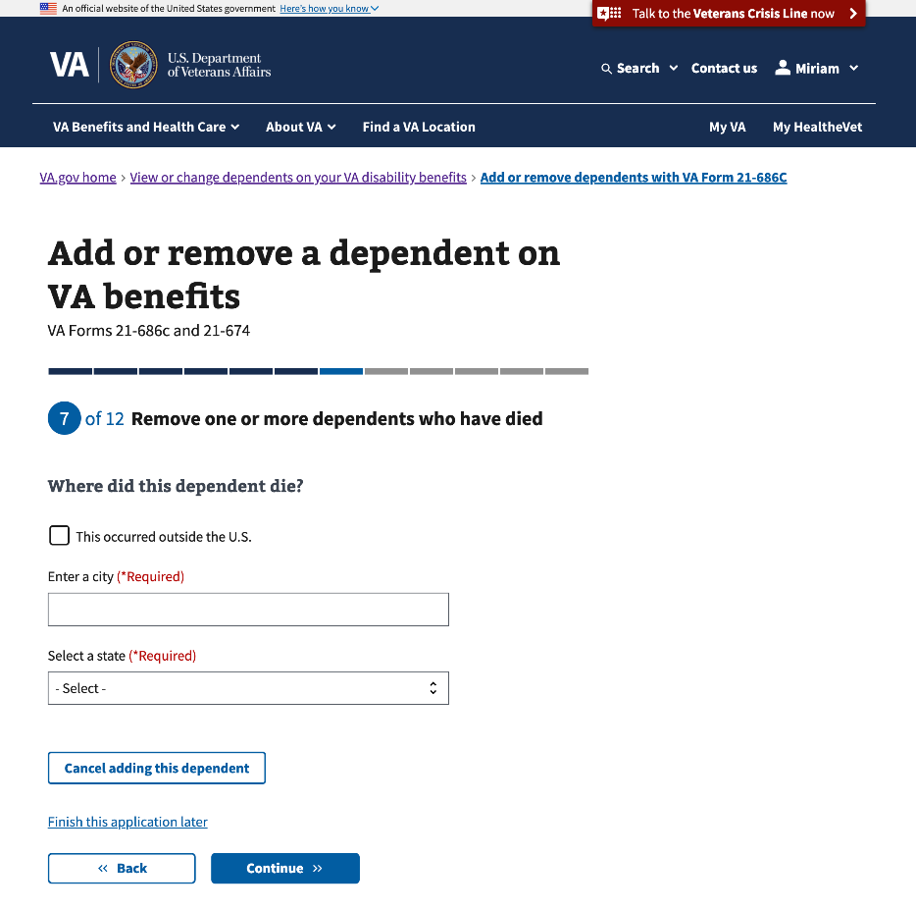

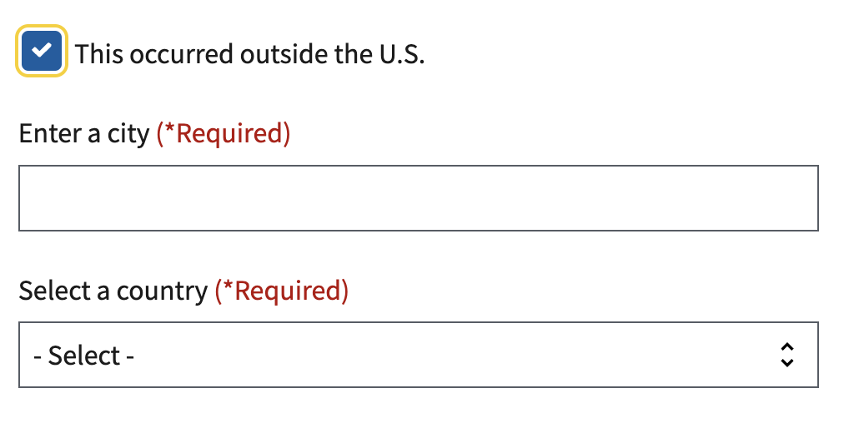

#### 3.71 Dependent’s income

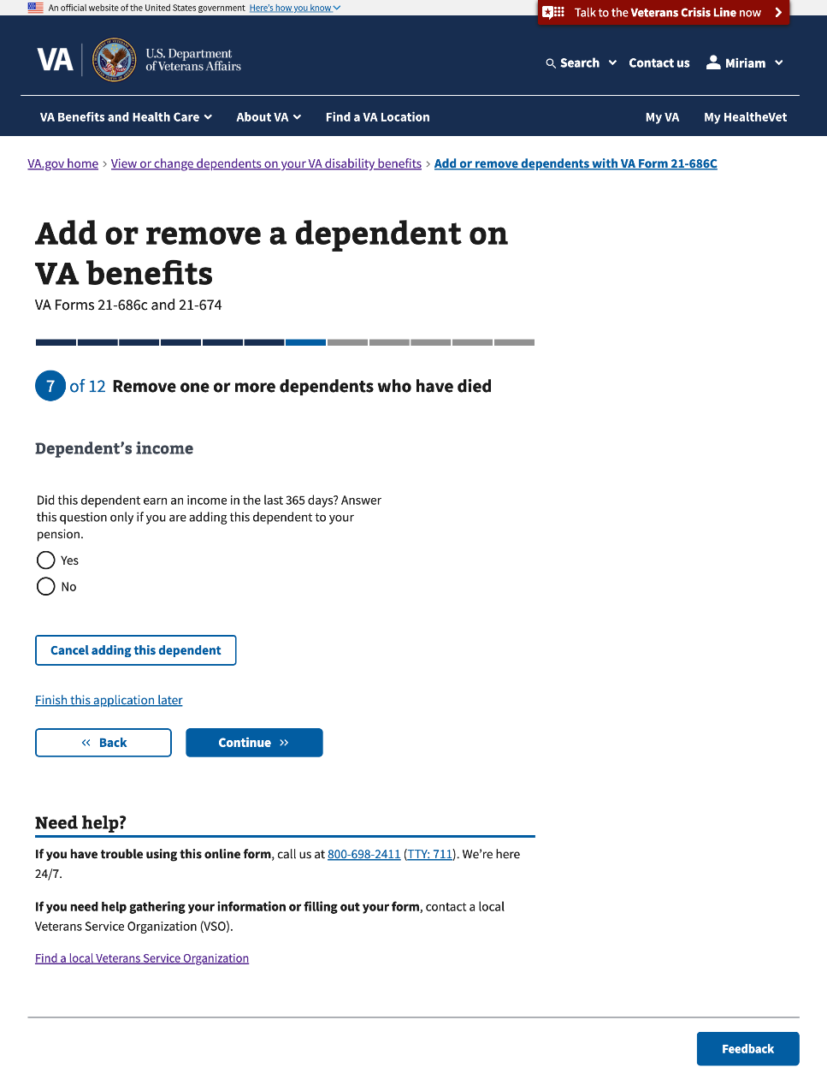

#### 

#### 3.72 Review your dependents who have died

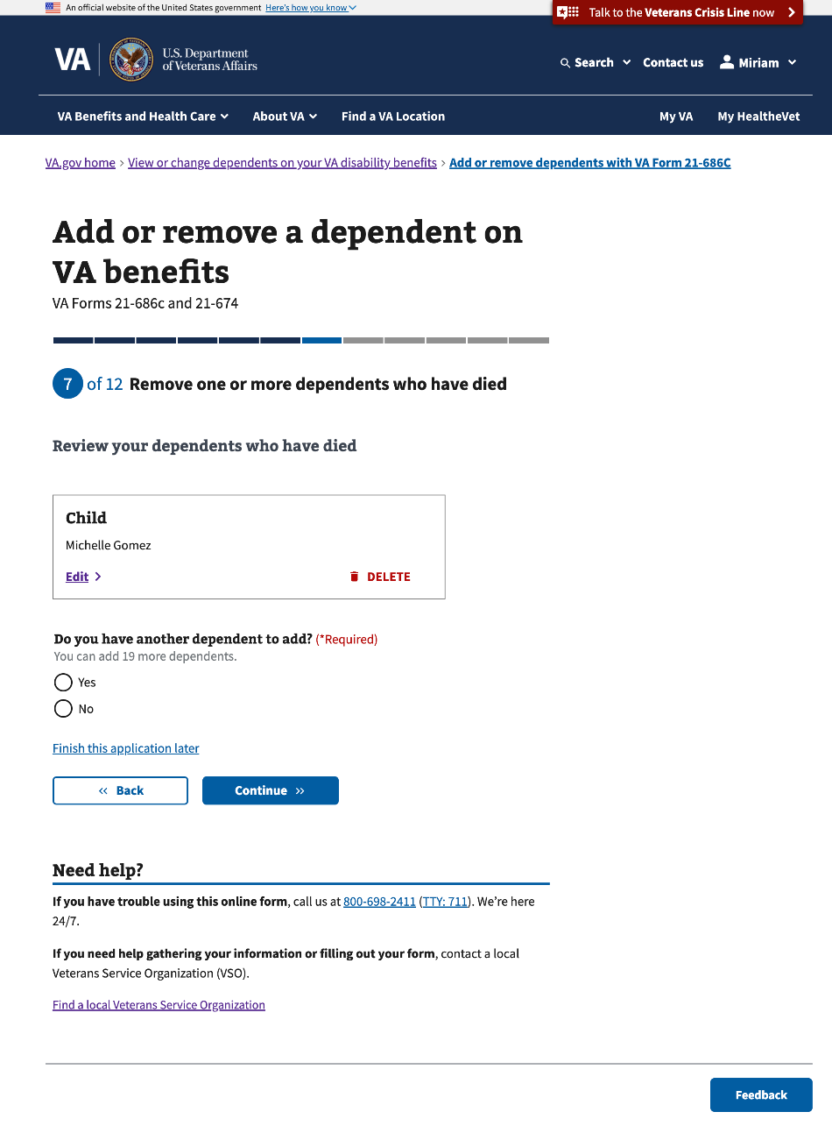

### 

### Step 3: Remove one or more stepchildren who have left your household

This section of Step 3 will conditionally show if the Veteran selects to remove one or more stepchildren who have left their household on Step 1. This section of Step 3 has 7 sub-pages that ask questions about the stepchild’s personal and contact information.

#### 3.73 Your stepchildren who have left your household

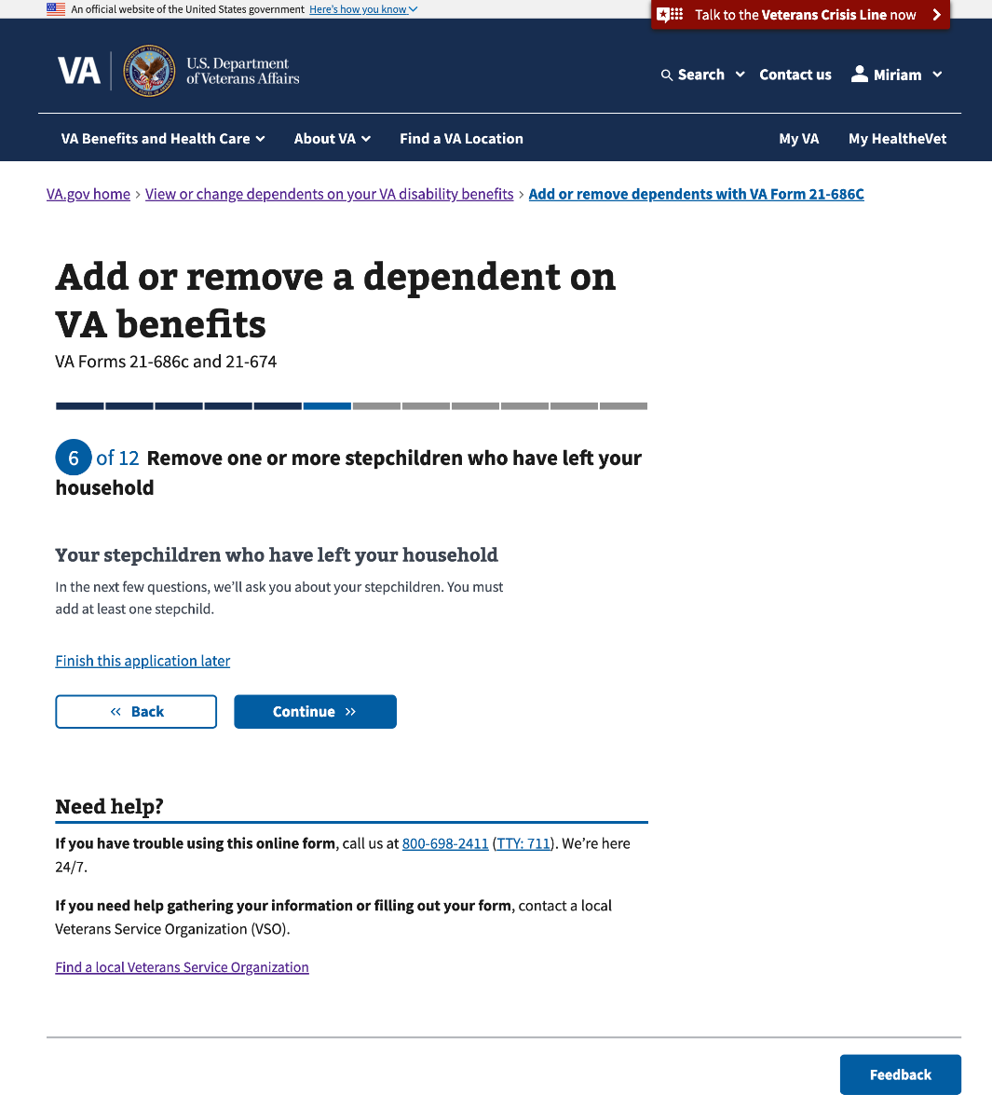

#### 

#### 3.74 Remove a stepchild who has left your household

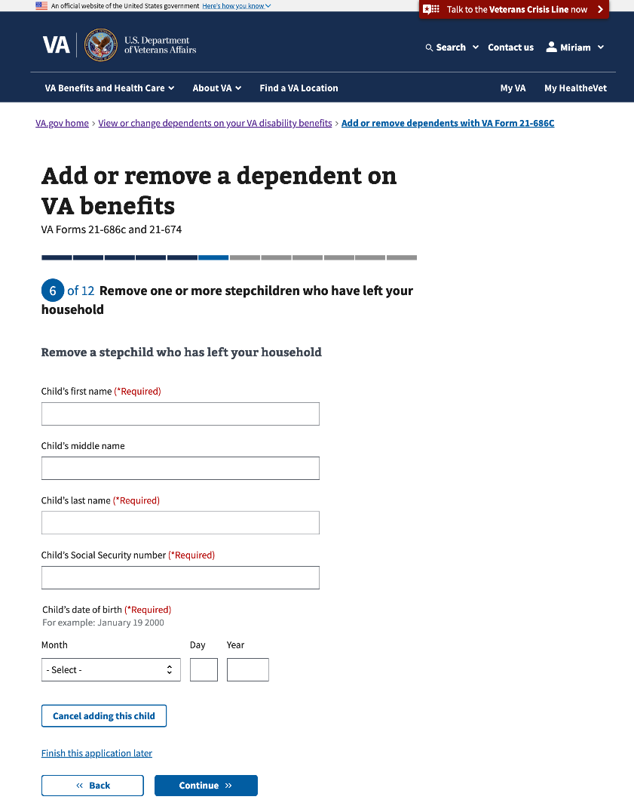

#### 

#### 3.75 Your support of this stepchild

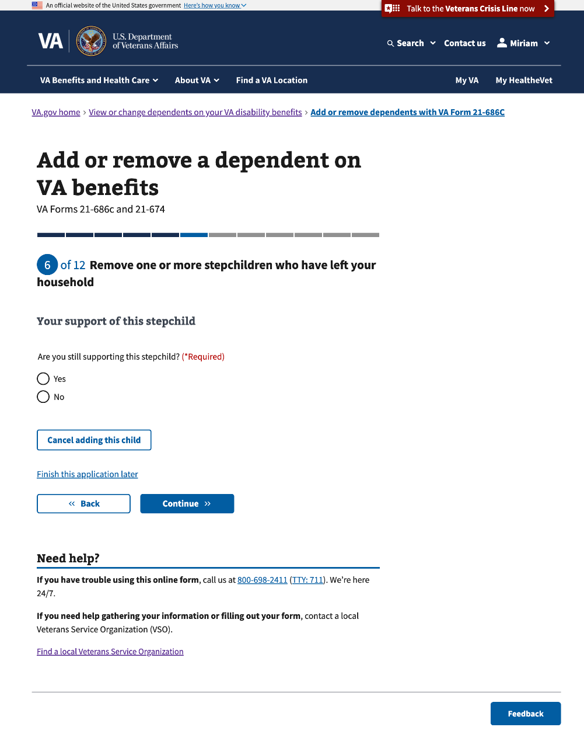

#### 

#### 3.76 Your support of this stepchild (Con’t)

This page conditionally shows if the Veteran selects “Yes” to “Are you still supporting this stepchild?”

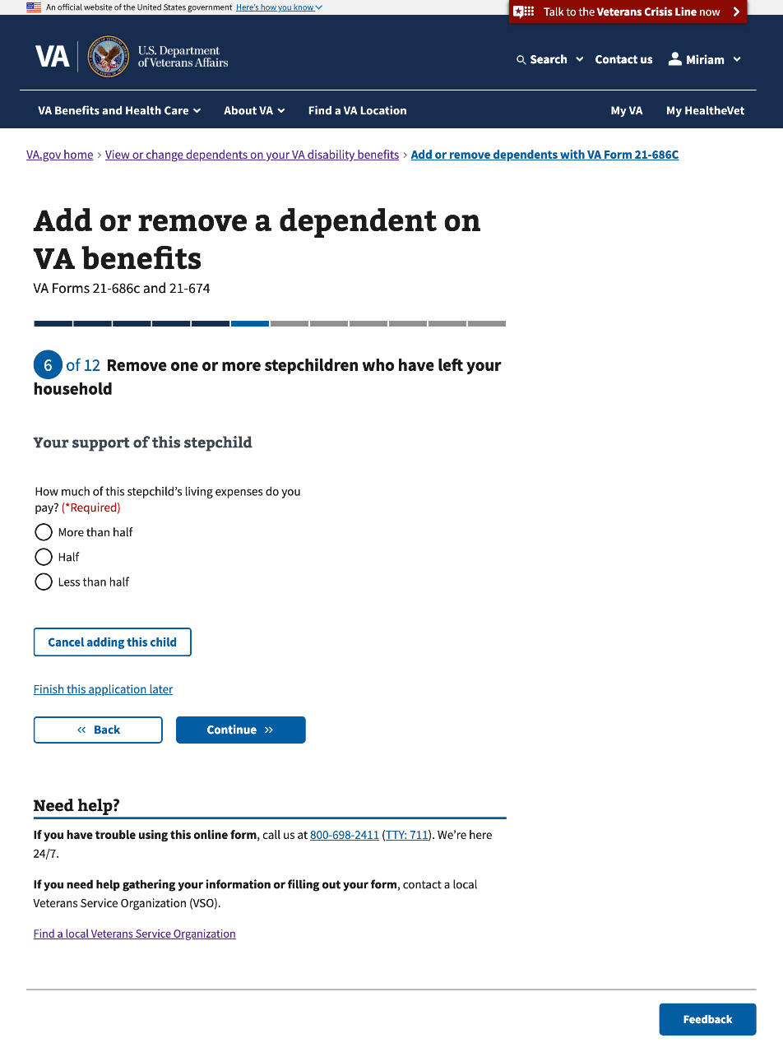

#### 3.77 Stepchild’s address

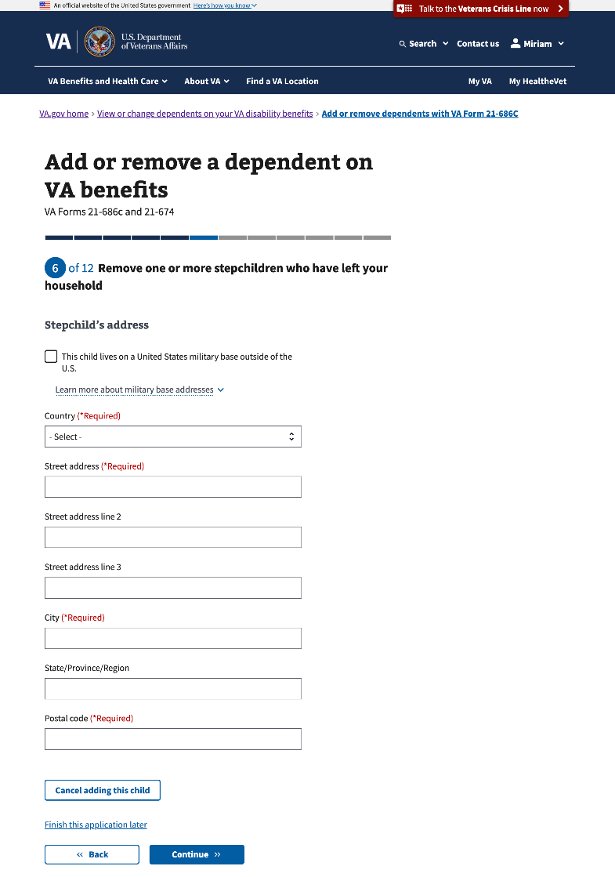

#### 3.78 Tell us who this stepchild lives with

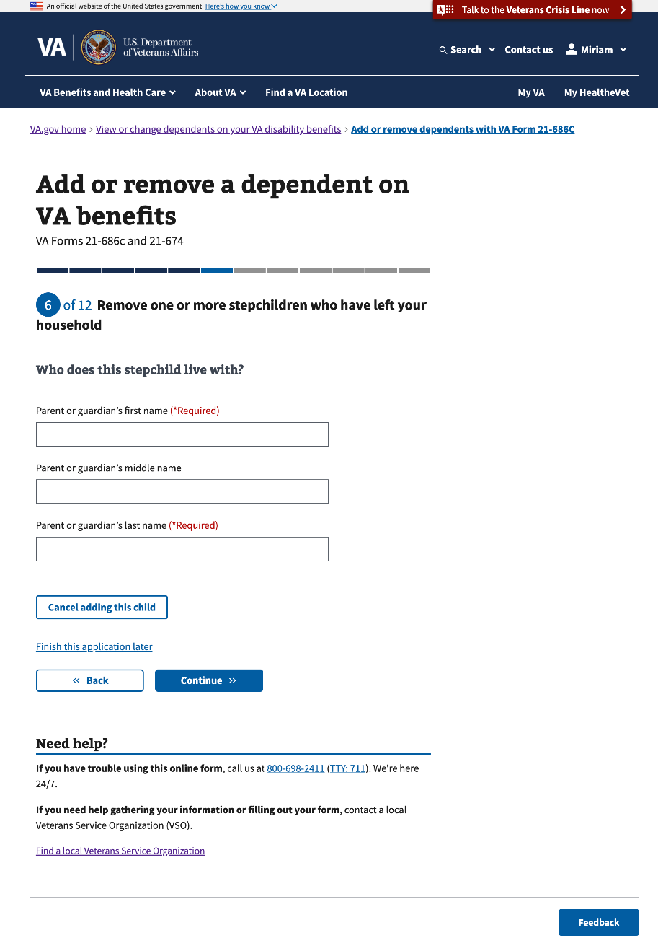

#### 3.79 Review your stepchildren who have left your household

This is the last page to add information about the Veteran’s student(s) who left their household.

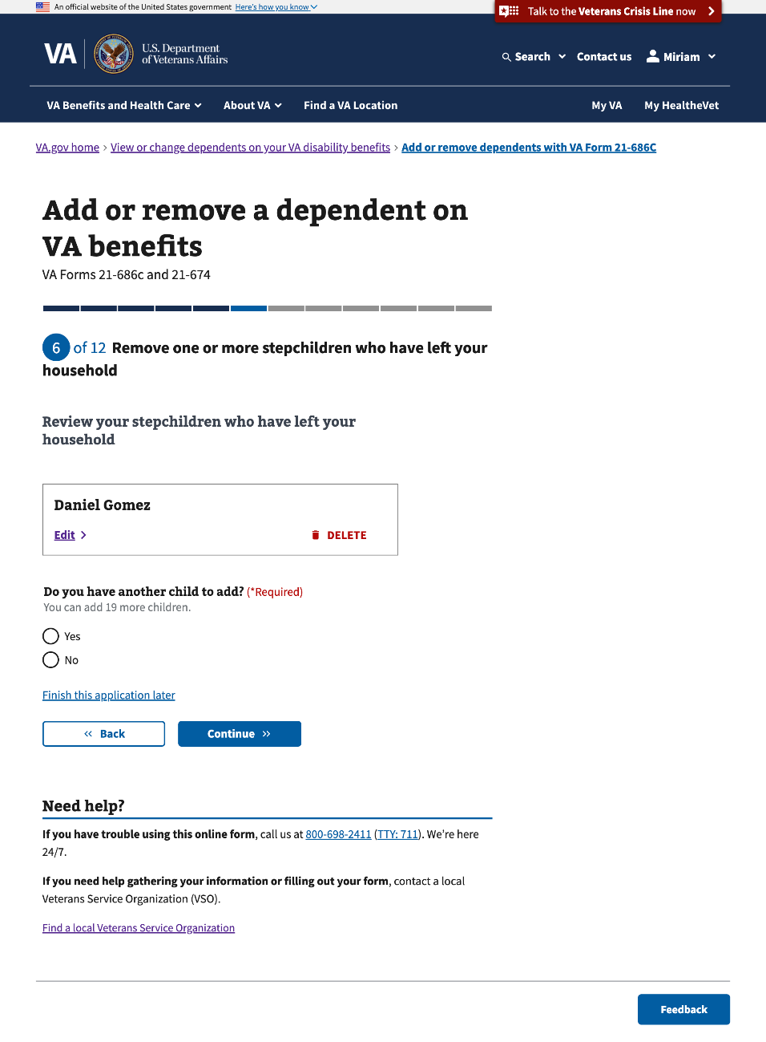

### Step 3: Remove one or more children who got married

This section of Step 3 will conditionally show if the Veteran selects to remove one or more children who got married in Step 1. This section of Step 3 has **5 sub-pages** that ask questions about the child’s personal information.

#### 3.80 Your children under 18 who got married

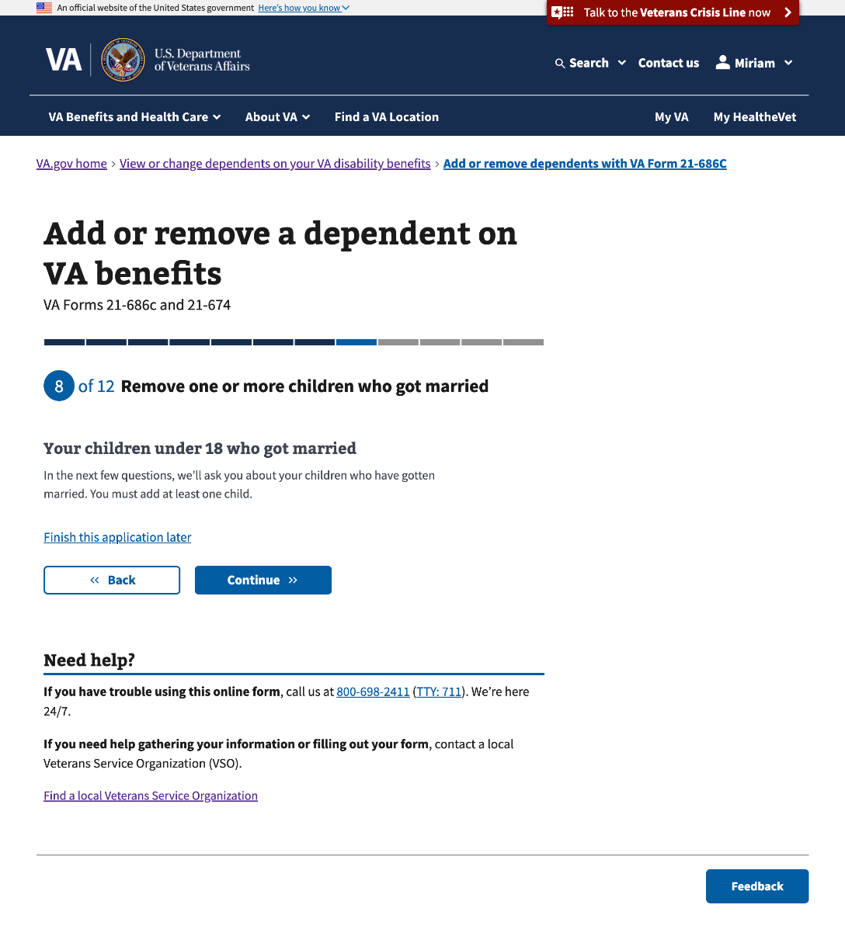

#### 3.81 Remove a child who got married

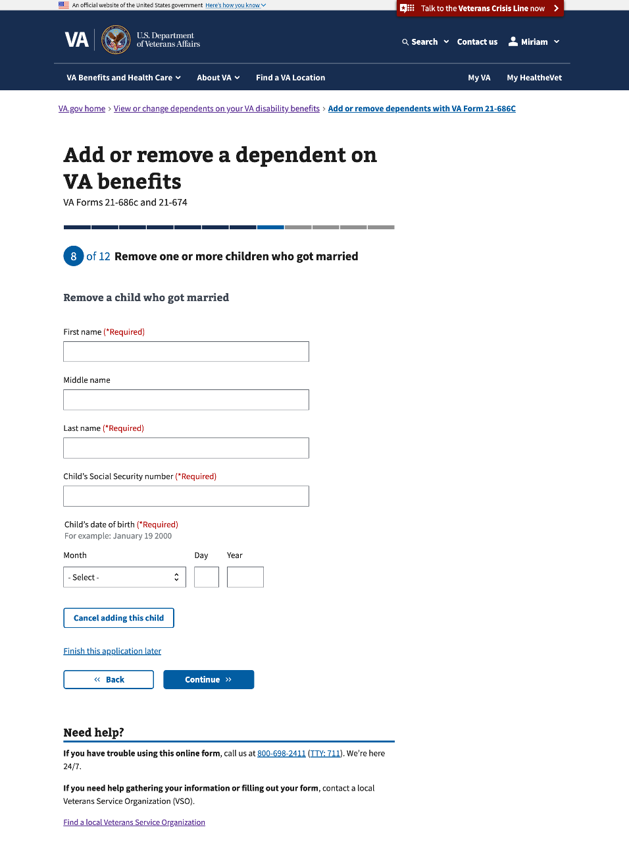

#### 3.82 Child’s marriage date

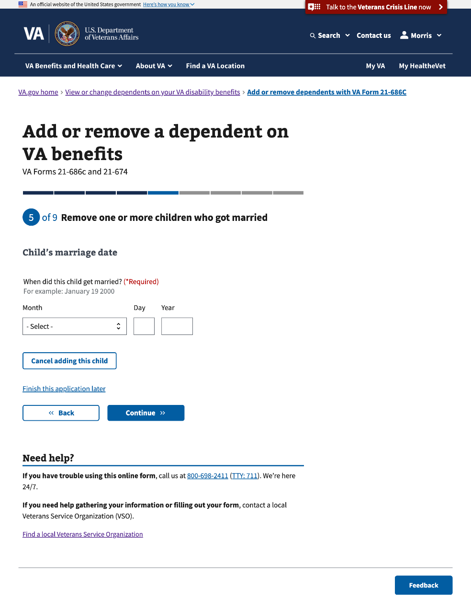

#### 

#### 3.83 Child’s income

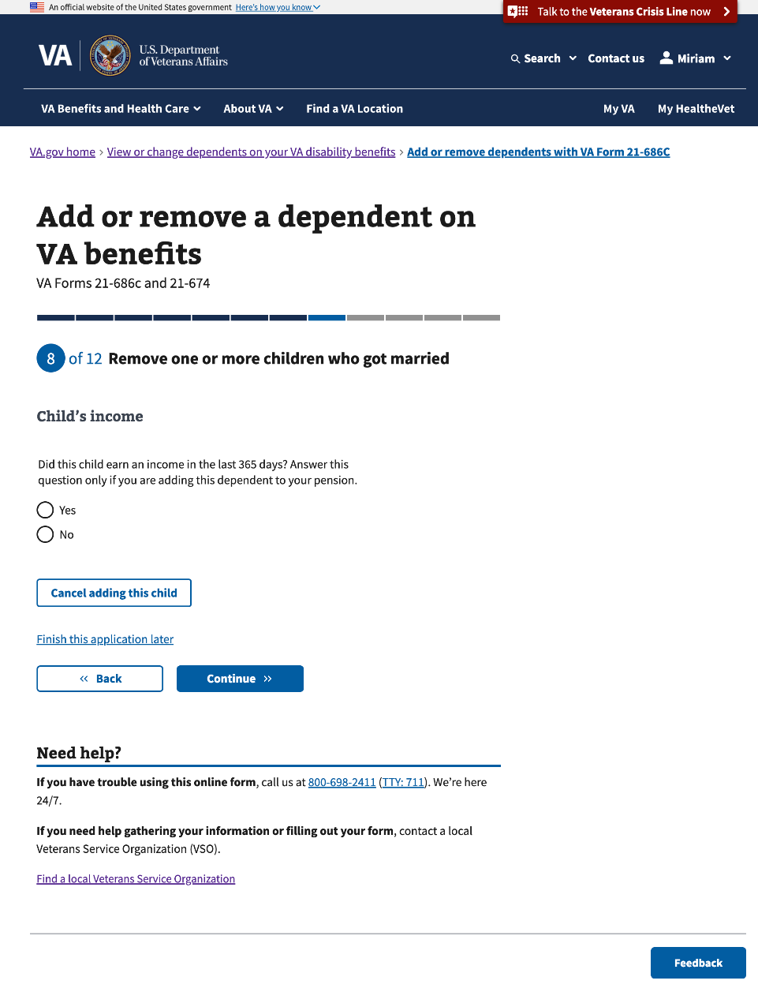

#### 

#### 3.84 Review your children under 18 who got married This is the last page to add information about the Veteran’s children under 18 who got married.

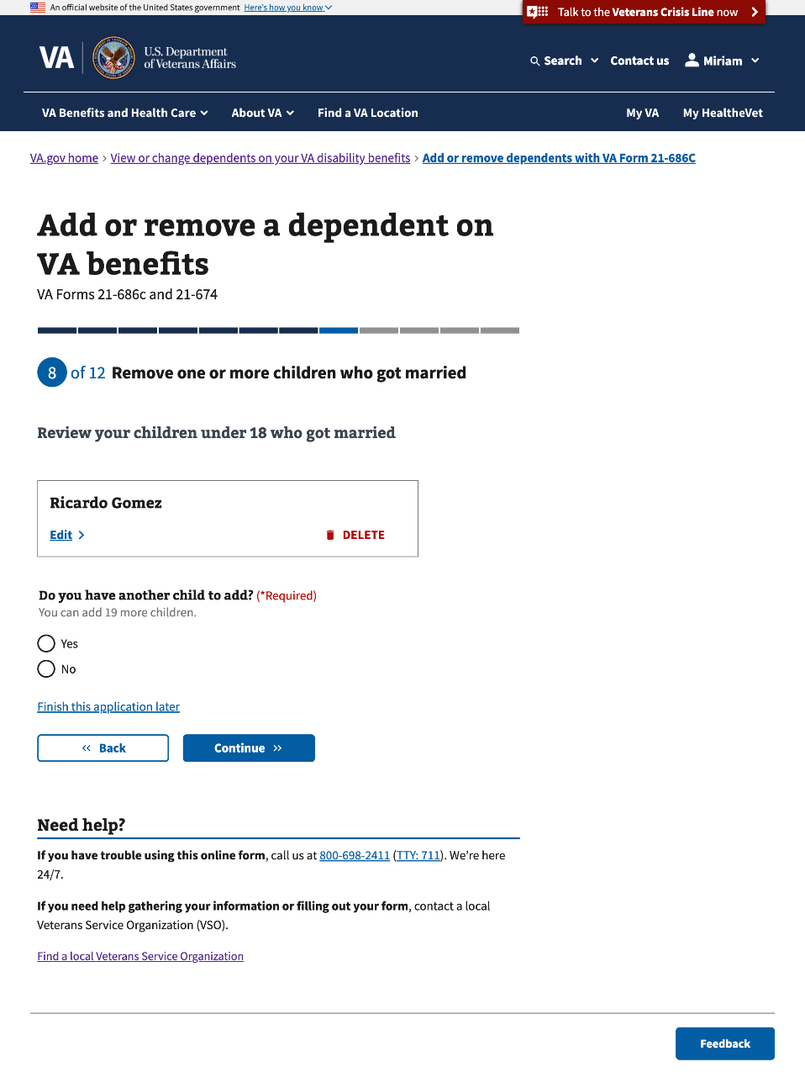

### Step 3: Remove one or more children between ages 18 and 23 who left school

This section of Step 3 will conditionally show if the Veteran selects to remove one or more children between 18 and 23 who left school on Step 1. This section of Step 3 has **5 sub-pages** that ask questions about the child’s personal information.

#### 3.85 Your children between ages 18 and 23 who left school

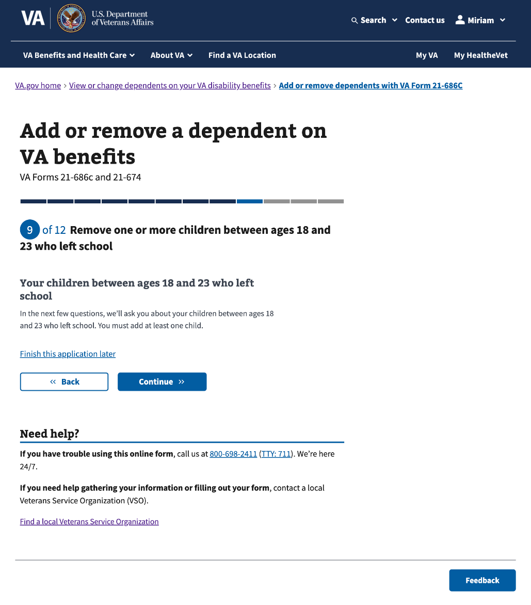

#### 

#### 3.86 Remove a child between ages 18 and 23 who left school

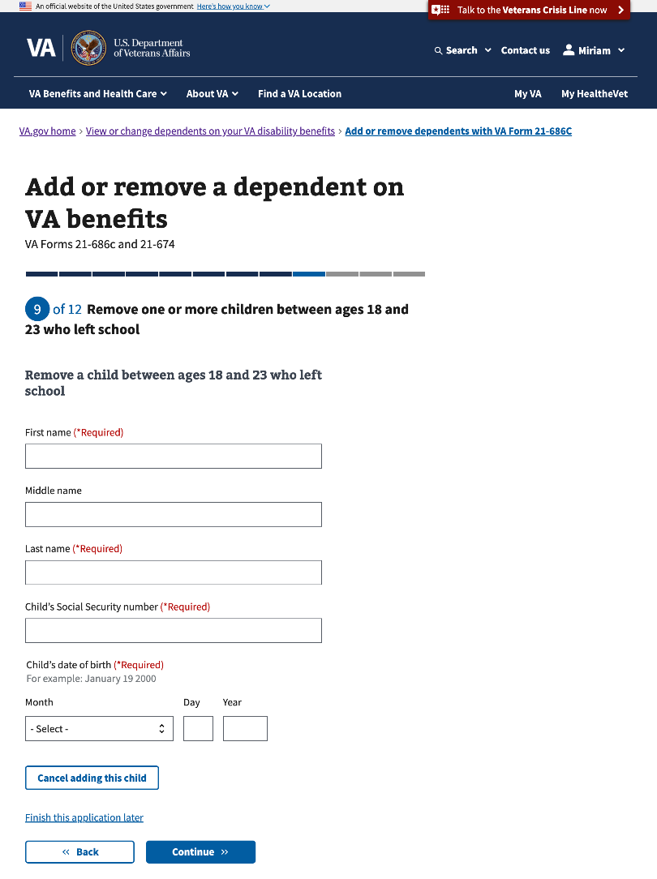

#### 3.87 Child’s school information

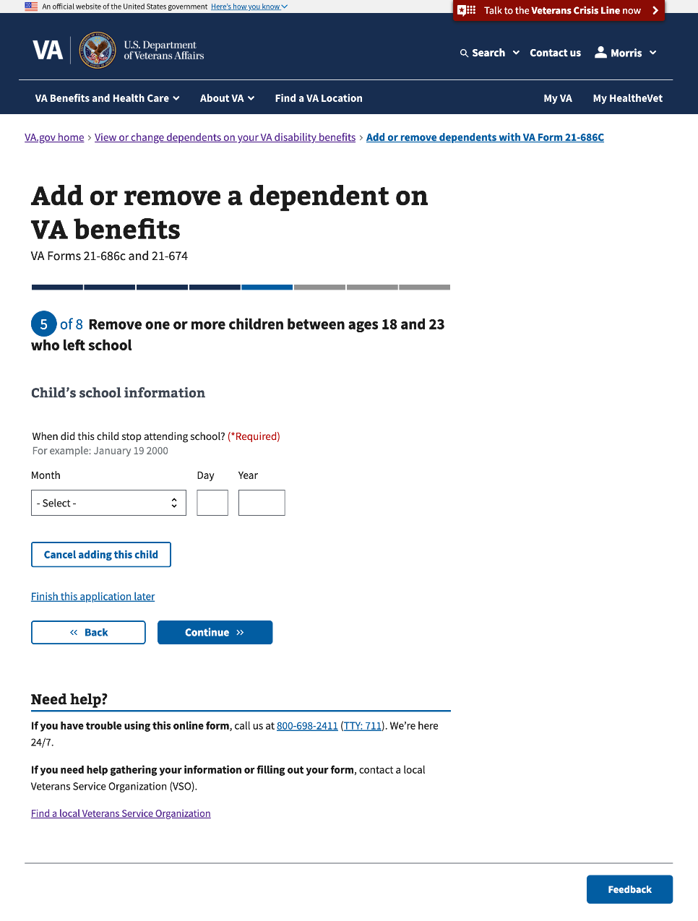

#### 

#### 3.88 Child’s income

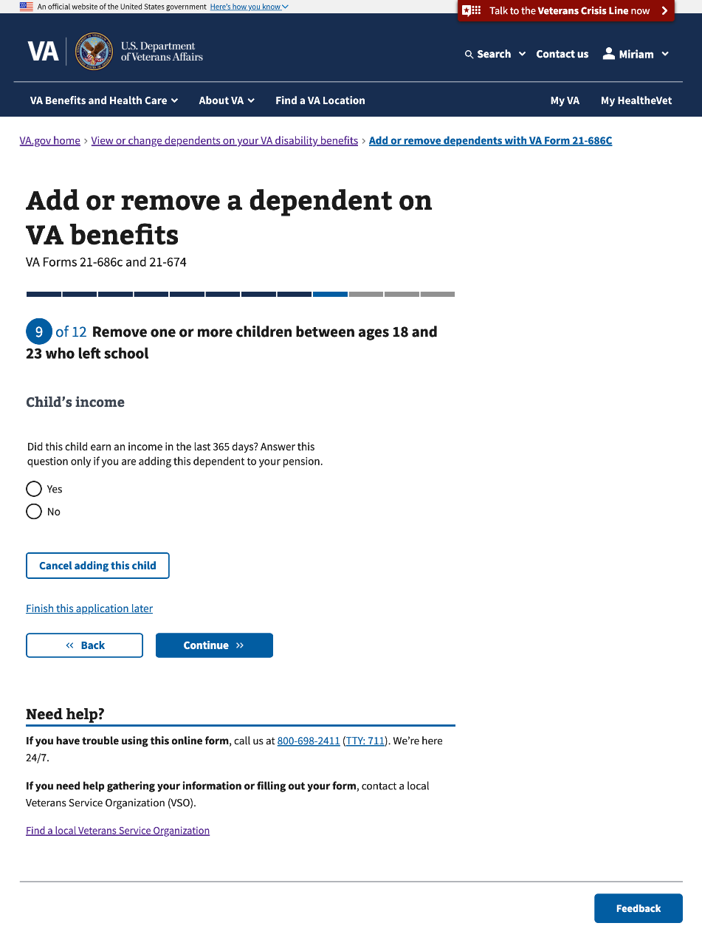

#### 

#### 3.89 Review your children between ages 18 and 23 who left school

This is the last page to add information about the Veteran’s children who left school.

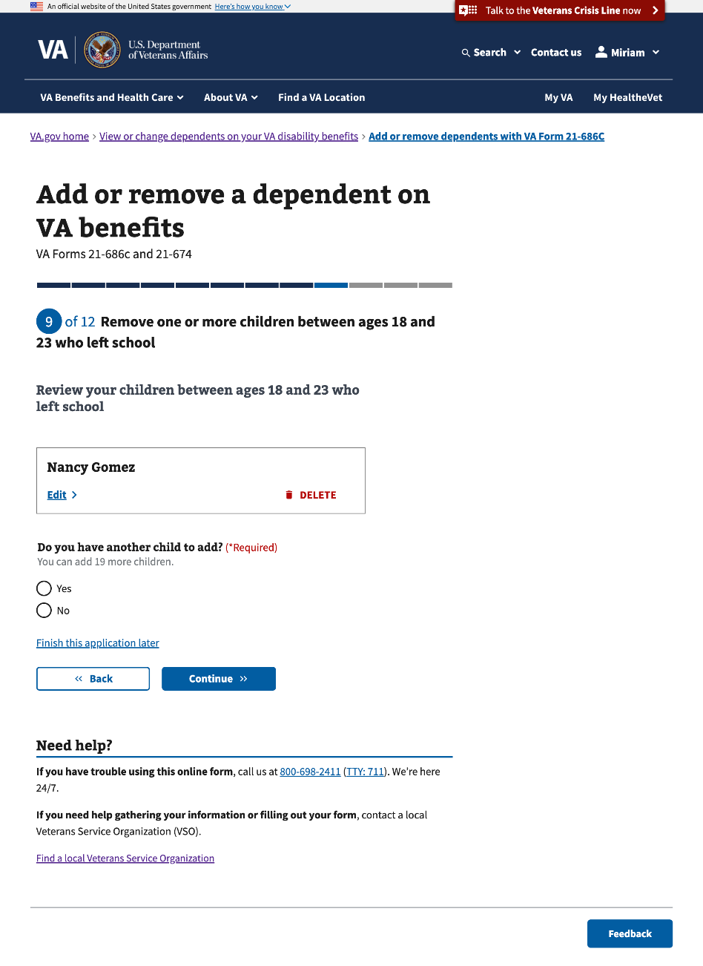

### Step 4 Your net worth

This step has 1 sub-page that asks a question about the Veteran’s net worth.

#### 4.0 Your net worth

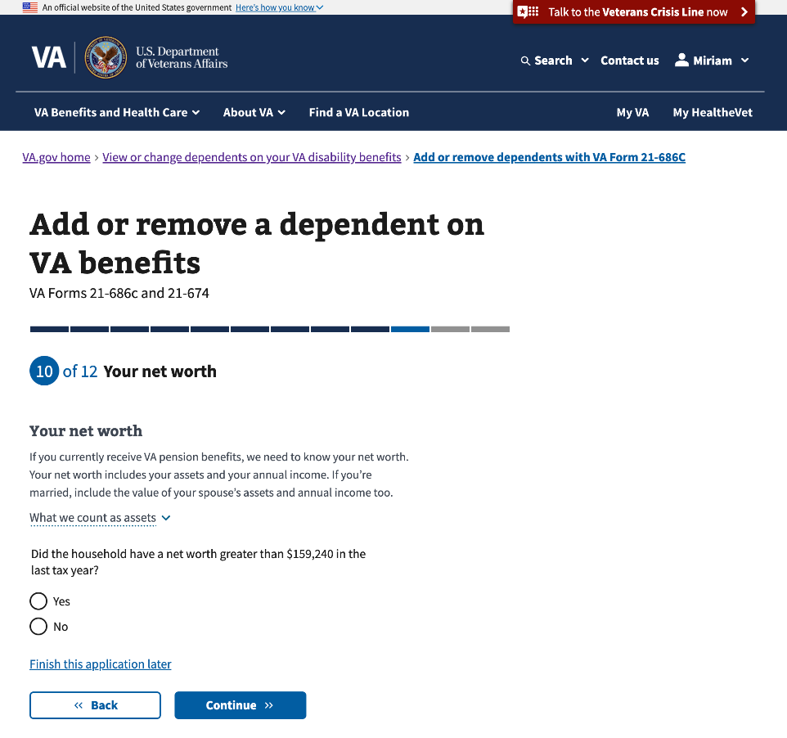

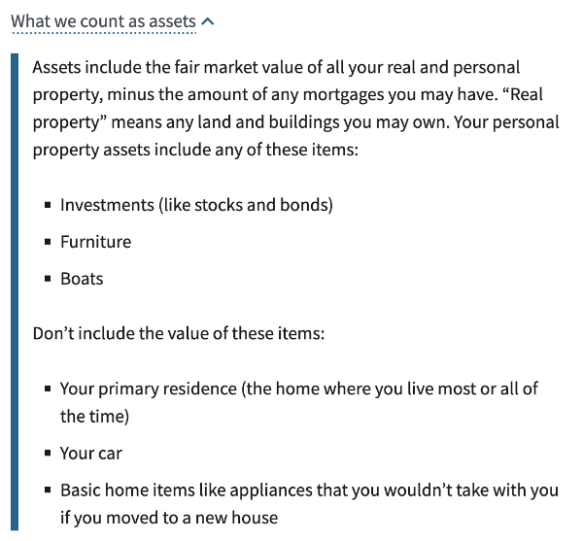

### Step 5 Additional information

This step has 1 sub-page that informs Veterans what type of supporting documents they need to submit and provides a way to upload them digitally.

#### 5.0 Submit supporting evidence to add your spouse

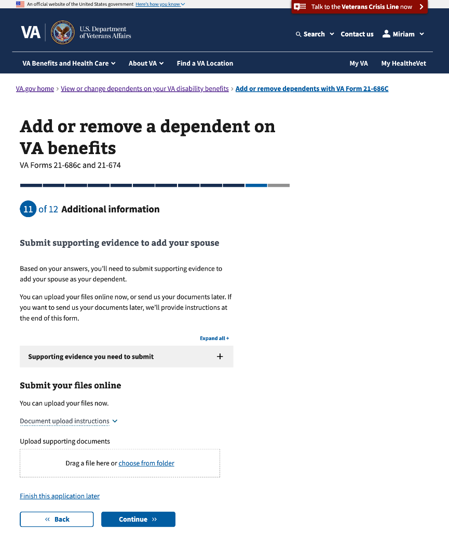

##### Uploaded file

##### 

##### Supporting evidence

The content in the “Supporting evidence you need to submit” will change based on the type of marriage the Veteran selects when adding a spouse.

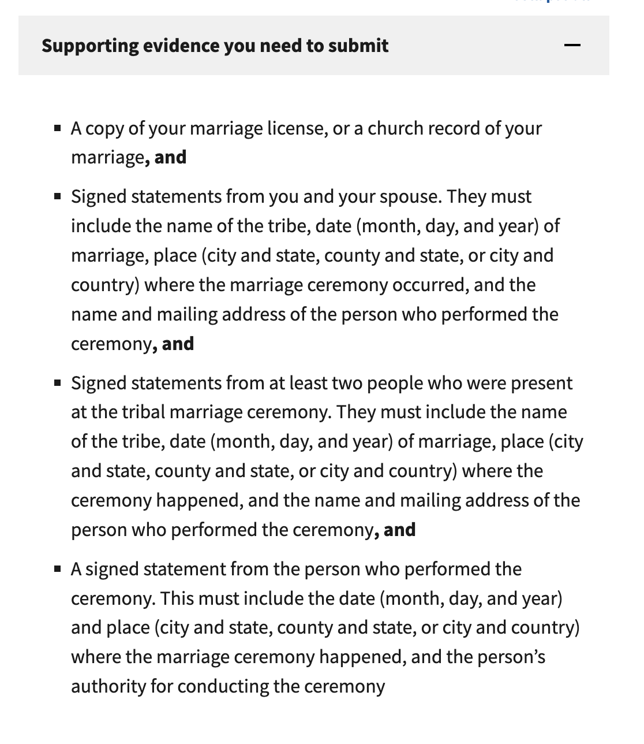

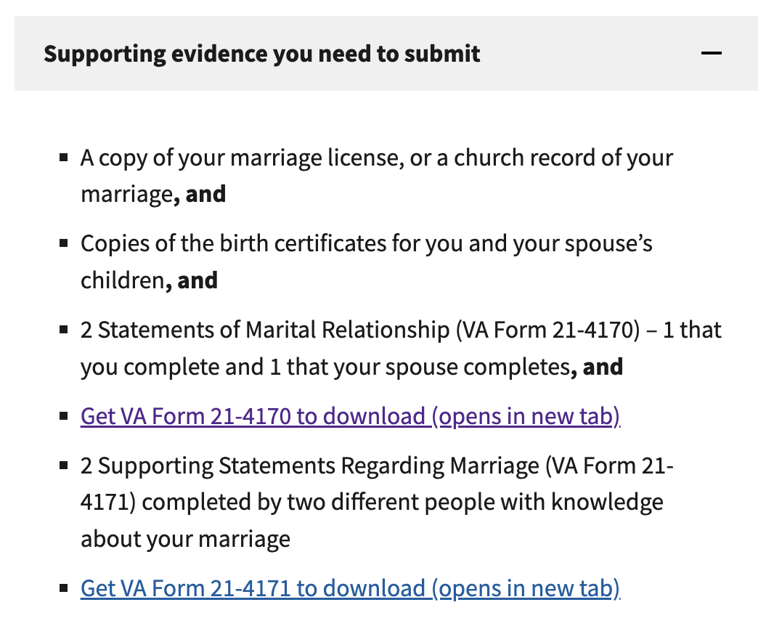

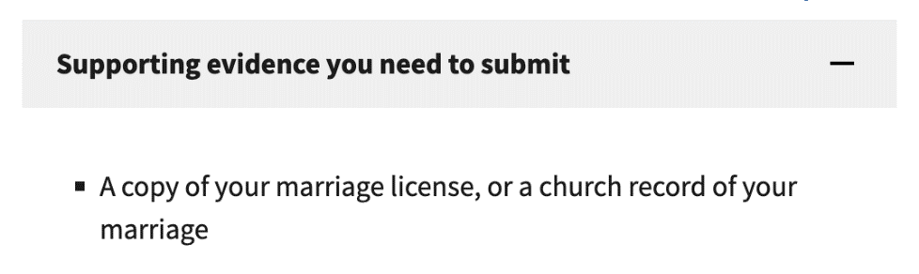

##### Document upload instructions



### 

#### 5.1 Submit supporting evidence to add your child

##### 

##### Uploaded file

##### 

##### Supporting evidence

The content in the “Supporting evidence you need to submit” will change based on the type of child the Veteran is adding. If the Veteran is adding a stepchild or if the child doesn’t live in the U.S., they’ll see the first bullet. If the Veteran is adding a child with a disability, they’ll see the second bullet. If the Veteran is adding an adopted child, they’ll see the third bullet.   
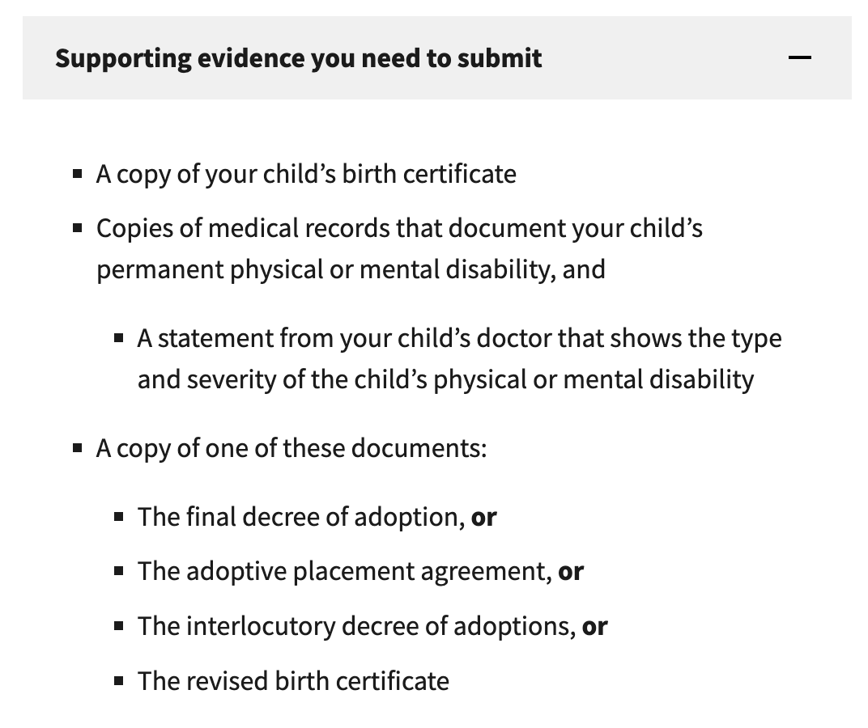

### Step 5 Review application

This step has 1 sub-page that allows the Veteran to review and edit any information they have entered.

#### 5.0 Review application

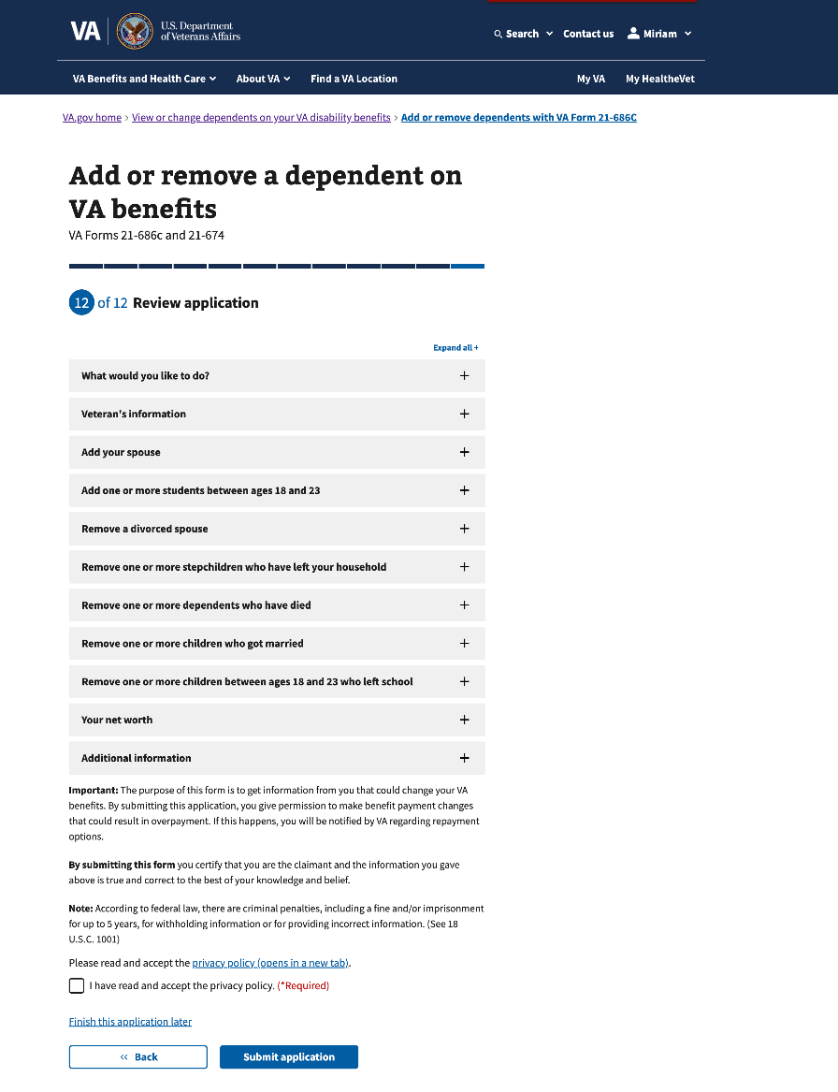

### Confirmation

After the Veteran submits this form, they will view a confirmation page that lists the following: The form starts on the date, the confirmation number, who submitted the form, what to expect next, how to submit additional evidence, and how to contact VA with questions.

#### 6.0 Confirmation

#### 6.0 Confirmation (Con’t)

## 

## 5. Email notifications

The Veteran could receive a series of emails through the application process.

#### Reminder

This email will be sent once to Veterans after 7 days of inactivity during their application process.

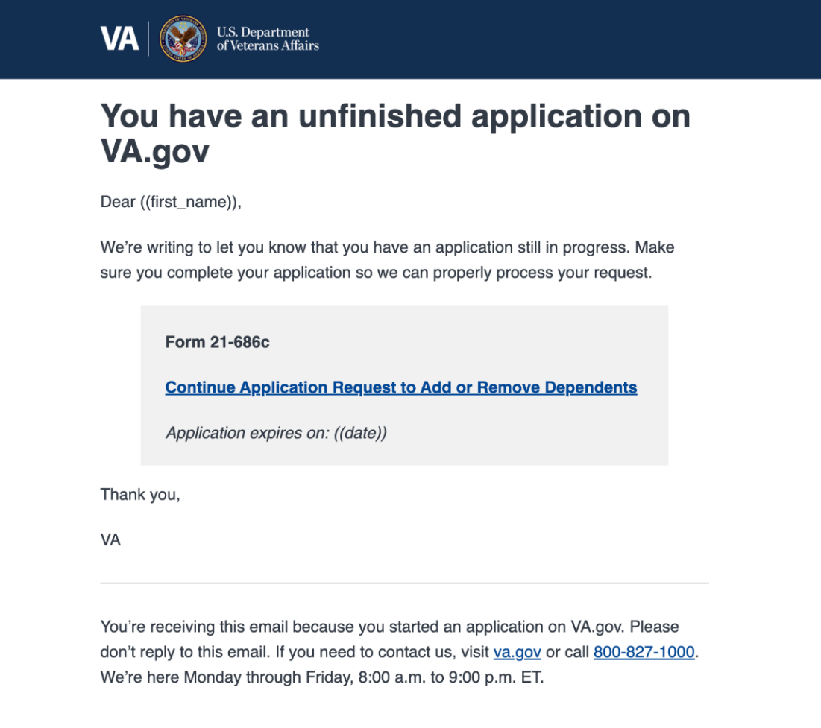

#### 

#### In-progress

This email is sent to Veterans right after they submit their applications, informing them that their application has been received and is being processed.

##### 686c

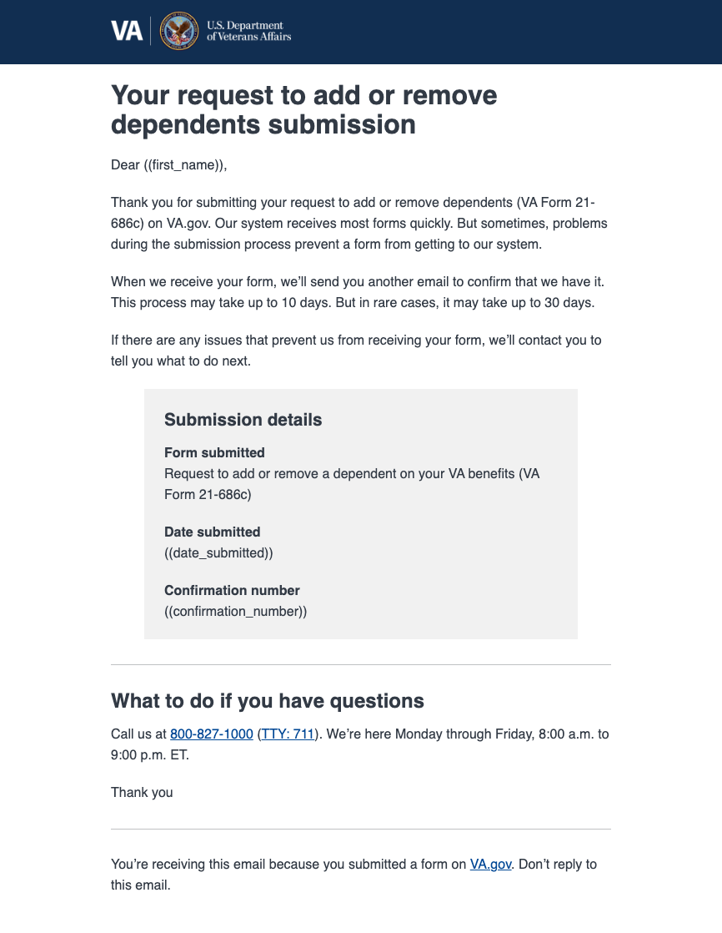

##### 674

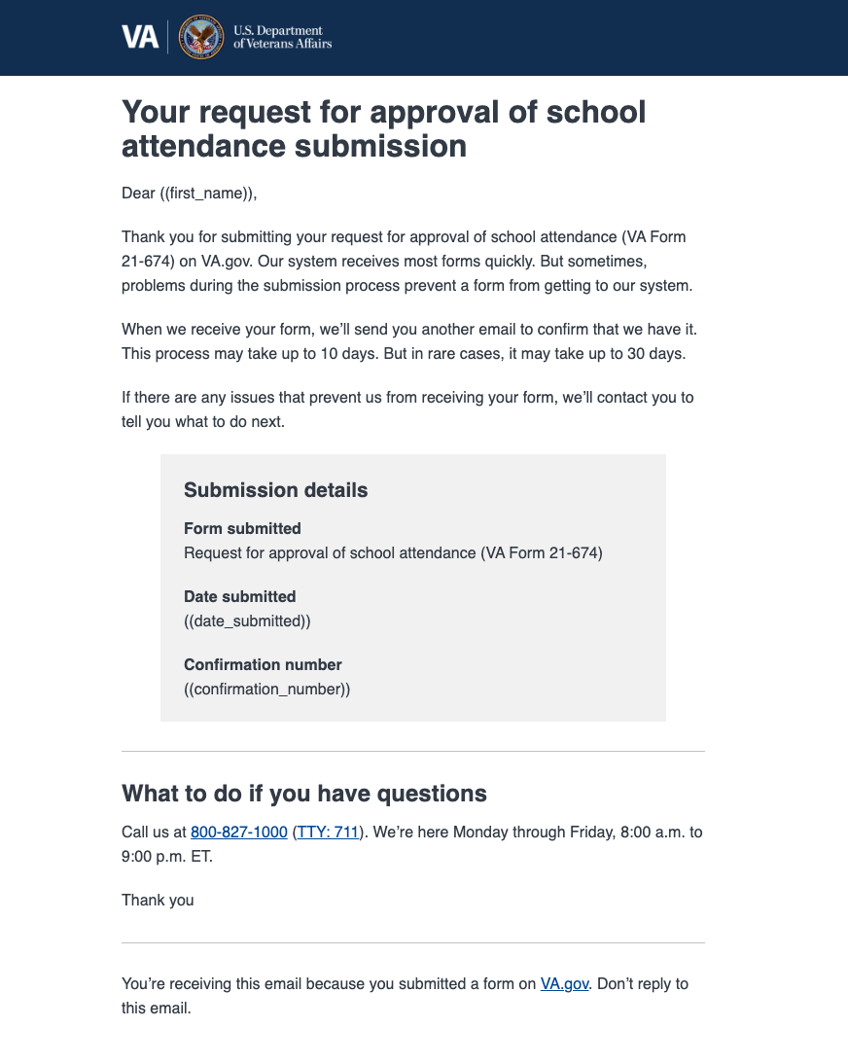

##### 686 and 674

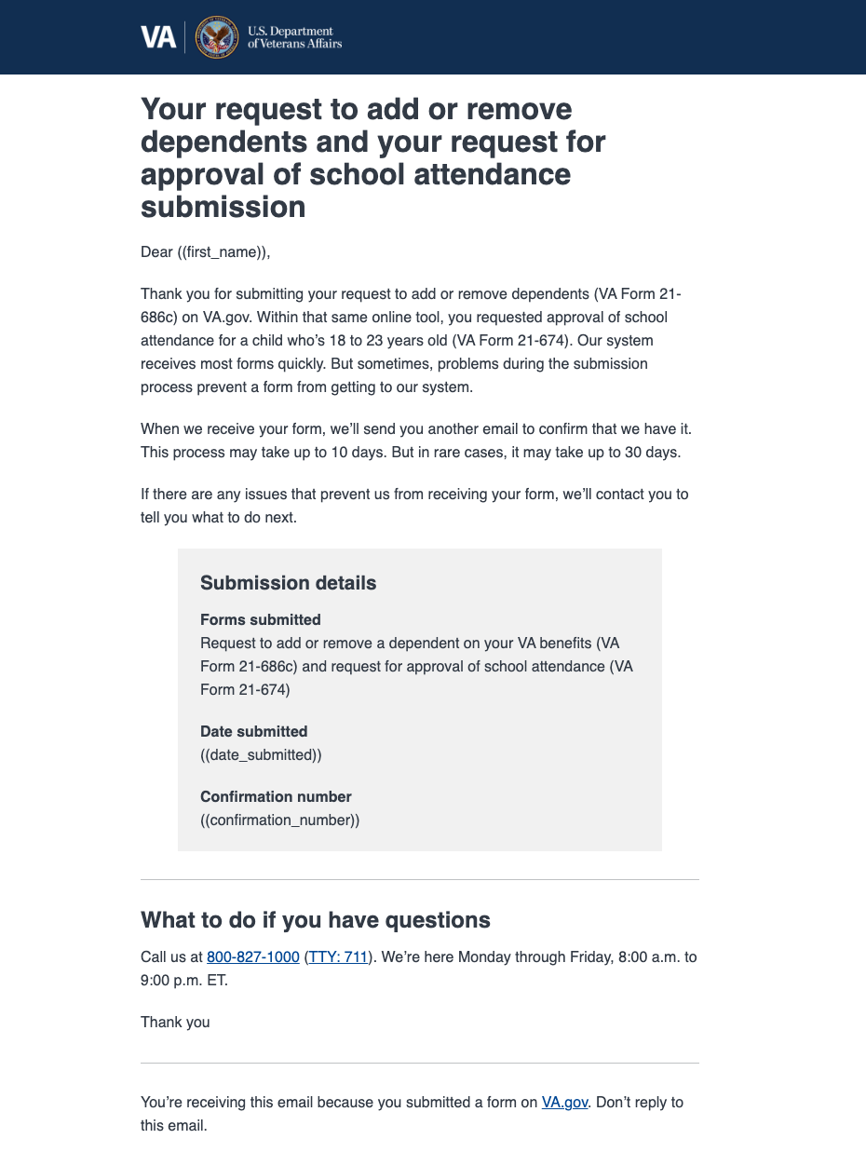

#### 

#### Received

This email will follow the “in-progress email " and inform Veterans that we have successfully received their applications and have encountered no problems in our systems.

##### 686c

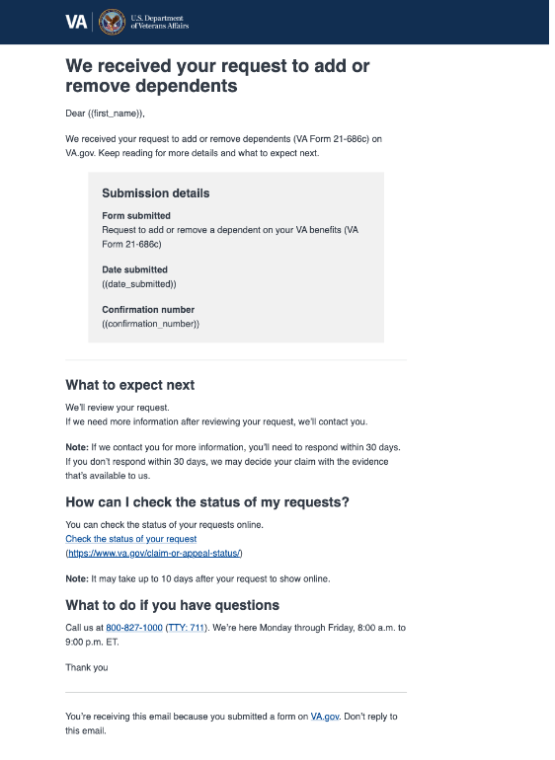

##### 674

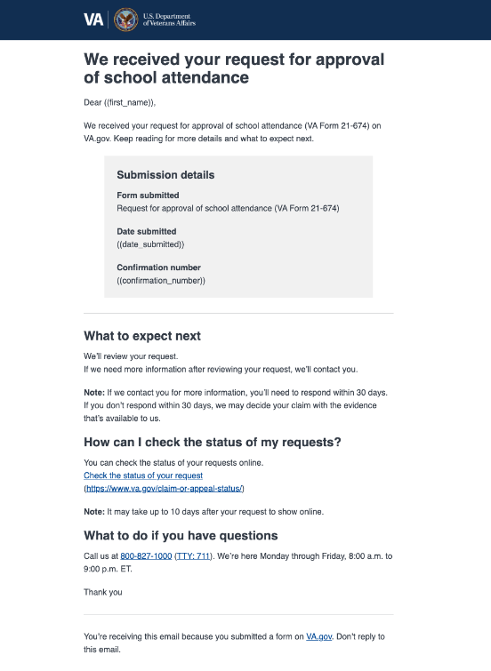

##### 686c and 674

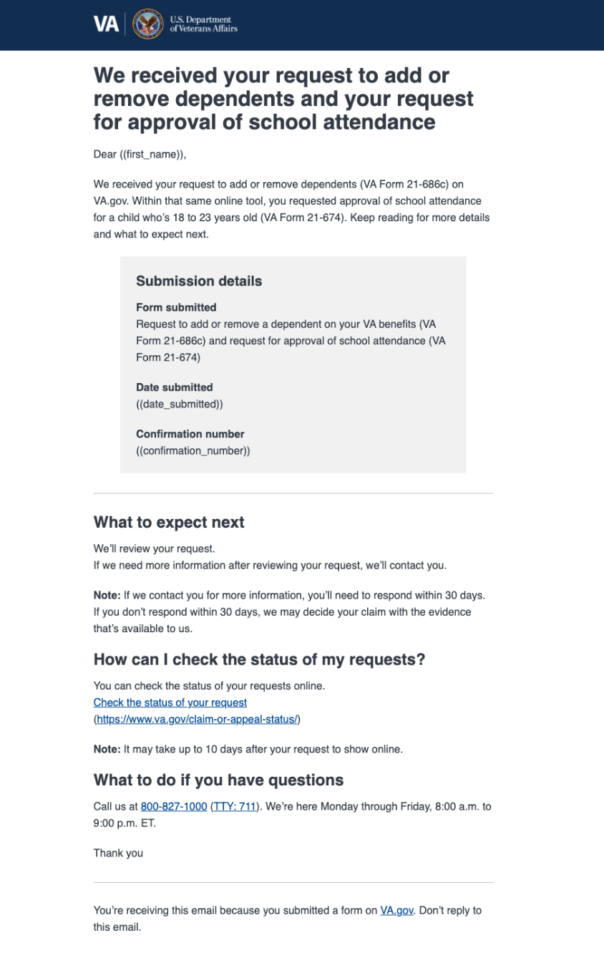

#### Action needed

This email could be sent to Veterans after the “in-progress” email when their application encounters problems in our systems. It will outline what they must do and how to contact the VA if they have any questions.

##### 686c

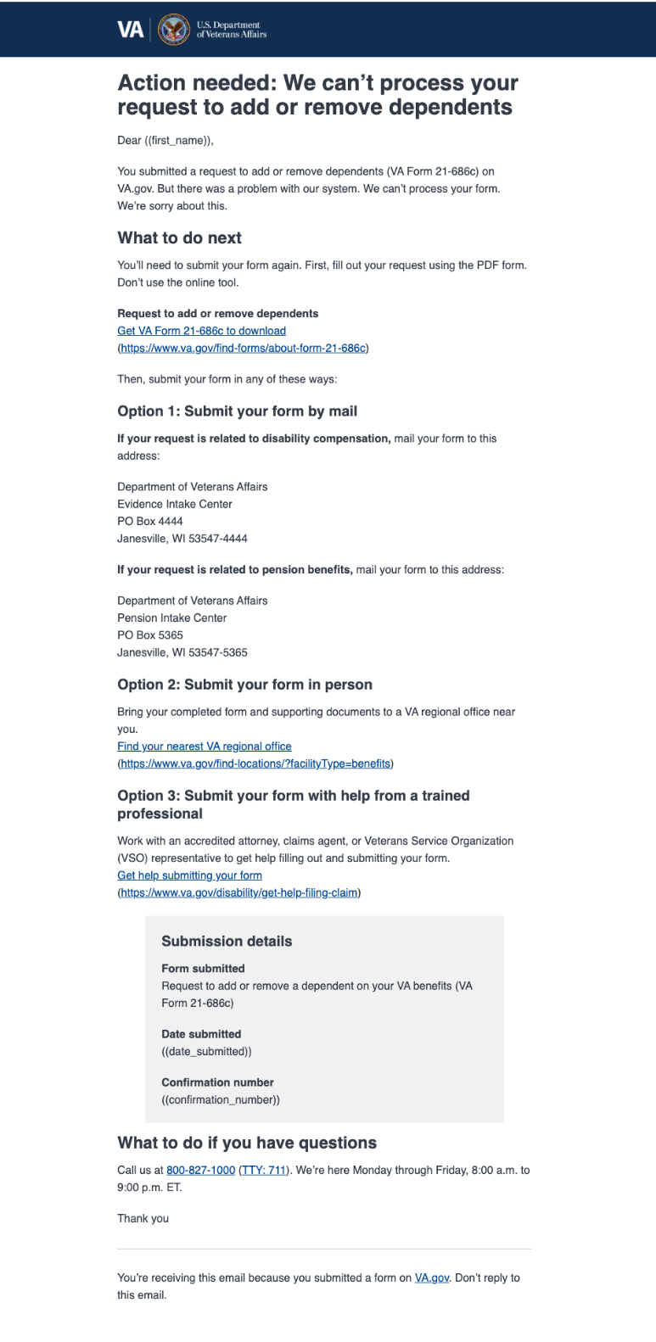

##### 674

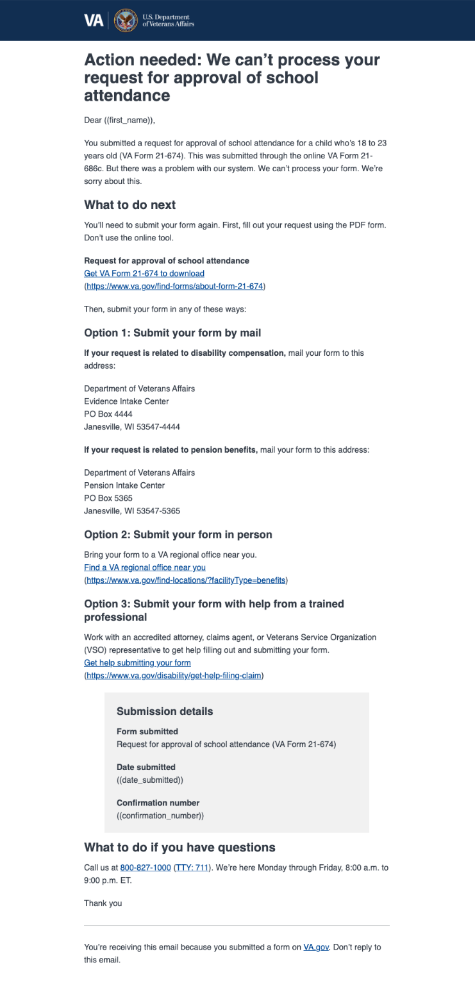

##### 686c and 674

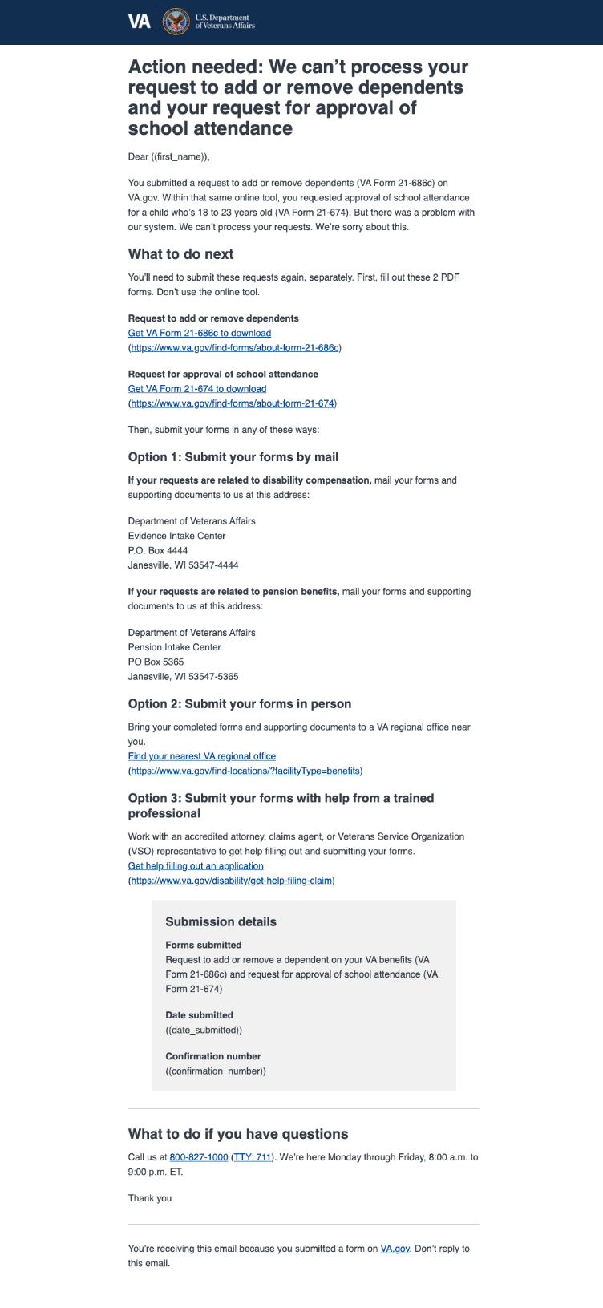

## 6. Major Issues and Error Messages

#### Required response

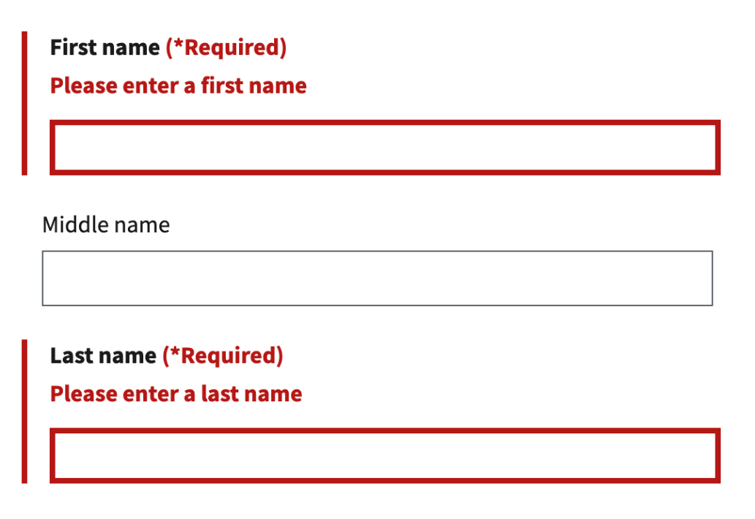

#### Incomplete information

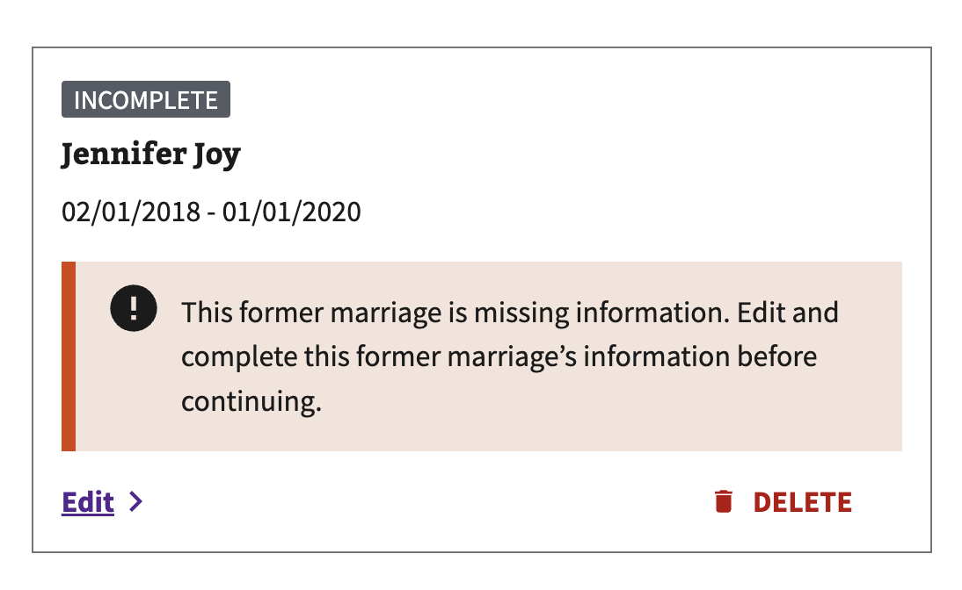

#### Privacy policy

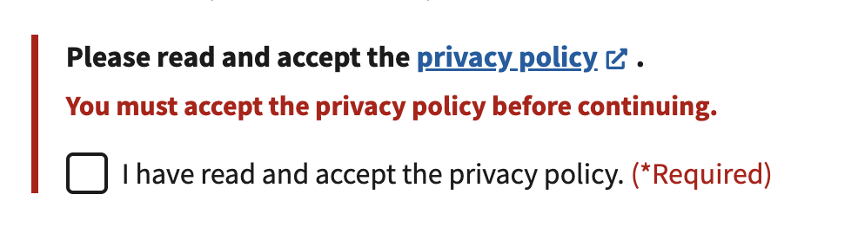

#### Missing information

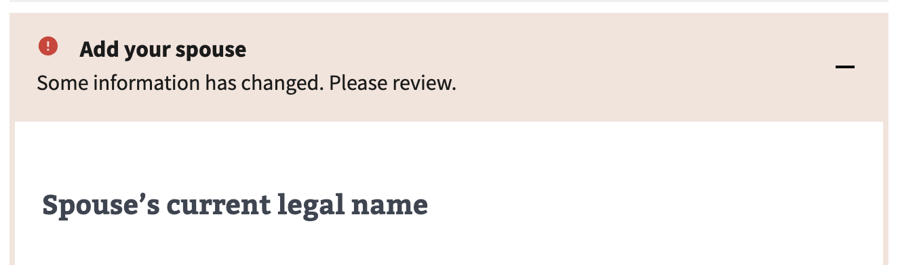

#### Submission failure

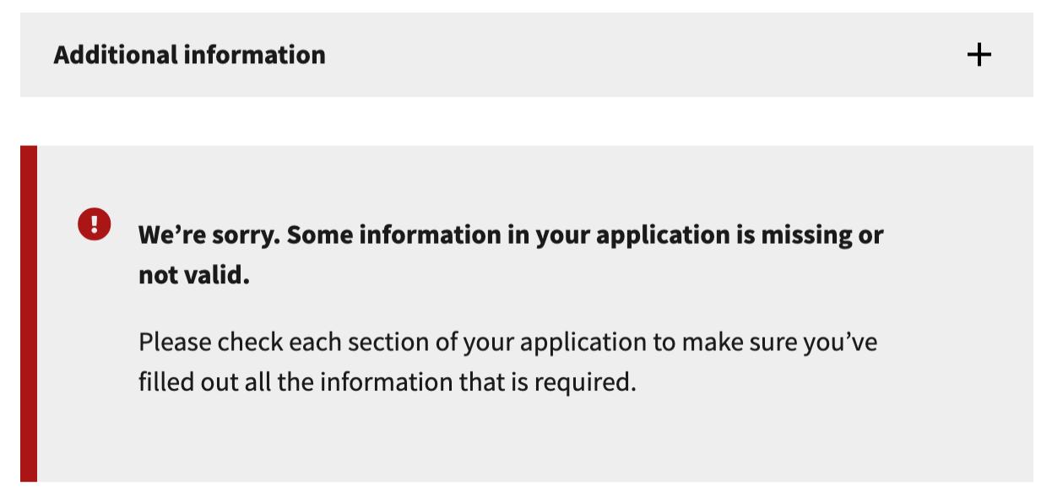

#### Connection error

